Allotment in Anstruther

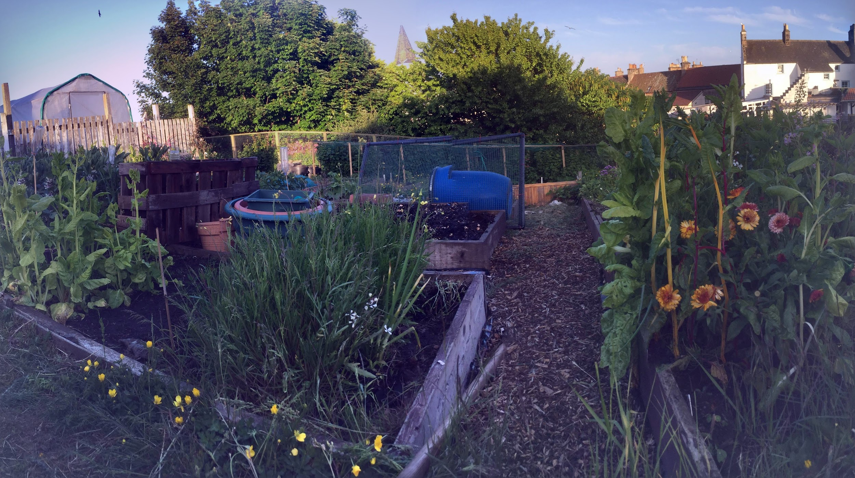
From: 2020 August/ September
Design Framework: GOBRADIMET
Client: Myself - Priya Logan

Background 3
Design Framework 5
GOALS 6
OBSERVATION 7
Map hand drawn 8
Location Details 10
PASTE 11
Plants 11
DAFOR 11
Animals 12
Structures: 12
Tools 13
Events 13
Soil Test 13
Soil Test - Jar 13
This test showed up that there is quite a large sand layer and has a small amount of clay and silt in comparison. 13
PH Test 14
All the soil is tending strongly towards alkaline about 7 on the scale. 14
Treating Soil 14
Client interview 14
Client wants and needs 16
BOUNDARIES 16
RESOURCES 17
ANALYSIS 17
Functions Systems and Elements 18
Zones 18
Our Zones as a family as relates to food production 18
PRINCIPLES 20
If it ain’t broke, don’t fix it. 20
Use on-site and local resources whenever possible. 20
Soil Enricher 20
Cardboard 20
Compost 20
Water 20
Resilience is true security. 21
Get some, obtain a yield. 21
Energy is abundant but not unlimited 21
DESIGN 21
What we want to grow. 22
What is already there. 22
Resources for decision making, mapping and planning 24
Making the plan 24
Increase food yield and diversity 25
Create a planting plan 25
Nourish soil 25
Sustainable input and output of energy 25
Relaxation 25
Biodiversity 25
Growing Spaces Available 25
Home 25
My Allotment 26
Jaysons Allotment 26
Glasshouses at home 26
Next steps of Design 27
Working out the Final Design 28
Defining the spaces. 28
The final plan for the first year. 29
Four Year Rotation Plan 30
IMPLEMENT 31
Planting Plan 32
Implementation Plan 33
MAINTAIN 33
EVALUATE 33
Increase food yield and diversity 34
Create a planting plan 34
Nourish soil 34
Sustainable input and output of energy 34
Relaxation 34
Biodiversity 35
Final Word 35
TWEAK 35
Resources 36
THE THREE ETHICS 36
Earth Care 36
People Care 36
Fair Share 37
REFLECTION 37
GALLERY 38

Background

After lots of learning made and undertaken at the allotment we had for over two years in Glasgow it was sad to leave it and start again.

When we moved to Anstruther I had a contact who had an allotment whom I offered to help out with. It was quite a large plot and the boundaries were not that clear but I was keen to start growing things again and having a nice spot by the river was good plus it was so much closer to where we lived than the allotment we had in Glasgow was to where we lived then.

After going there a few times and feeling a bit overwhelmed by the project plus the season - late Winter I was fortuitously offered a ready to go plot of my own. It is a quarter full size.

For me these happenings had a deeper resonance too, I was coming to terms with my youngest child turning four years old and realising that I had not had a baby either in utero or breastfeeding since I was twenty one and I had the capacity to spend time away on my own if needed.

It's also a beautiful place to be a picturesque spot. In a way this energy has been formative in how I have approached thinking about the space.

I have a great, neat four bed space which is somewhat restrictive in terms of large wild adventures or grand statements but for my purposes and resources is a perfect space to grow what we need and create a beautiful, experimental, productive learning area.

The plot has been used over the past few years in a rotation now and have had varying levels of success with it.

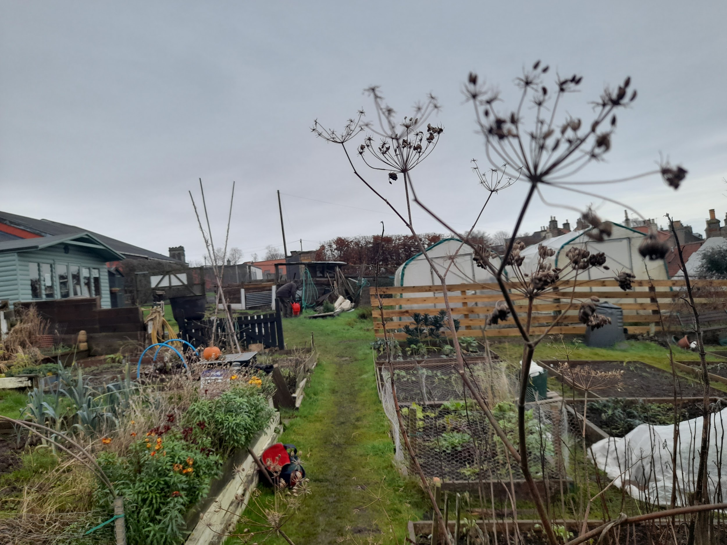

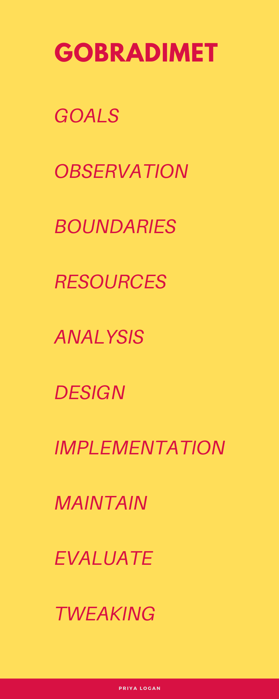

Design Framework

GOBRADIMET

This design framework is more extensive but having read through quite a few designs that have used this I fancied giving it a go.

This design process appealed because it seems to be thorough and dynamic. I read a lot about it on Permaculture Women.
See: permaculturewomen.com

GOALS

- Increase food yield and diversity
- Create a planting plan
- Nourish soil
- Sustainable input and output of energy
- Relaxation
- Biodiversity

OBSERVATION

- Have had the allotment for three years.

- I acquired it in April 2017.

- Have roughly two days a week to spend there.

- It’s one of three growing areas

- The beds are clear, strong and well built.

- The plot is south facing and has no shade.

- Planting plan is from 2021 early

- We have two compost bins at home, and two greenhouses

Map hand drawn
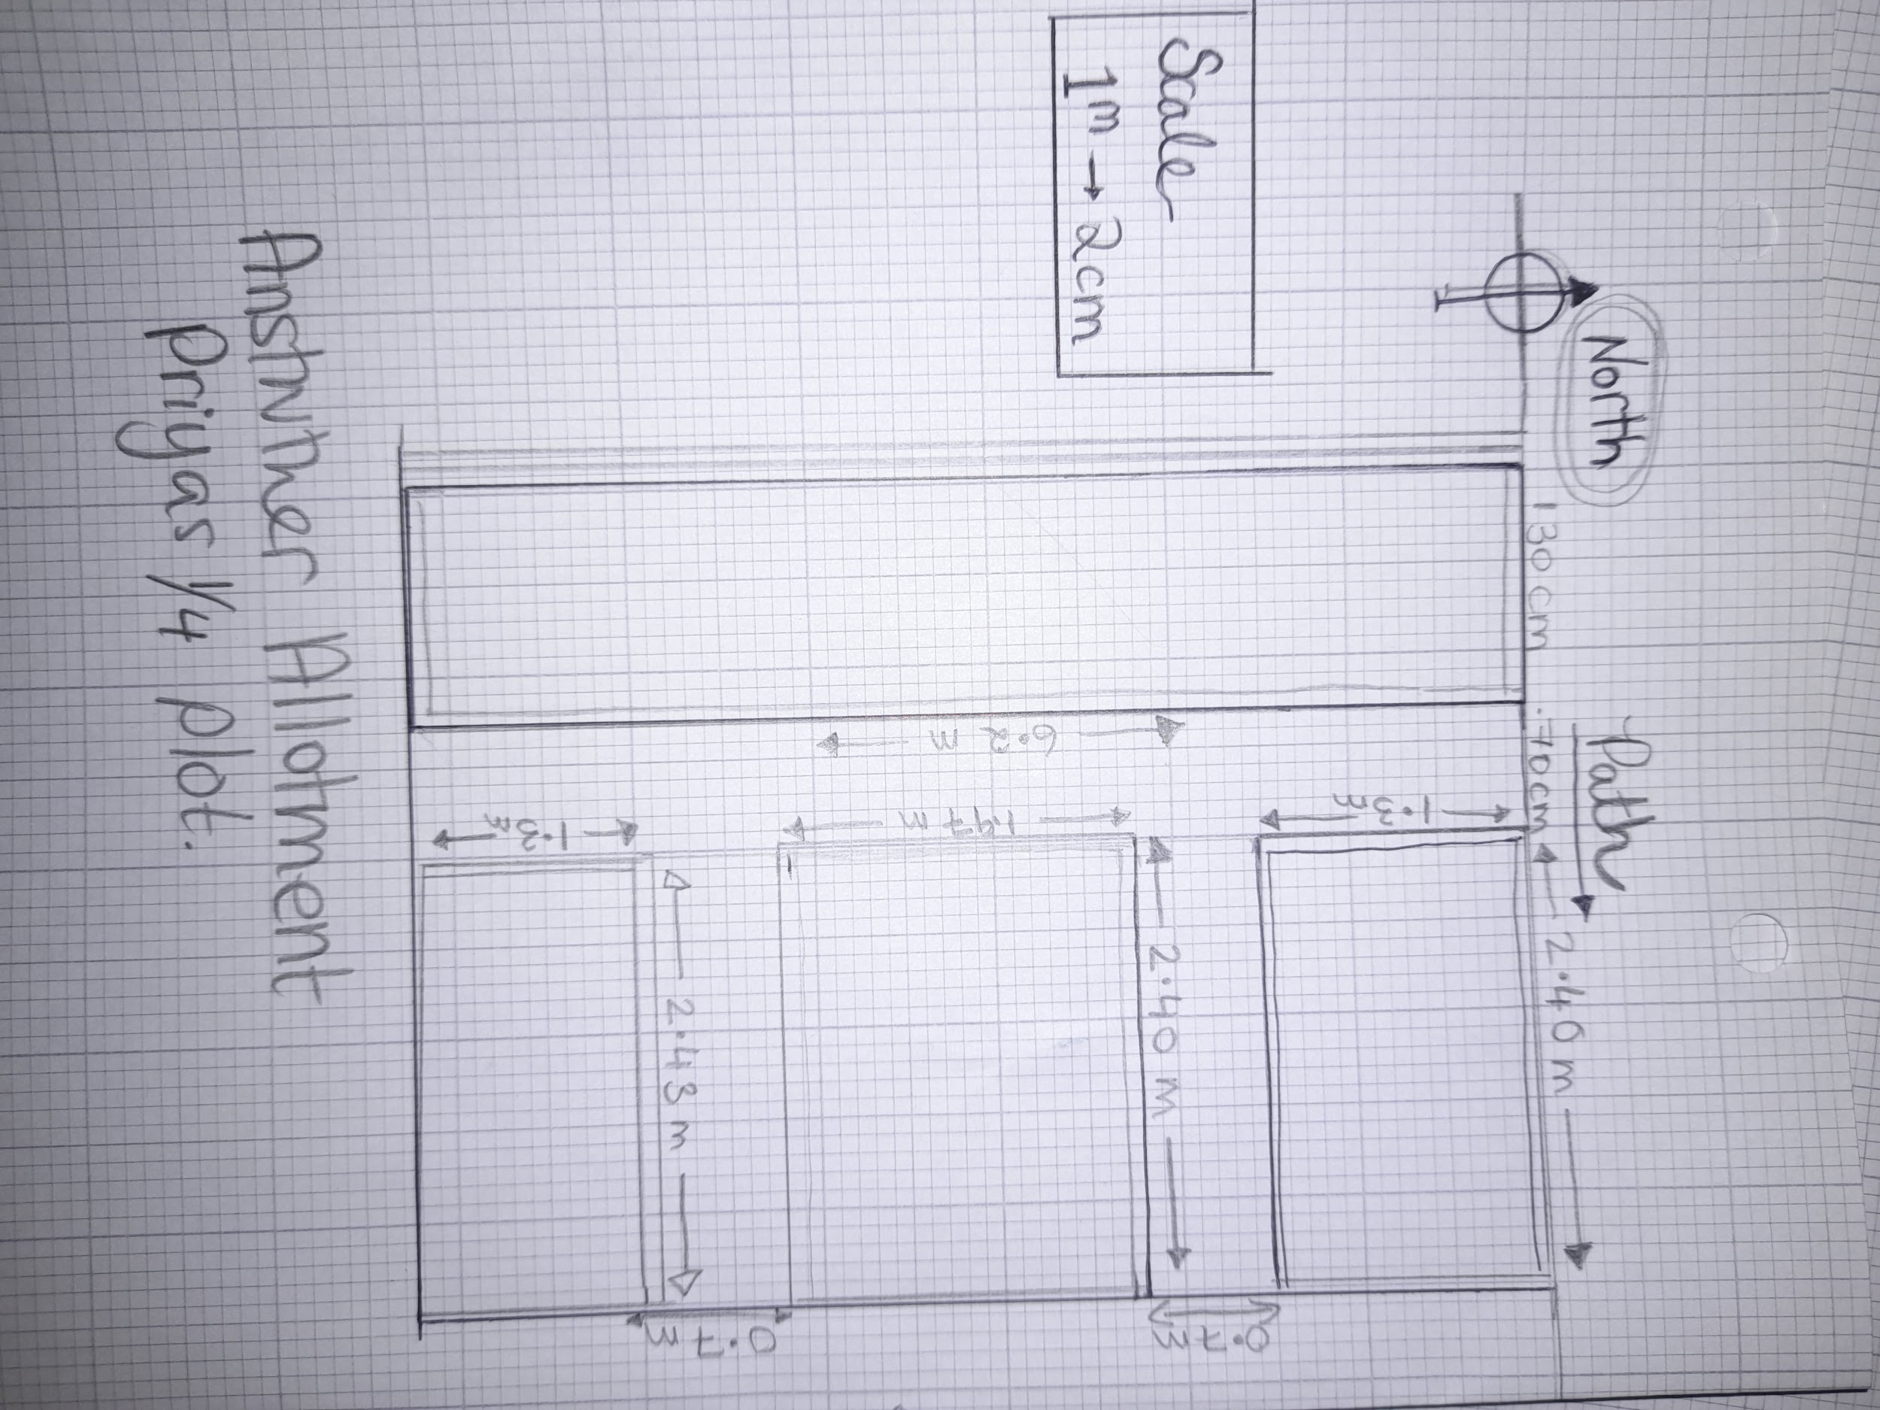
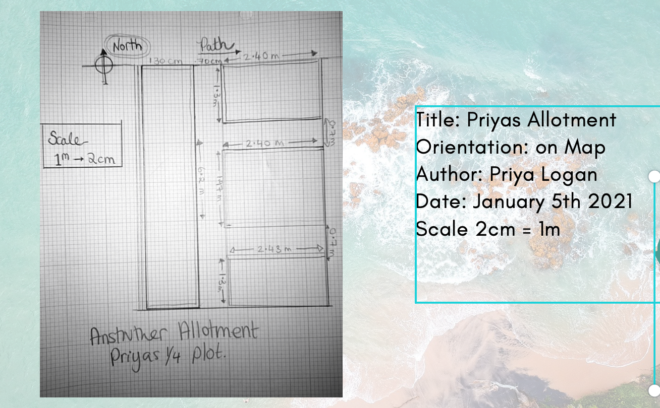

Location Details
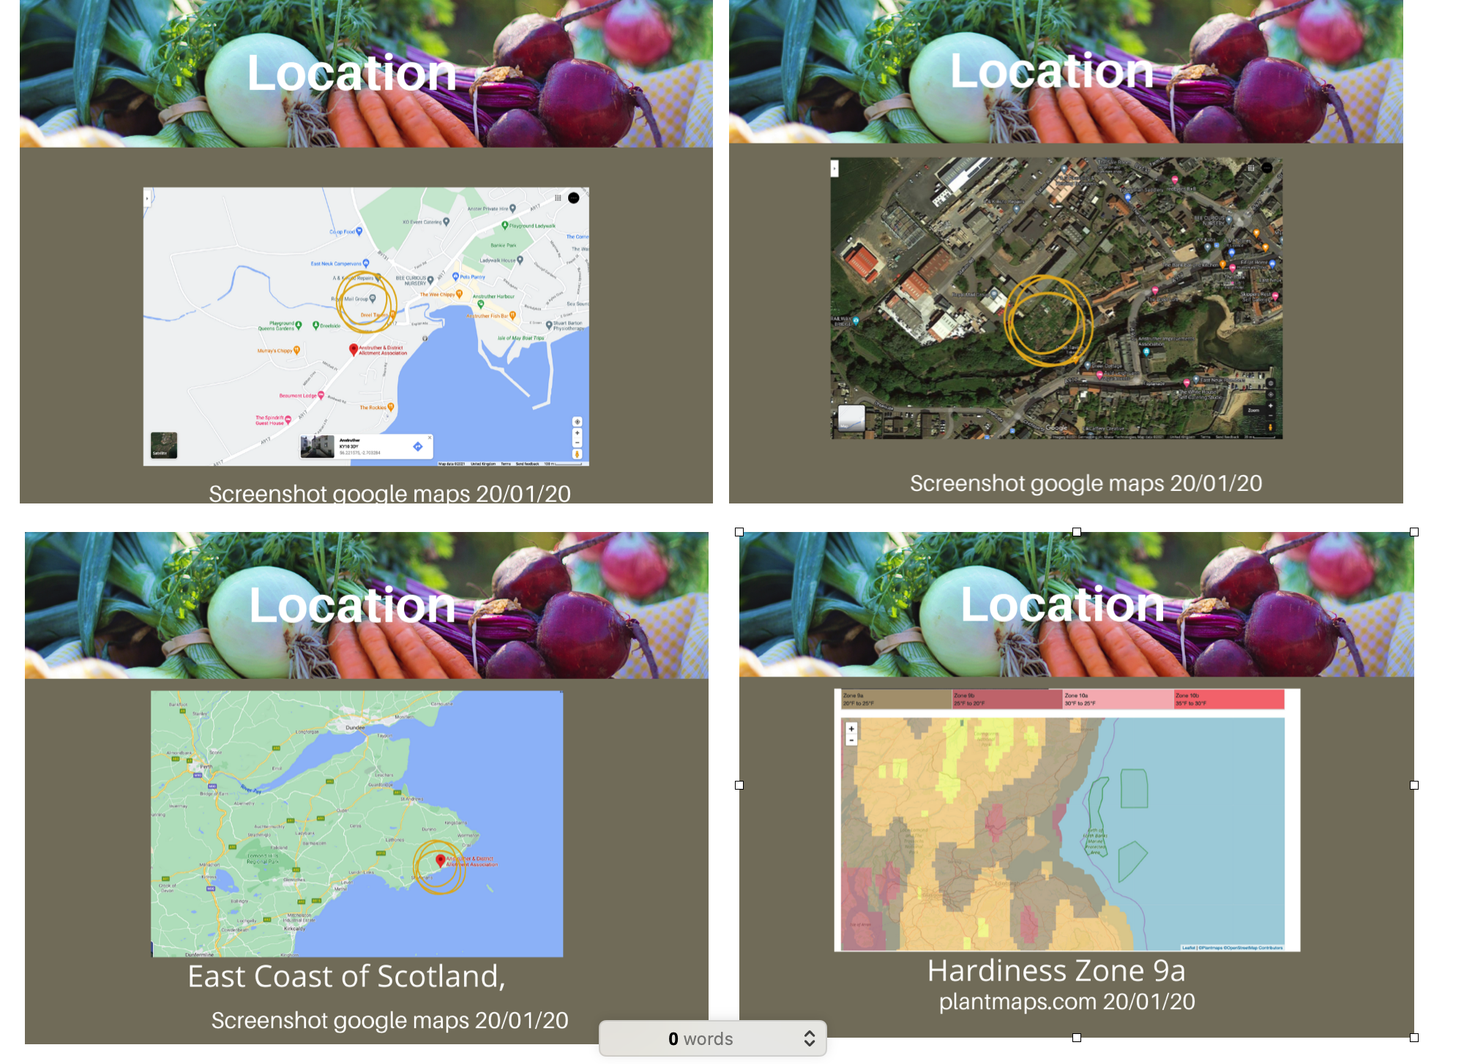

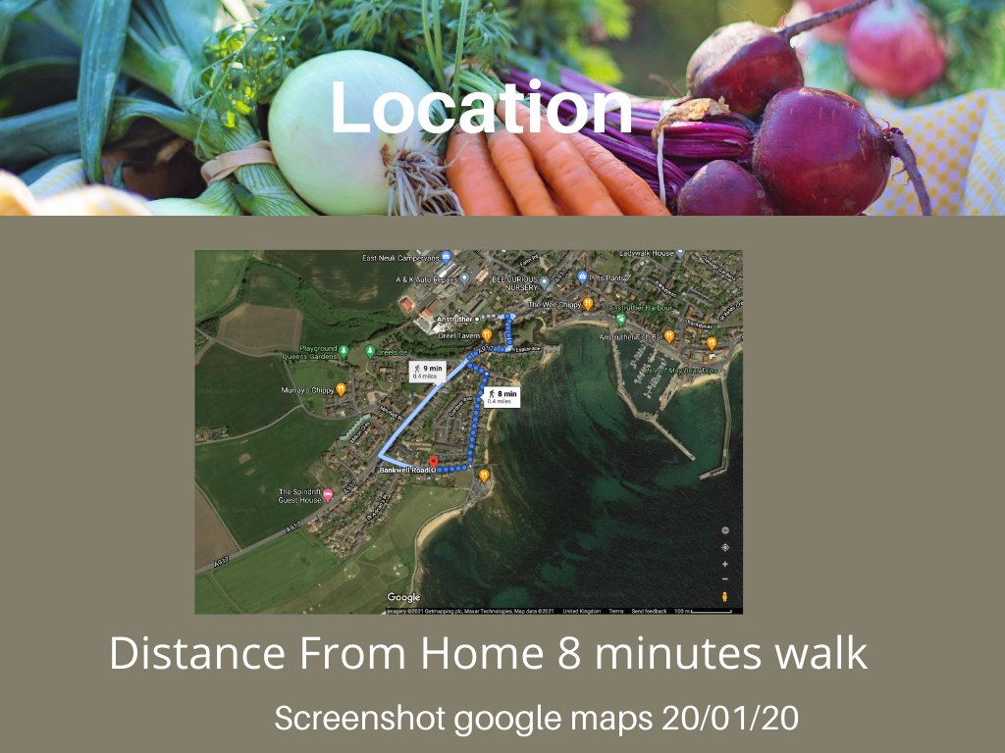

Collection of maps showing relative distance to town, location in Scotland home and hardiness zone. All from Google Maps except the Hardiness Zone which is from plantmaps.com

PASTE

Plants

There is a lot of wild fennel gone wild and comfrey nearby.

On my actual plot there are jerusalem artichokes that keep re-emerging and several recurring plants listed and categorised here:

DAFOR

Dominant/abundant/frequent/occasional/rare

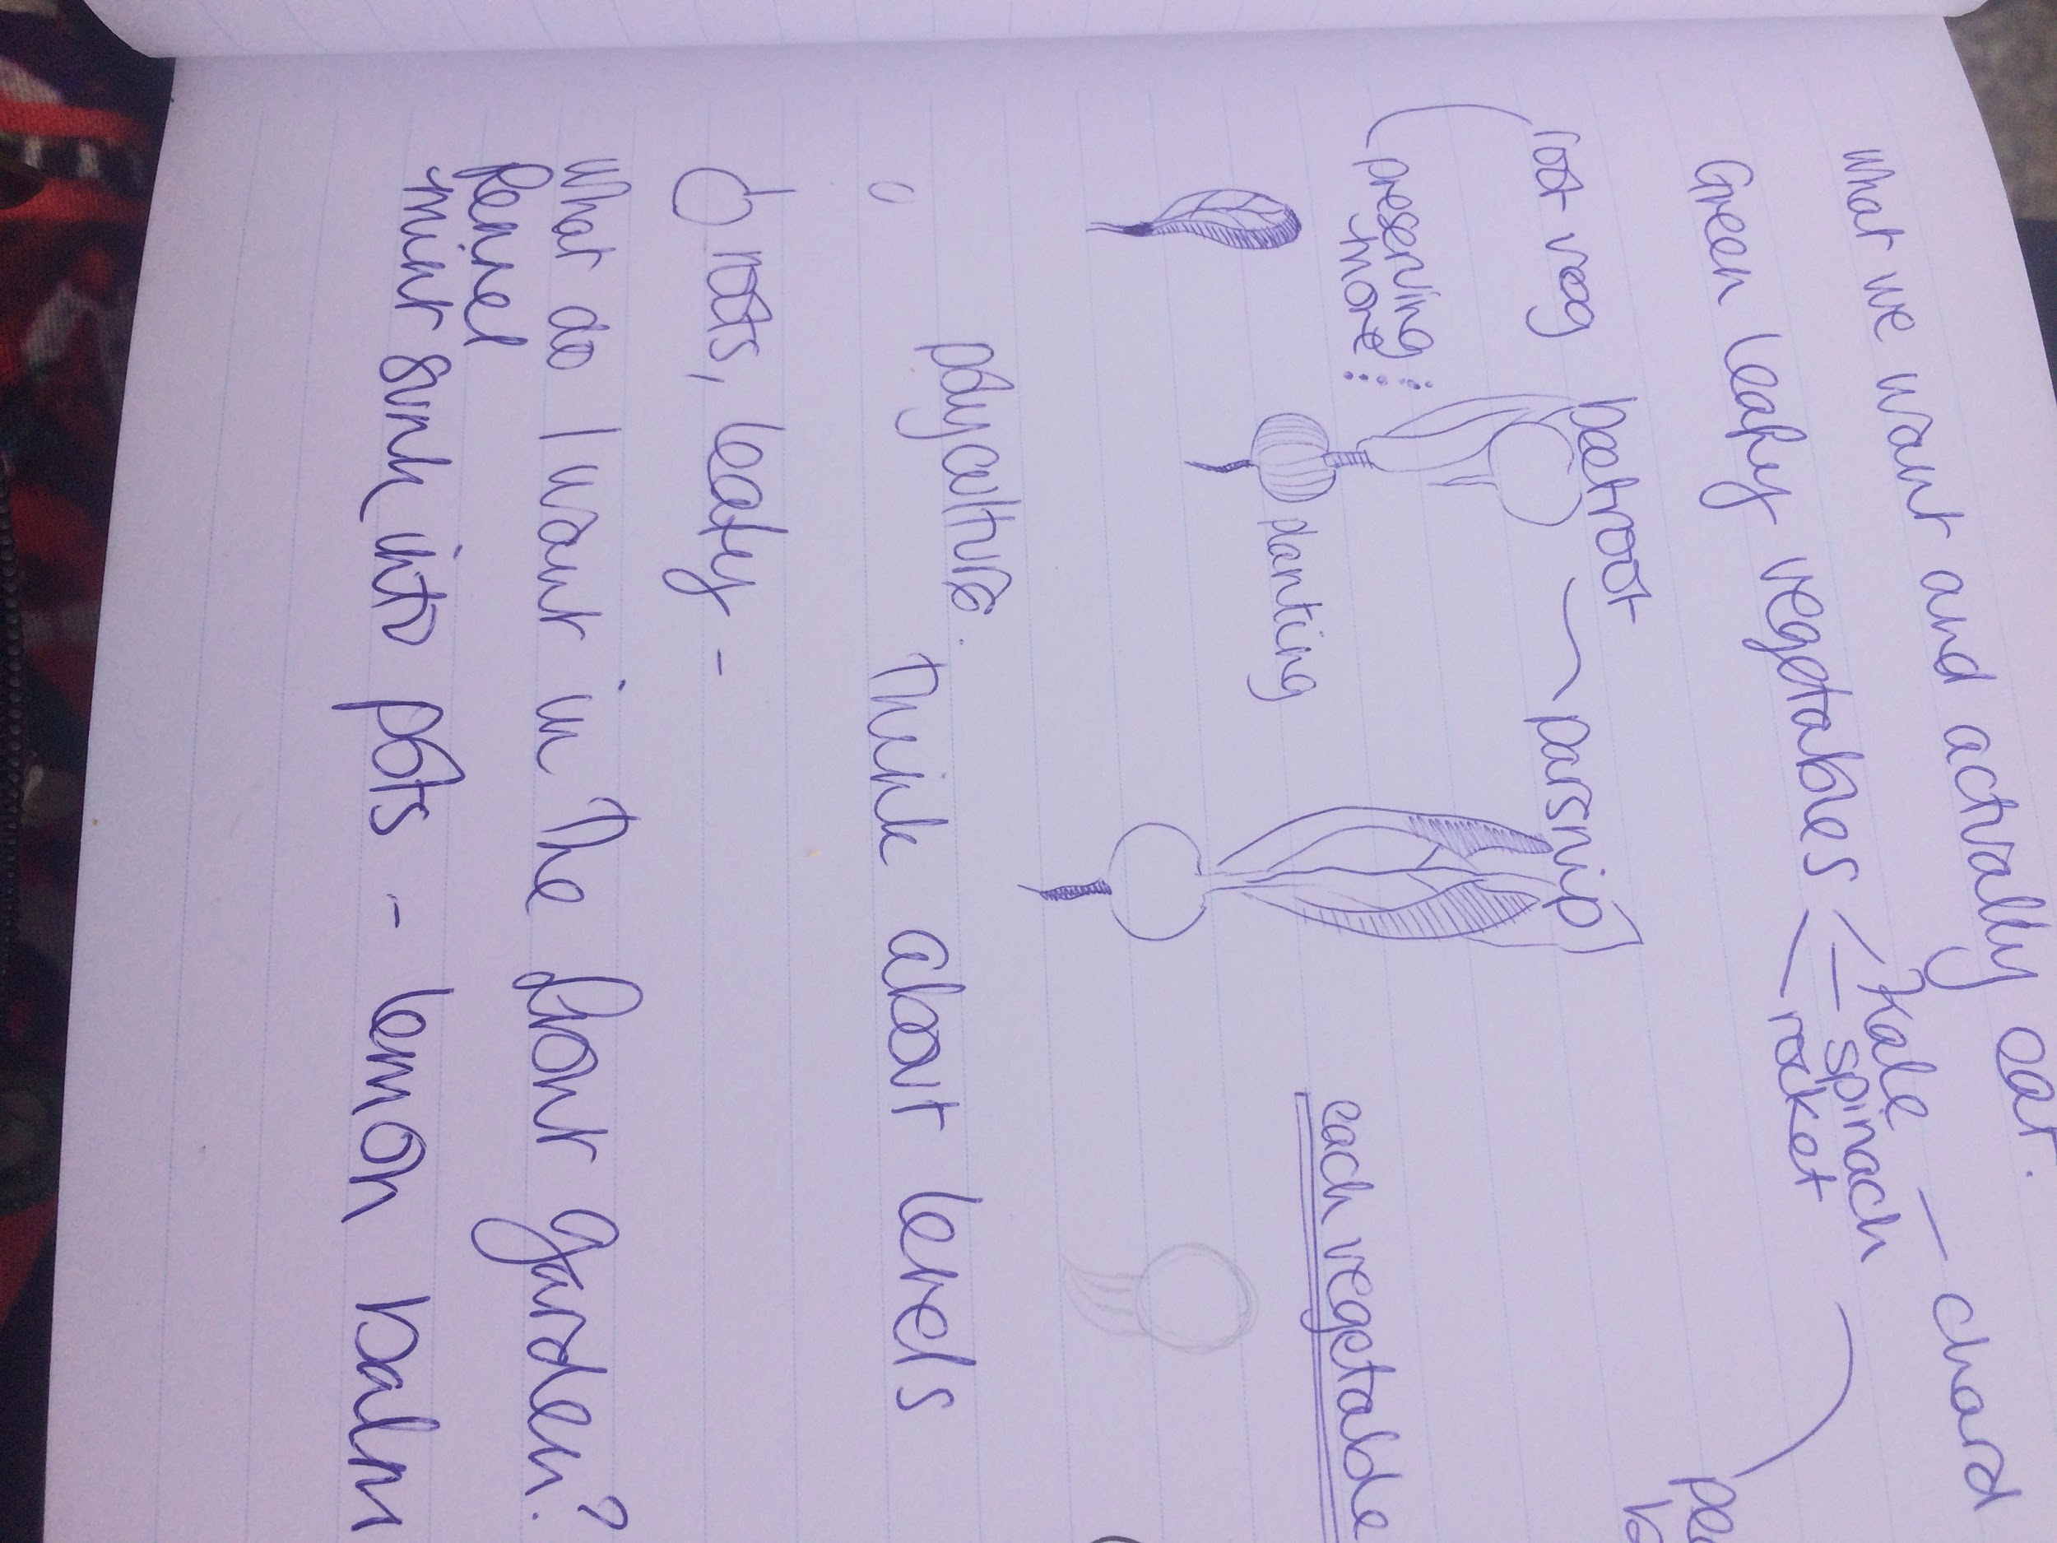
Dominant | Couch Grass  Jerusalem artichoke  Creeping Buttercup
Abundant | Mare's Tale  Dock  Rocket  Raspberry  Blackcurrant  Gooseberry  Rhubarb
Frequent: | Splurge  Fennel  Nettle  Speedwell  Groundsel
Occasional: | Shepherds purse  Prickly milk thistle
Rare:

Animals

- Some wild rabbits
- Many wild birds
- Molehills
- Mice and voles noticed on site
- Our dog when we take him along

Structures:

On our site there are only raised beds.

Nearby that we can use:

- There is a large summer house - shared.
- Three Shared Sheds with tools
- Large Compost Bins
- Wheelbarrow “station”
- Polytunnels x 2
- Taps on site ( only one can be used at a time as low pressure. ) In dry weather there is a shortage. Mentioned to the allotment committee about putting in communal water butts.

Tools

We have access to general garden tools that are onsite including wheelbarrows, spades, forks etc.

Events

There are community work days occasionally and also sometimes Barbeques.
It can become very busy with other people working in peak seasons.

Soil Test

Soil Test - Jar

This test showed that there is quite a large sand layer and has a small amount of clay and silt in comparison.

This explains why the soil tends to be on the dryer side. It definitely means that it could benefit from more compost and enrichers.

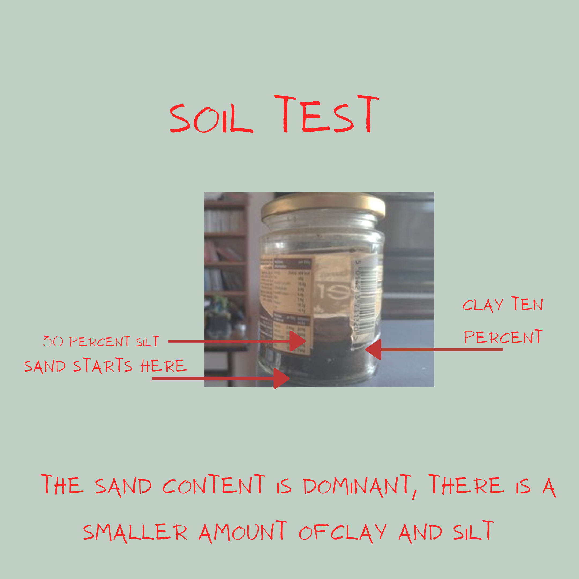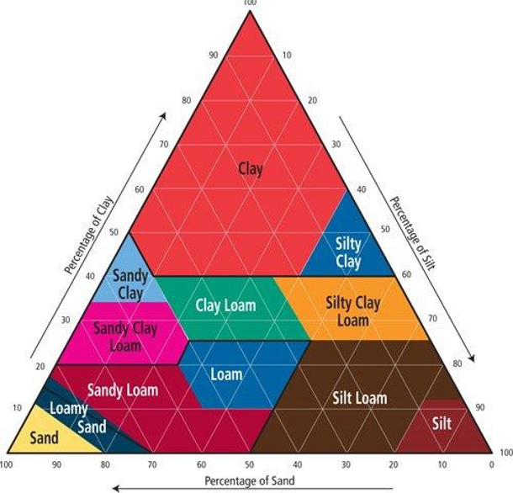

The soil is generally on the dry site and there are a lot of stones in the soil.
60% sand
30% silt
10% clay
This means the soil is a sandy loam.

PH Test

All the soil is tending strongly towards alkaline about 7 on the scale.

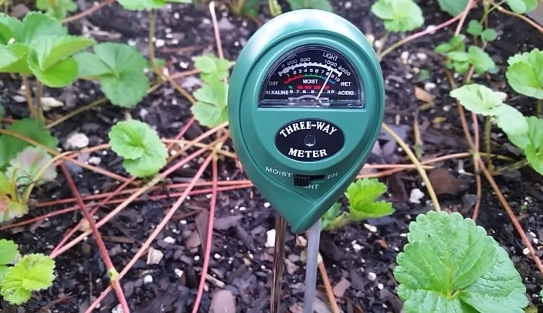

Treating Soil

Most people at the allotment have had to treat the soil in many ways.

Over the past years we have added a lot of partially rotted seaweed and compost to the soil as a mulch which has definitely had benefits overall. The soil has become darker and crumblier though it needs more.

Client interview

Client name: Priya Logan
Address: 15 Bankwell Road Anstruther
Property size: ¼ size allotment
Number of people on site (typical/average): one or two
Groups that use the site: Just our family of five - two adults do most of the work.
Physical challenges that need to be considered (blind, wheelchairs etc): n/a
Occupations & skills: Home based - amateur with several years practice
Lifestyle/ethos of group: We have time every week of at least a day at around 3 or 4 hours sometimes more and sometimes it's broken into a few days of an hour or so.
Eating habits: We eat a lot of vegetables and use fruit too.
Age ranges: 8-46 in the family ( the children sometimes help.)
Financial situation (vis-a-vis the design): Modest - We pay £25 for the allotment per year
On site resources: Water, Shelter, Tools, Compost
Site tenure (owned freehold, leasehold, rented): Rented allotment annual renewal.
Restrictions on land use (tenancy agreements, covenants etc). There is an expectation of taking reasonable care and keeping it fairly tidy as it is part of the Beautiful Fife Awards entries, it is an organic site
Potential catastrophes (vandalism, flooding etc): It is a secure site with a few people looking over it. Flooding is not really a risk as drainage is high. There has been some wind damage but it didn’t affect our site
Plans and drawings: A few home sketches, a map I’ve made myself and one through vegplotter.com, Google Maps.
Level/type of crop required 1/3rd of the vegetable supplies for at least four months of the year is a new goal.

Privacy (views, difficult neighbours, respecting other people’s privacy
where site is overlooking others) It is fairly private from the main roads
Priorities for the site: Place to go plus food production - increase and sustain yield and
Water general- Mains Tap on Site, have water butts that will
Soils - Tend towards sandy
Erosion
Aspect - North South Aspect

Client wants and needs

Increase food yield and diversity:

- Greens throughout the winter
- Clear planting plan so I know what I want to do, where. Needs to be ready by February 2020.
- More perennials
- Implementation plan - so I have definite tasks to do in my plot in each month
- Use the space efficiently
- Replenish the soil

Sustainable input and output of energy

- Work out a time schedule
- Input of energy - my physical time
- Output of energy - the food I get from the garden, make sure I’m harvesting at appropriate times.
- Find out more about and/or try out edible perennials e.g. welsh onions, perennial kale…

BOUNDARIES

The place has pretty clear boundaries in terms of physicality.
The larger allotment has boundaries.

Limiting factors

- Boundary of the site
- Time/other commitments
- Size of the site
- Money
- Weather
- Allotment rules (organic)
- Couch grass & Jerusalem artichokes from neighbour

RESOURCES
- Seaweed
- Seeds (saved and leftover)
- Fruit bushes from Jayson’s other job
- Rhubarb from another place
- Seedlings from neighbour
- Time - proximity to house, really value going there.
- Hot compost bin at home now with extra things going on
- Water - 2 taps
- 2 communal polytunnels nearby, we have a seedbed
- Shared shed
- Shared summer house
- Greenhouse at home

ANALYSIS
Goals:

- Increase food yield and diversity
- Create a planting plan
- Nourish soil
- Sustainable input and output of
energy
- Relaxation
- Biodiversity

Functions Systems and Elements
Functions | Systems | Elements
Food | Annual vegetables  Perennial veg  Top fruit  Soft fruit | Green Veg - Chard, Rocket, Spinach, Kale. Broadbeans  Jerusalem Artichoke  Raspberries  Raised beds
Soil building | Composting  Mulch  Green manures?  Liquid manure | Compost bin  Green & brown waste  Seaweed  Comfrey on neighbouring plot  Bucket with lid  Water  Watering can
Relaxation | Space  Nature Connection  Plants | Seat  River  Sheltered/hidden  Birds  Diversity of plants  Sun & sky
Biodiversity | Wildlife plants  Wild Spaces | Wild plants, flowers, herbs  Worms  Moles  Rabbits  Birds

Zones

I have had a think about how the allotment fits into the zones and identified that it covers zone three and five - there is the mindful/wild/nature connection element as outlined in the original goals as well as the vegetable production element.

Our Zones as a family as relates to food production

Zone | Location | Function ( in our lives)
One | Our House | Some seedlings and seeds stored, where we plan
Two | Garden front and back | Have greenhouse, green vegetables, herbs and hardening off
Three | Allotment | Place to go, learning and food production
Four | Sea, forest | Foraging, exploring
Five | Allotment and beyond Allotment ( and other places) | Peace and nature connection

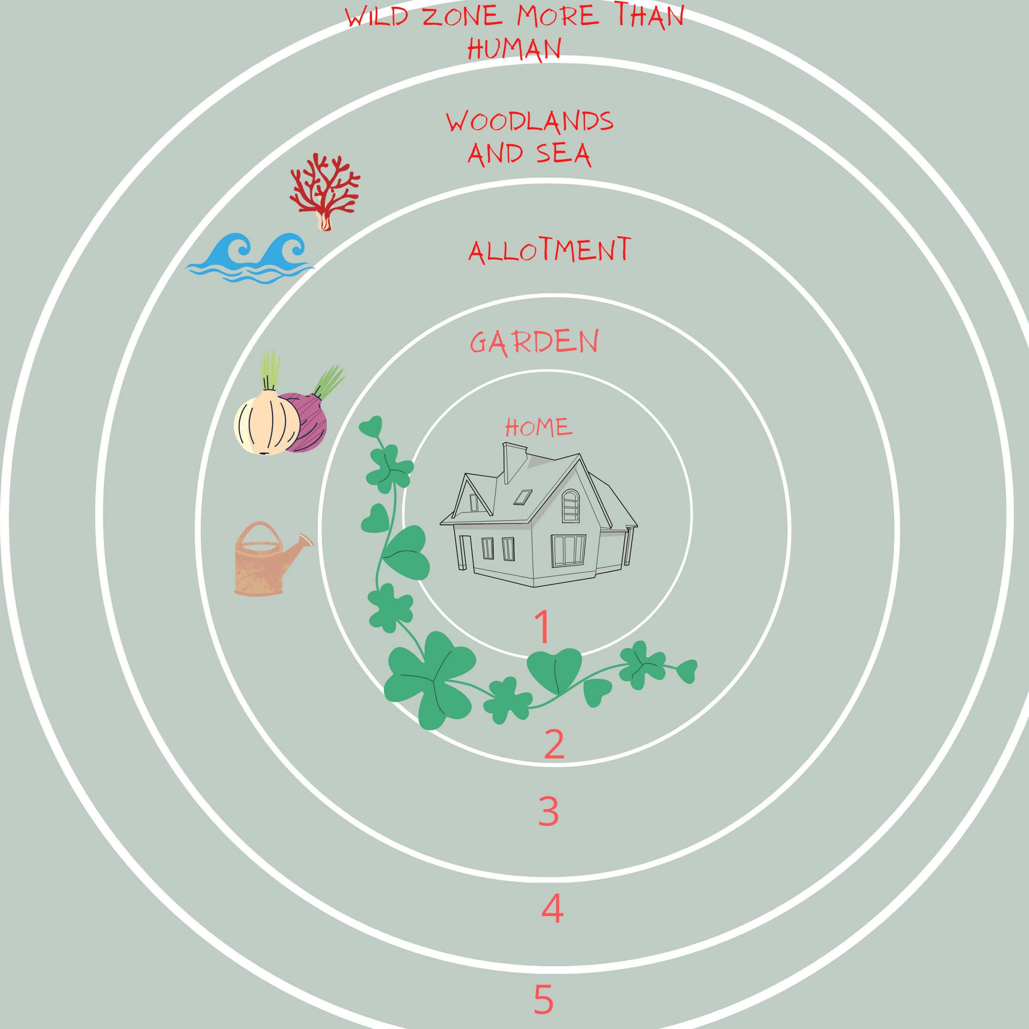

Wind Comes from the west, in general the plot is sheltered.
The sun reaches most of the plot during the day. In summer it has eight hours of uninterrupted sunlight with no shadow

PRINCIPLES
I have decided to Use Starhawk’s Common Sense Permaculture Principles to see how they will work. The pragmatic approach of these ones appealed to me as well as the excitement of choosing another set of principles.

If it ain’t broke, don’t fix it.

This plot came with clearly defined edges and strong shapes. In part, at the time when I got the allotment it held a lot of appeal for this reason as it allowed me to accept what was there, and work with the rest.

We have also noticed a lot of perennial fruits start to encroach on my site and Jayson has been given several fruit bushes.

Use on-site and local resources whenever possible.

Soil Enricher
We have predominantly addressed fertility in the soil issues with very local resources: namely Seaweed which comes from a nearby beach which we pass enroute.

Cardboard
our own and some from the recycling spot which is about two minutes away.

Compost
There is compost on site. We have a hot composter and more compost at home.

Water
on site can be scarce at certain times of the year and pressure can be low and we are looking into ways to solve this.

Resilience is true security.

Resilience within the design is represented in the layers of perennial and annual crops which means that the soil will be protected and the overall design will be sturdy and resilient.

The design also plans for crops during the year with varying needs for input.
I am looking at more stacking and layering and this will really help with succession and fruit bushes becoming established.

Get some, obtain a yield.
This is essential. A major part of the plan is for it to be productive. We need to gain a substantial yield of fruit and vegetables we will use that equals the time and energy in.

Having a clear and straightforward planting plan and a low maintenance plot means this will make it easier to get as much as we give and start creating a cycle of abundance which means more for less.

The intangible yields when things are going well are joy, satisfaction, retreat and learning.

I also have the yield of connecting to the community of the allotment and Anstruther.

Energy is abundant but not unlimited

For me this also relates to energy exchange with the allotment. At least one of the years since we owned it, if not two, the allotment took a fair amount of energy.

DESIGN

I have looked at several things to make the next step.

What we want to grow.
I want to grow lots of leafy greens.
We want and will eat :

- Salads
- Green Leafy Veg
- Tomatoes and Cucumbers
- Root Vegetables: Parsnip, Beetroot Carrot, KohlRabi
- Fruit Bushes
- Herbs
- Flowers
- Brassicas
- Rocket and Sorrel

What is already there.

There are raspberries growing on the south entrance.
There are four beds.
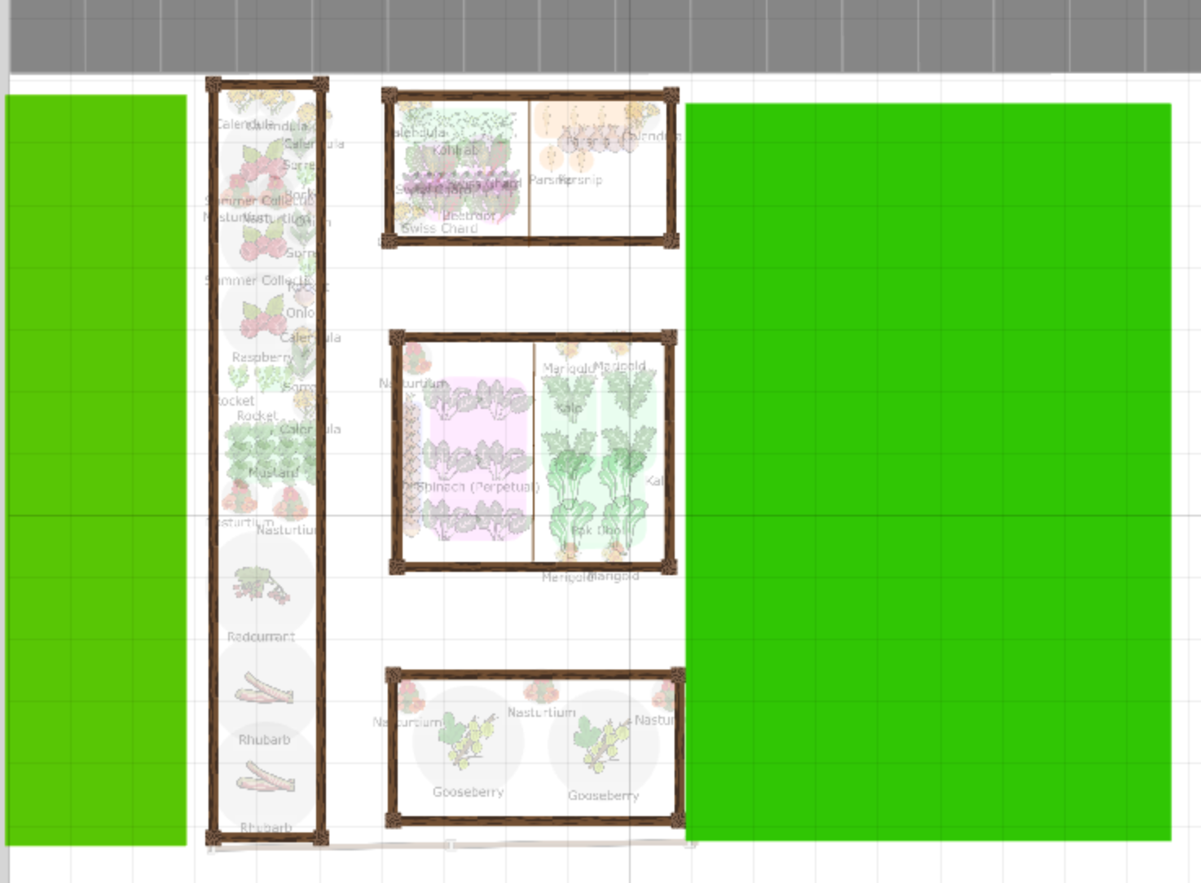
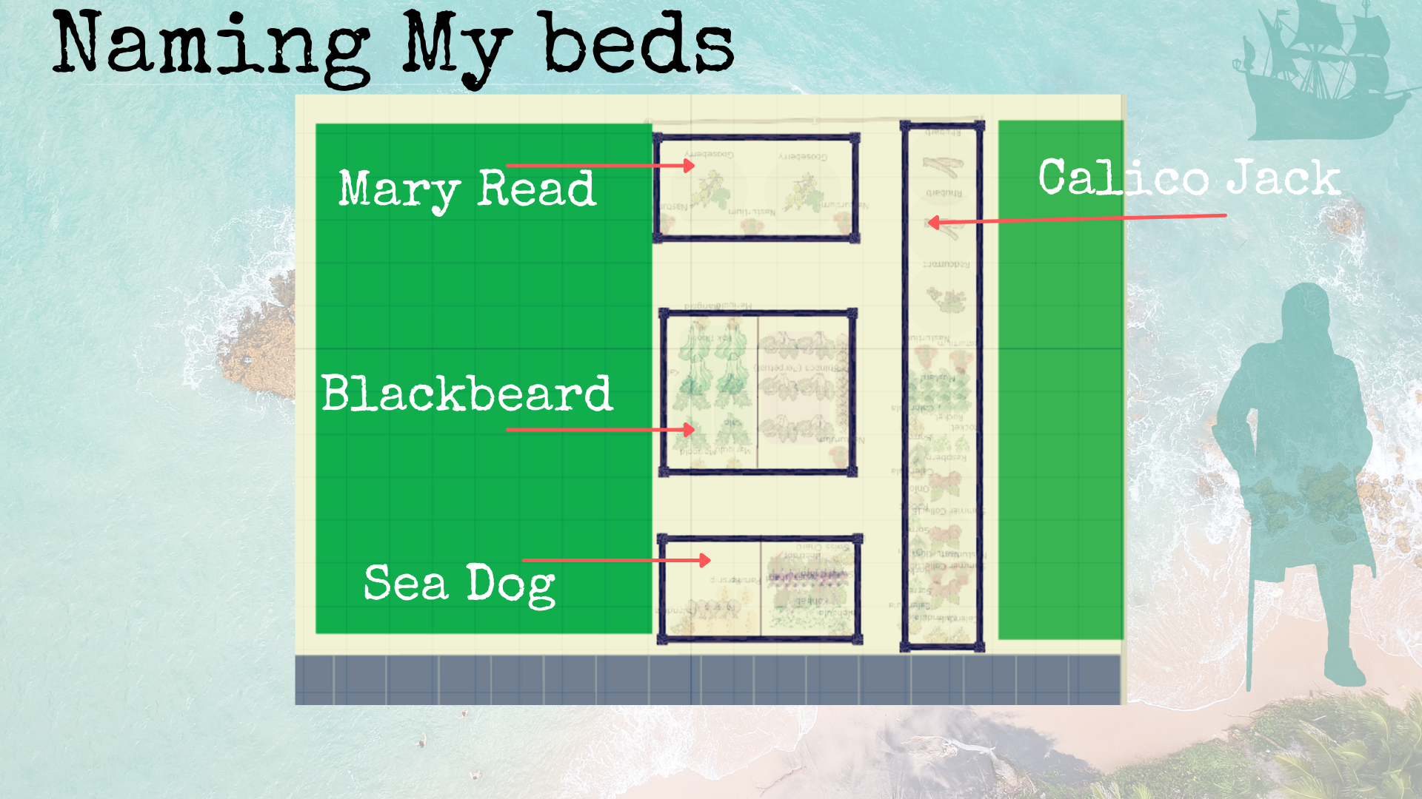

The layout of the allotment is here. Refer to map for full measurements.

I have decided to name my beds after pirates to go with the maritime theme and also to make it a bit clearer in my head and not so boring as numbering them. We will see how it goes.

What’s in each bed as it stands before planting up.

There are various plants on site in January.

We have inherited several fruit bushes from a long term job of Jaysons

Sea Dog - Broad Beans, Chard ( quite badly eaten )
Blackbeard - Pak Choi, Kale
Mary Read - Gooseberries
Calico Jack- Raspberries, South End, Blackcurrants in the middle and Rhubarb at the end.

Looking at what we want to grow, I want to think through each one with relation to companion planting and also with regard to the zones being our two allotments and home growing spaces.

OVERVIEW OF PLANTS AND NEEDS WITH REGARD TO ZONES

Crop Type | Needs | Best Location(s)
Kale | Less intense care, Rotation, Netting | Rotating. Beds either allotment. Zone 3
Salads | Frequent care and picking | Home, Zone 2 Garden
Roots ( Beets, Carrot, Parsnip) | Stability, water, Good soil ( drainage for carrots) | Could be Home - Garden Zone 2 or Allotment
Brassicas | Rotation, Netting Various | Preferably allotment
Tomatoes/ Cucumbers | Indoors, Polytunnel | Polytunnel shared or Glasshouses at home
Flowers ( companion friendly) | Intercropping everywhere. | Good everywhere
Fruit Bushes | Need to stay where they are will keep growing.  Need minimal care once established | Allotment
Rocket and Sorrel | Good intercropping and ground cover | Allotment

Resources for decision making, mapping and planning

I looked at several different online resources including

http://gardenorganic.org.uk for basic growing advice

https://www.gardenfocused.co.uk good for seasonal, climate-region specific advice

https://pfaf.org/user/Default.aspx good for information on companion planting

Vegplotter.com a mapping and planning tool

Growveg.com a gardening website

Making the plan

Looking at our many zones and spaces and home and the resources we have and comparing it to our original goals from the first step.

Increase food yield and diversity
Ideas: intercropping and layering, good use of space

Create a planting plan
Decide on individual plants . Use a map and planner

Nourish soil
Using what we already have we are looking at a combination of mulching, manures and compost.

Sustainable input and output of energy
Having plants that only need two or three visits a week.
Looking at high yield and low input plants.

Relaxation
To remember the nourishment, to have spaces.

Biodiversity
Having flowers and herbs intercropped. Being aware of keeping and appreciating wild space.

We looked at the plants we want to grow and looked at the spaces we have.

Growing Spaces Available

Home
We have indoor spaces for seedlings and we also have a glasshouse and a small polytunnel.
Good for plants we need to harvest on a very regular basis for instance Herbs, flowers, courgettes and salad greens.

My Allotment
I have several fruit bushes in the beds though I am making two beds named - Mary Read and Blackbeard on my map that will effectively be divided into four growing spaces by halving each of them. This will enable crop rotation of annual veg and allow me to do layered intercropping with the fruit bushes in the rest of the space.

Jaysons Allotment
Jayson has twice the size allotment and his allotment will be much more suited to potatoes and larger crops such as pumpkins he will also grow root vegetables and brassicas

Glasshouses at home
We have been given two glasshouses and have realised we can fit both of them in at home. This will enable us to start off seeds and also grow things that need protection year round.

Crops | Needs | Where
Herbs | Potting, boundaries, ready to pick | At home
Leafy Greens | Sun, water, regular harvesting twice a week min | Allotment and home
Tomatoes | Warmth, protection | In Glasshouses
Root Veg | Good Soil - minimum disturbance | Mine and Jaysons allotment
Fruit Bushes | Stability | My allotment, some Jaysons
Brassicas | Rotation and stability | Jaysons and my allotments
Flowers | Varies | Everywhere
Salads | Frequent Care | Home

Next steps of Design

So I searched out some programmes that help with planning - I initially tried out vegplotter.com.

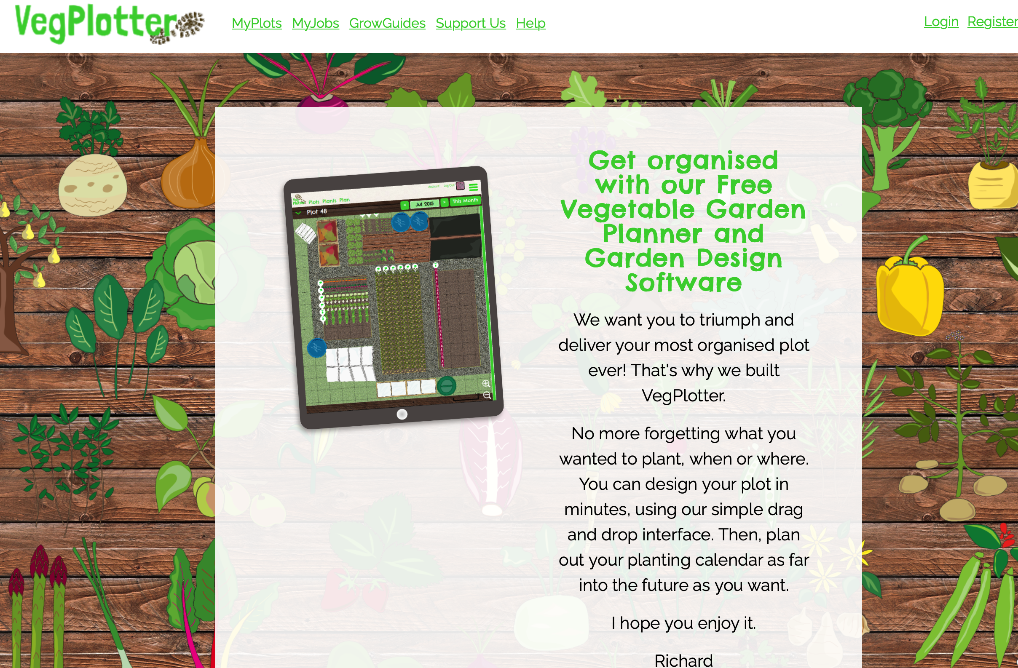

There was a limitation with the veg that was on Veg Plotter and the features although it was entirely free.

I did a bit of research and came across GrowVeg which looked like it had a lot more available crops and was easier to work with. It also seemed a bit less “clunky”.

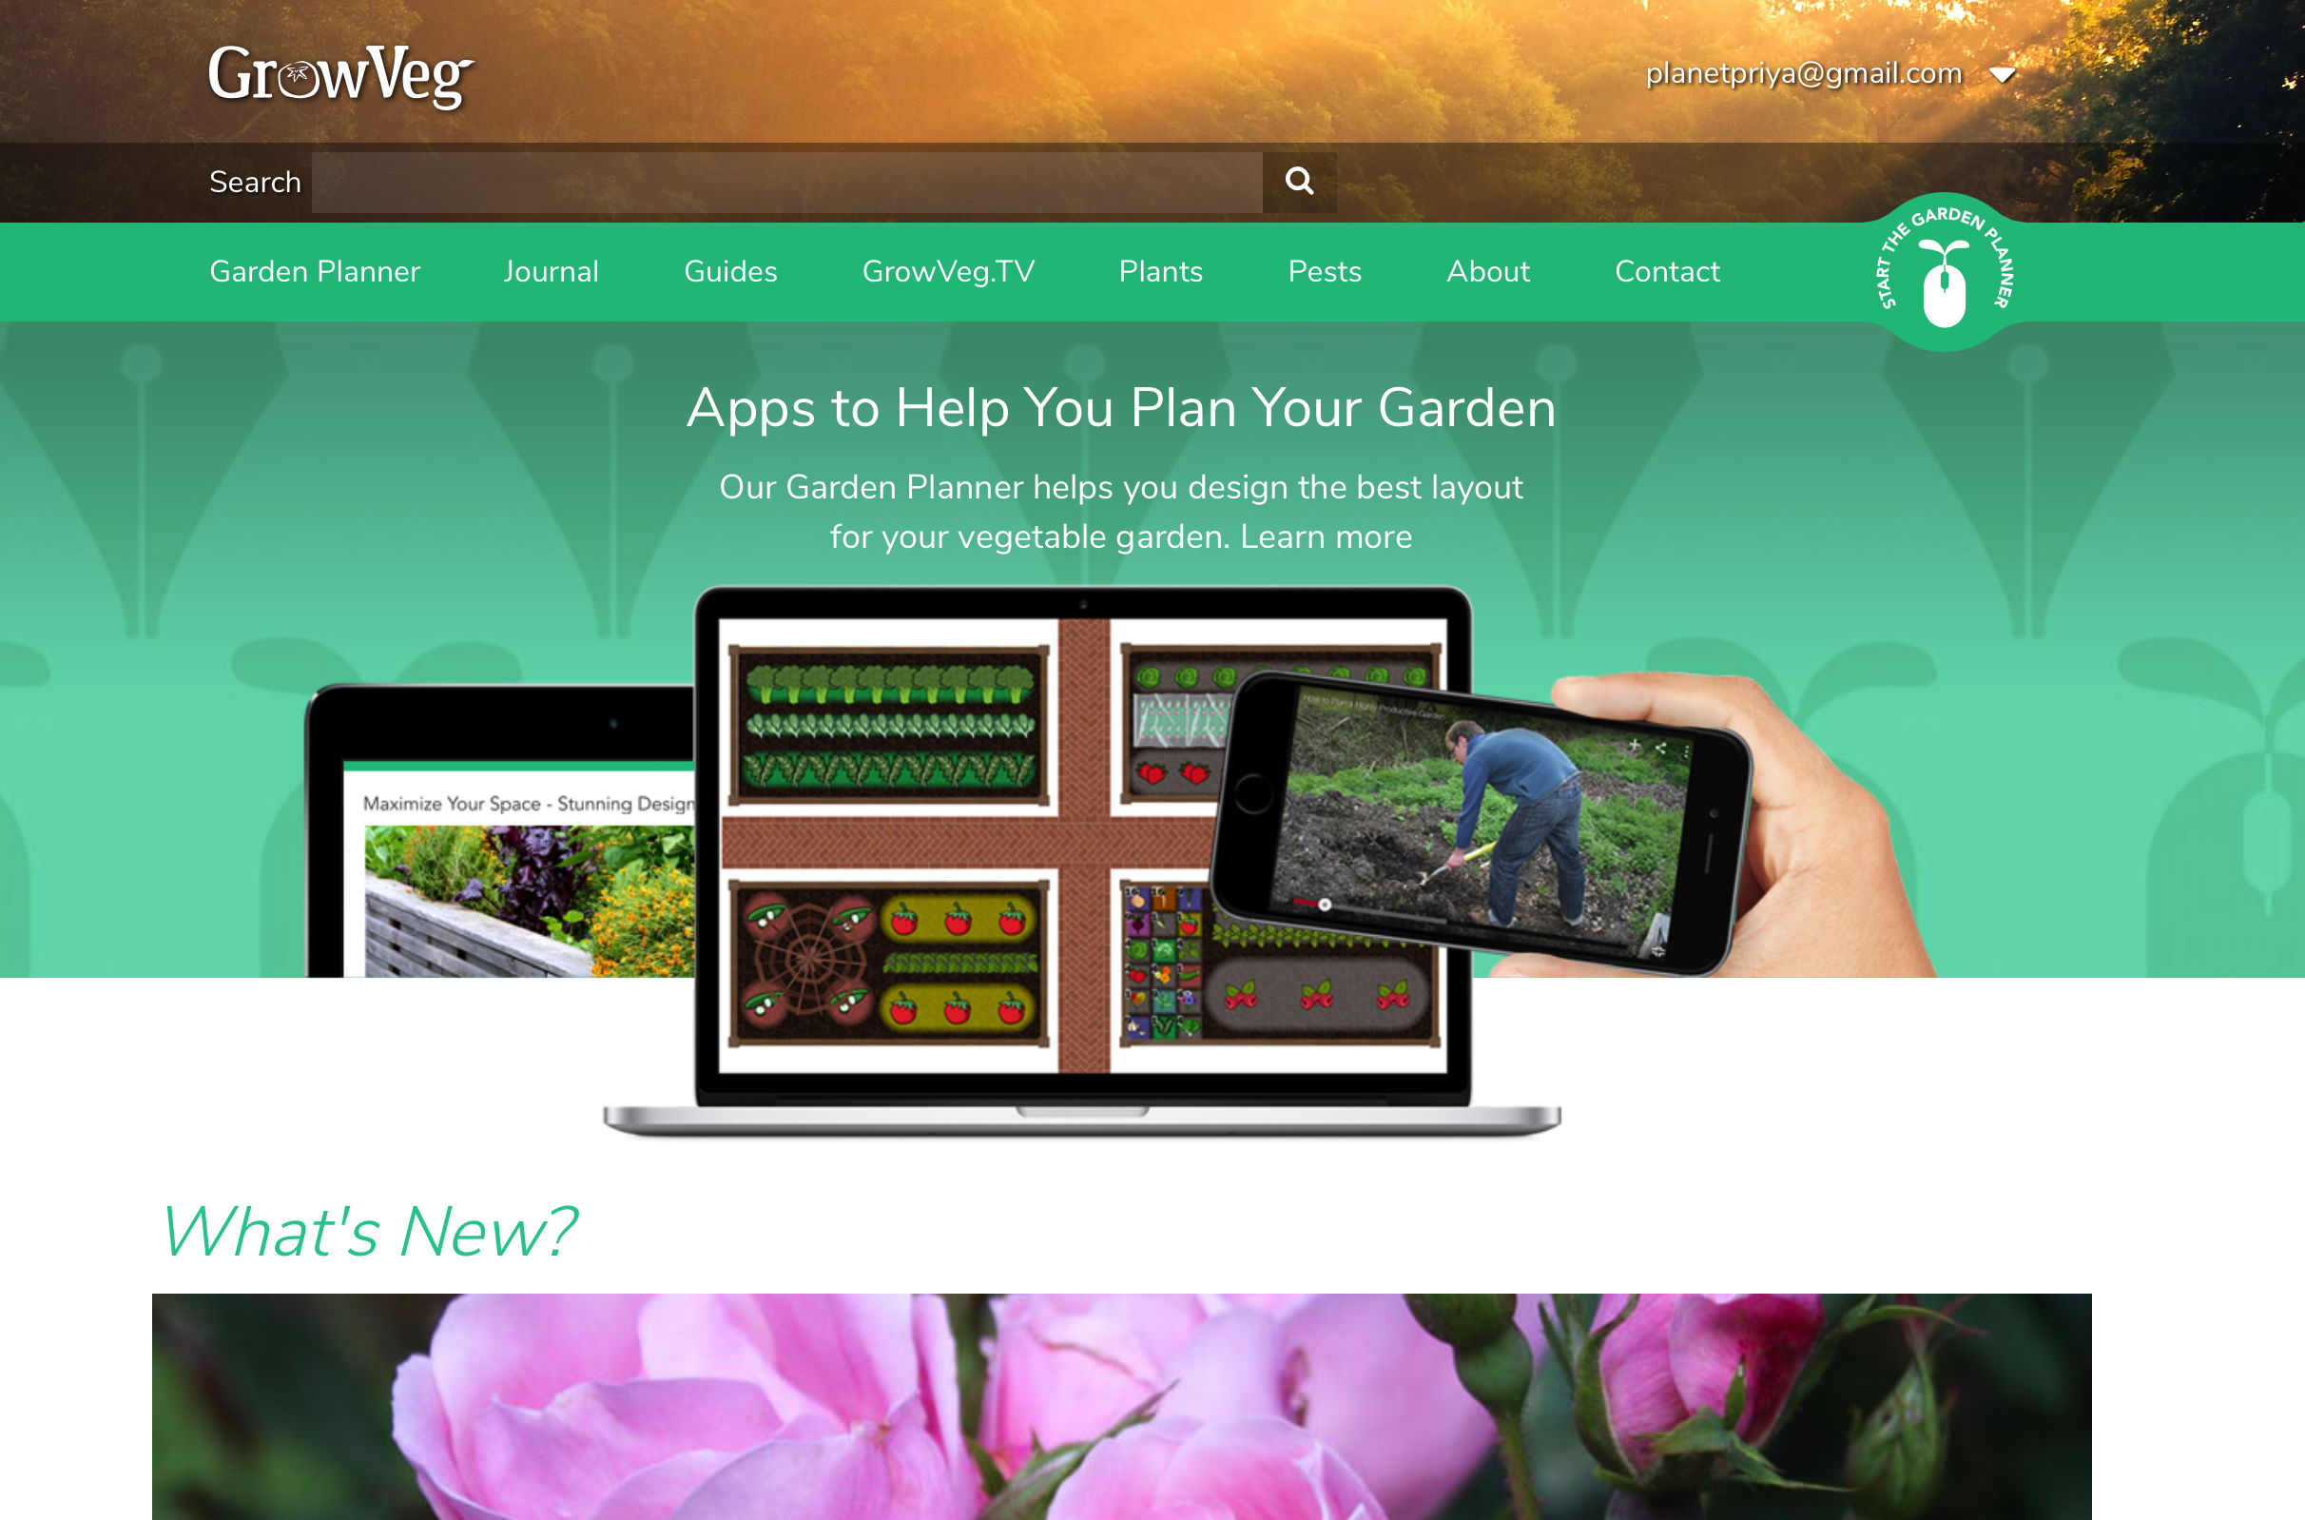 Growveg.com

Working out the Final Design

I input all my final crops into the Grow Veg and decided to divide the two beds “Seadog” and “Blackbeard” into four defined spaces to enable crop rotation.

From this I worked out a planting plan that enables a smooth four year rotation in two beds.

Defining the spaces.

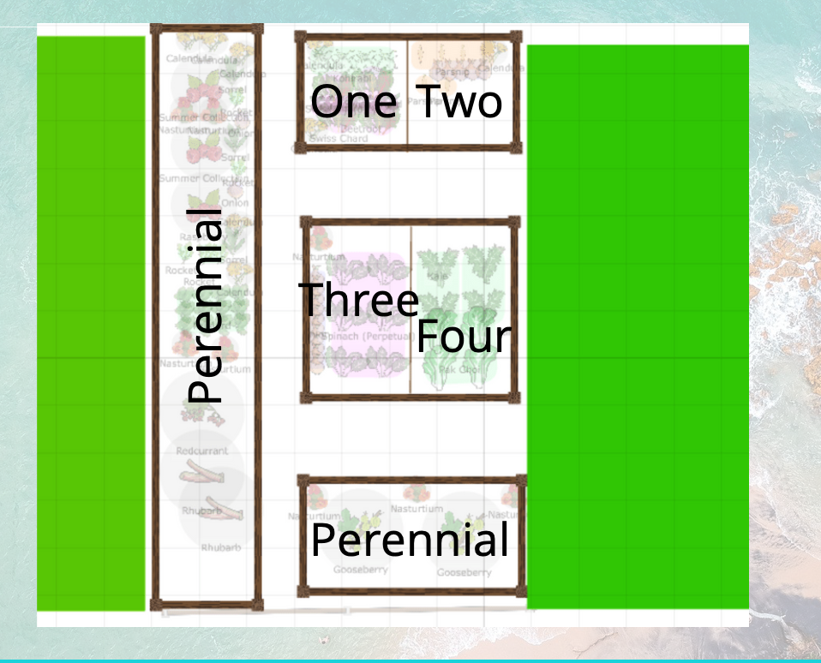

I then decided on the exact crops and placed them in where they should go.

The final plan for the first year.

It rotates sequentially - in the perennial beds we are intercropping base level plants.

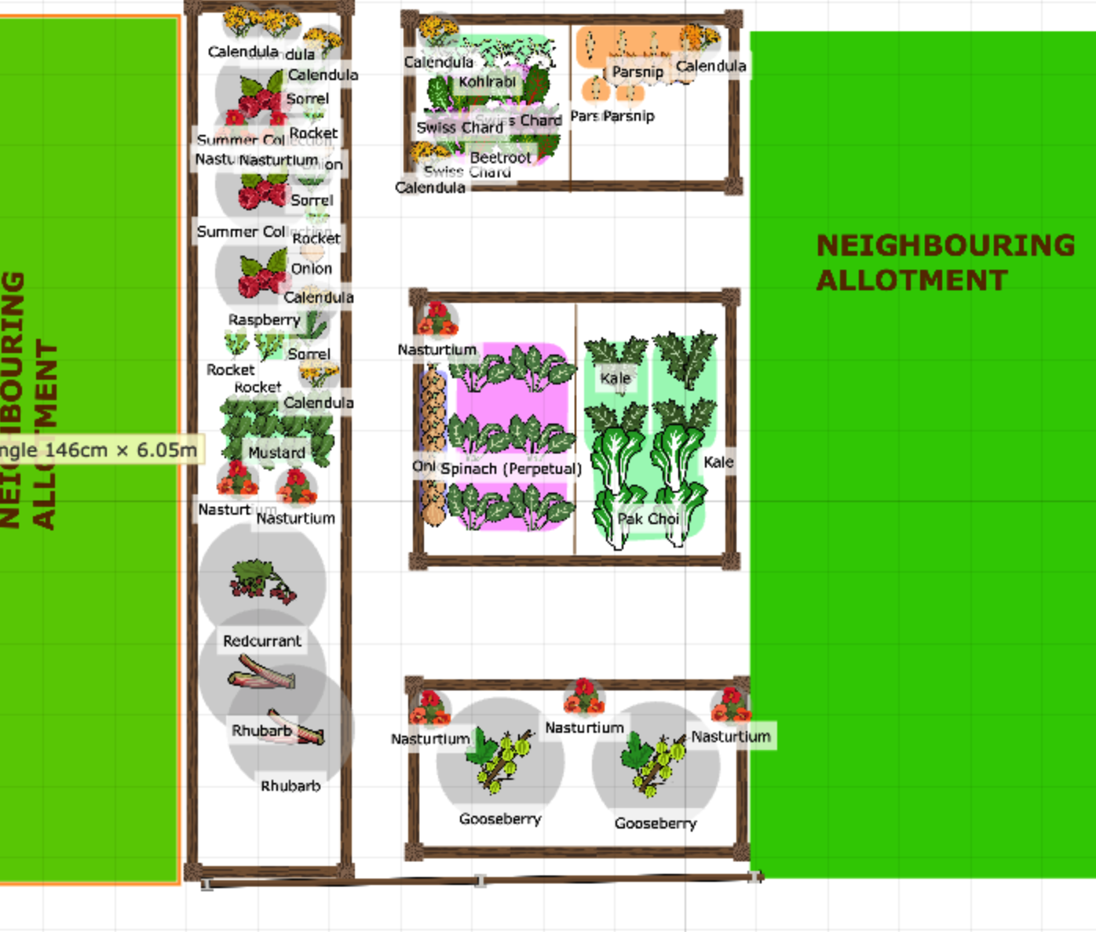

Four Year Rotation Plan

Year | Bed One | Bed Two | Bed Three | Bed Four
2021 | Kohl Rabi; Swiss Chard, Beetroot | Parsnips | Kale  Pak Choi | Perpetual Spinach
2022 | Parsnips | Kale, Pak Choi | Perpetual Spinach | Kohl Rabi, Swiss Chard
2023 | Kale Pak Choi | Perpetual Spinach | Kohl Rabi, Swiss Chard | Parsnips
2024 | Perpetual Spinach | Kohl Rabi,  Swiss Chard | Parsnips | Kale, Pak Choi

IMPLEMENT

What seeds we already have listed below.
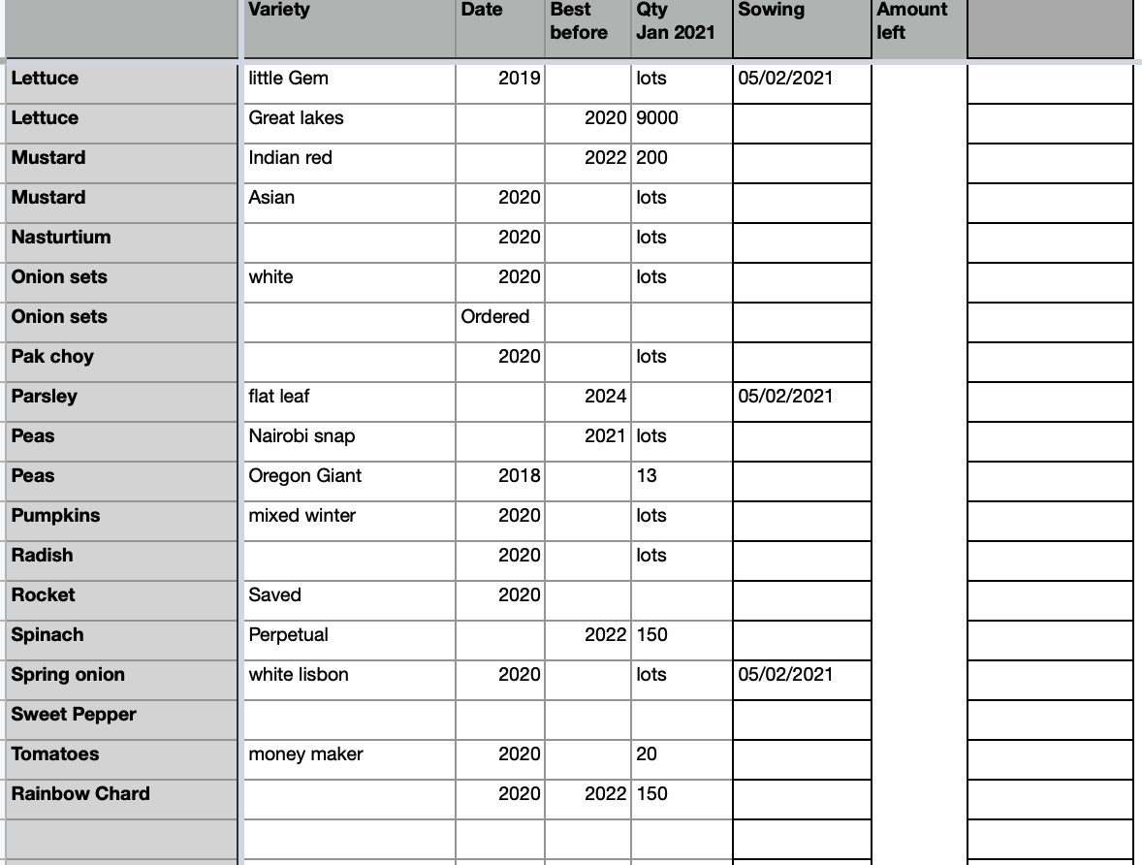

Growveg.com also gives a clear planting plan.

Planting Plan

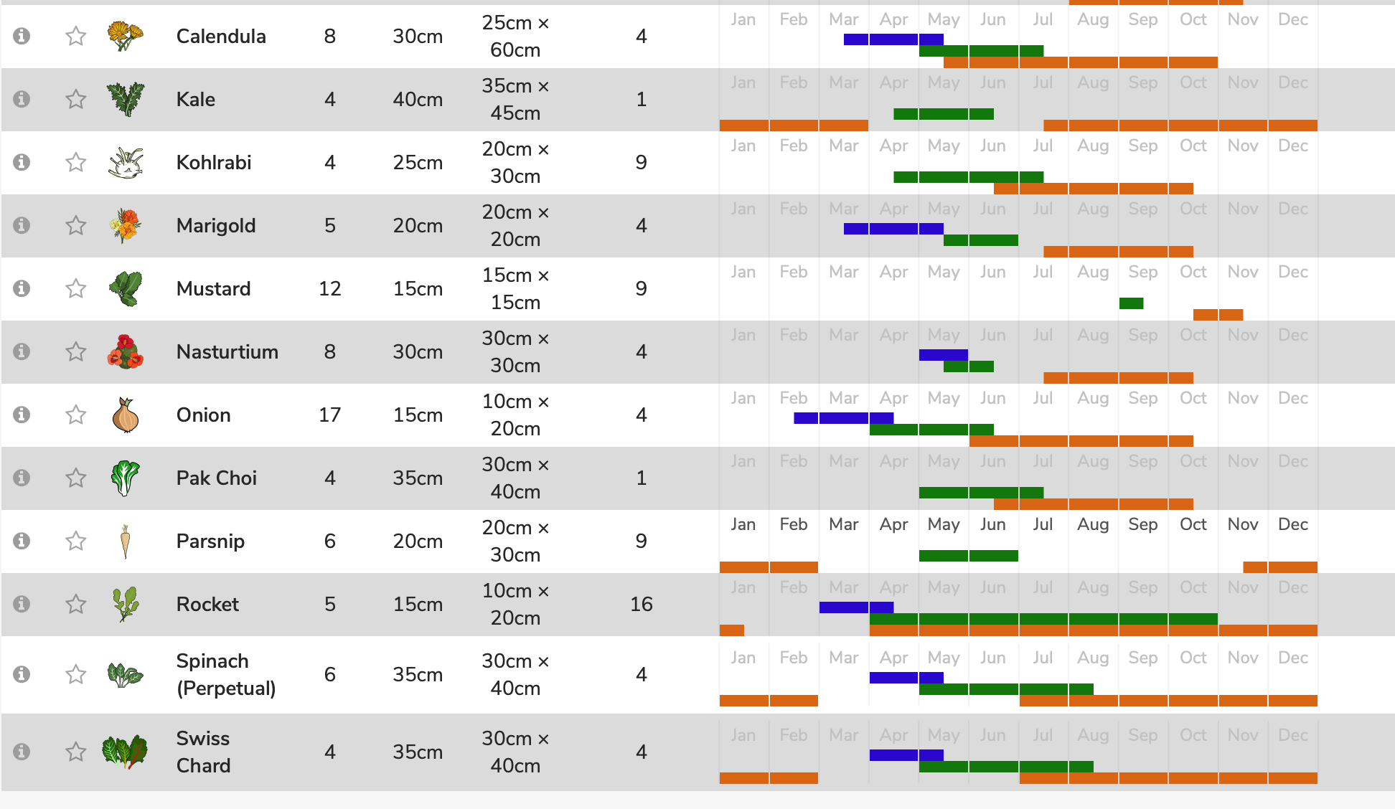


For spaces to start things off. We have a lot at home.

We have also decided to prepare the beds.

Implementation Plan

- Get hot compost at home sorted for enriching soil.
- Make sure we visit every two - three days making it a part of our daily practice.
- Order seeds we need. KohlRabi and Parsnip
- Pot everything up at home and rotate
- Keep planting plan up somewhere handy
- Make a Lasagna bed with seaweed in an empty bed cover over what is there and it will decompose. - collect seaweed and cardboard.
- Hot compost needs a bit of sorting after it got wet

MAINTAIN

The allotment will be maintained on a thrice weekly basis. In the spring summer the input will be larger timewise but it will be able to be done and will be welcome.

A big part of maintaining the allotment will be following the planting plan and tweaking as I go.

I will also be documenting the process.

EVALUATE

Looking at the original Goals I will go through each with regard to my final design.

Increase food yield and diversity
I have planned a greater variety of plants and also stacking through time for my particular allotment space and taken into account the other spaces.

Create a planting plan

I have used the GrowVeg website for this though through time it won’t be necessary it was good to get a plan up clear and defined.

Nourish soil

Using a mixture of green manures, seaweed, compost and mulching I feel like this target has been reached and is very much at the top of our priority. No dig is a method we have used for some time.

Sustainable input and output of energy
Having clearly defined tasks will mean that much of the thinking has been taken out of the process.

Working with zones has meant that the plan allows for slightly less intensive visiting at the allotment with plants that need a lot being nearer to the house.

Having a good spread of perennial bushes in the area will also mean less work ( throughout the year ) and more harvest.

Relaxation
The allotments are going to be a relaxing place with a clear plan. Having help from Jayson and maybe even the children sometimes will help that too.

Keeping the pace steady will help relaxation.

Doing some writing there and documenting will also help.

Perennial planting helps to bring down the labour quotient a bit too increasing relaxation and bringing a yummy yield.

Biodiversity

I have included flowers - notably calendula and nasturtium to increase biodiversity for pollinators and flowers.

Using a no dig method keeps life in the soil really important all round.

Final Word

By all these markers I feel like the explorations and plan I have come up with has successfully met my original criteria and therefore it feels like it will work for me going forward. Now to get planting.

TWEAK

I have learned a lot by going through this layered design for quite a while until deciding on a way forward.

If I were to do it again I would make my zones and what I wanted to grow the very first things that I focused on. I would also perhaps make this a lot more visual. I spent a lot of time working out what software to plan the garden on. Next time I don’t know if it would be so important.

Resources

Starhawk Principles https://heartwideearth.wordpress.com/2012/09/10/starhawks-common-sense-permaculture-principles/

No Dig Home and Garden - Charles Dowding
Alys Fowler Books
Plants for a future website
Martin Crawford - Forest Gardening
GrowVeg website
Social Landscapes Courses

THE THREE ETHICS

Earth Care

I have aimed to make the allotment mindful towards the overall health of the earth and look at factors like soil health and companion planting. We are not using any chemicals either and mainly using organic seeds.

People Care

The allotment feeds us as a family with nourishing delicious food. This is integral to our health. It is also very nourishing to me personally to have this beautiful productive spot to go to and we feel connected to the people there as there is a thriving community of co allotmenteers.

Fair Share

Allotments are all about access to land and fairness, the land is affordable and there are plots of all sizes. We are always looking to distribute the excess of our produce within the allotments or also to the community fridge. We also have some space for wildlife.

REFLECTION
It was so helpful to run through this detailed plan and I have learned a lot about a variety of tools in permaculture and how/when it is appropriate to use them.

In one way it was such a small plot that it feels like it is extensive in comparison to just jumping in and doing a straightforward planting plan but it hasn’t been getting the full use in the past few years so thinking about zoning and areas has actually made it much more simple for the years to come.

This is obviously the goal for permaculture design - not making it more complex but because this particular allotment design had been started and not finished for a couple of years in a row it really deserved some specific thought put into zones. This is also true because we have a variety of different growing spaces and it was important to work out what plants to grow where to utilise what we had more efficiently and include time distance and effort into our considerations.

Having a four year planting plan psychologically takes a lot of weight off of my mind as in this space every year we were starting from scratch.

Having a clear space for perennials has also clarified a lot and I feel really excited about the bulk harvest we will be cropping later this year.

25th February 2021

GALLERY
