`Priya’s Diploma

Learning Pathway

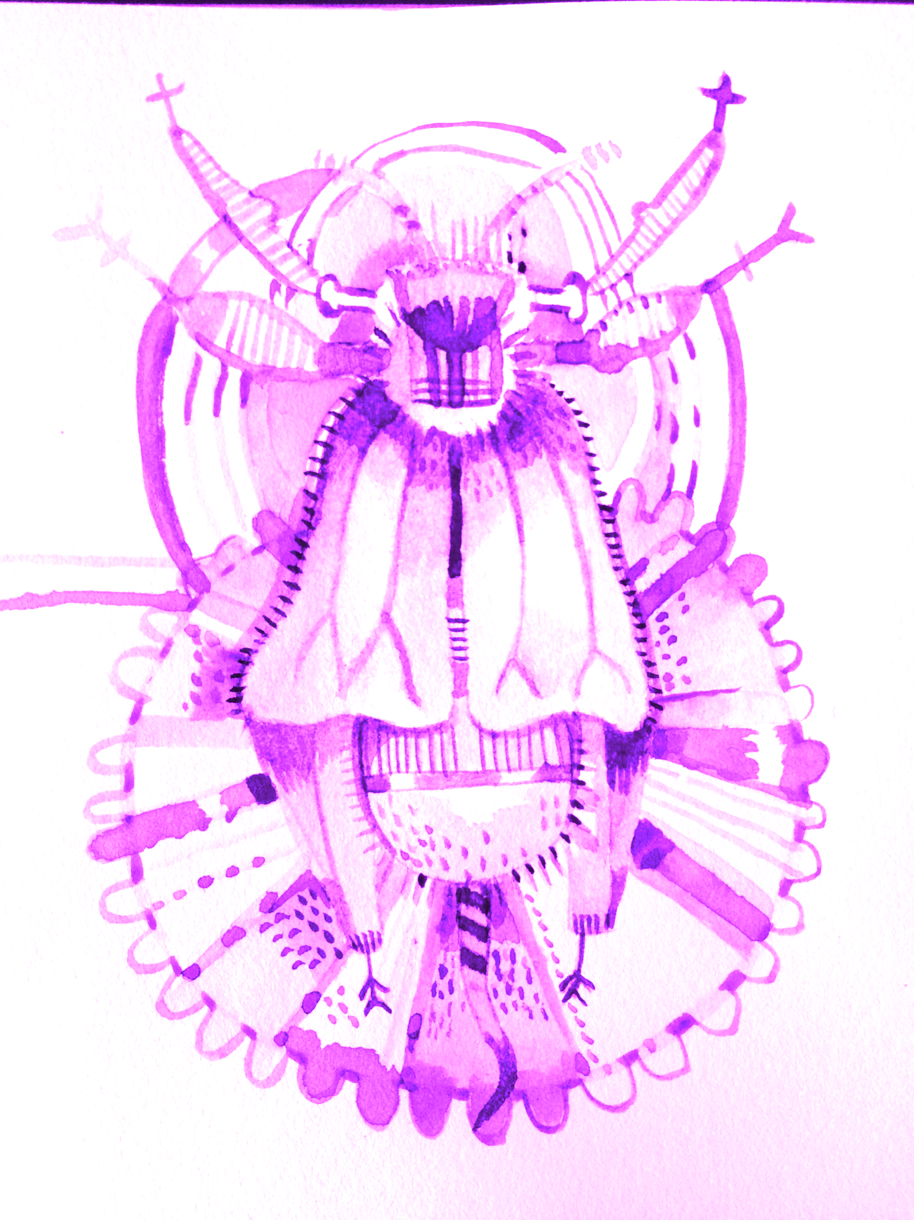

Design Method: 2
Date: 3
SURVEY 3
Where I have been so far, the backstory with Diploma and learning. 4
2010 4
2011 4
2012 4
2013 5
2014 5
2015 5
2016 5
2017 5
2018 5
2019 6
2020 6
Reflecting on why I wanted to undertake a permaculture diploma in the first place 7
Time frame: 7
Design Framework Choice 8
BRIEF: Goals and Aims 8
Goals: 8
Permaculture Ethics 9
How they are upheld throughout the diploma. 9
Design Web 9
The crux of this design: 14
Diploma criteria 14
INPUT AND OUTPUT ANALYSIS 20
DESIGN 22
Timeline: 23
EVALUATION 23
REFLECTION 24

Design Method:

Loobys Design Web

See: People in Permaculture

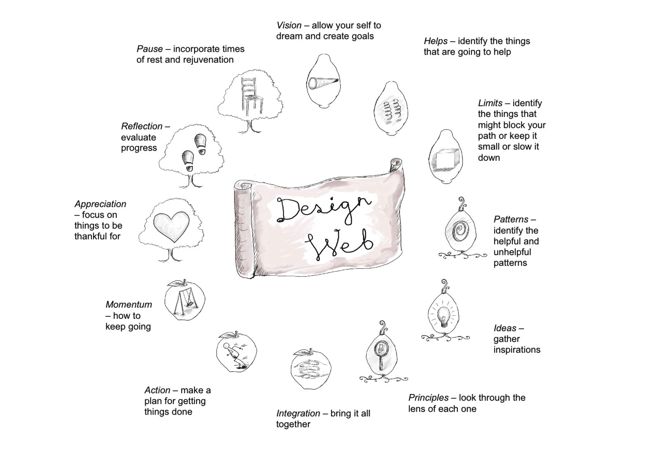

Date:

Beginning of 2021 taking into account the last few years.

SURVEY

Client - Priya Logan

Background

Having reached the culmination of getting past the halfway point of my portfolio I wanted to take stock of where I have been throughout my permaculture and life journey and make a vision/ plan for what I want the Diploma to symbolise and function as.

Permaculture is such a large umbrella term and in lots of ways I feel like I have just started learning about many aspects of it. It is truly a life time journey to learn processes and there have been many personal situations that have layered themselves into this learning pathway.

This design I will

- Summarise and take stock
- Look at the stages of the diploma already taken
- Evaluate the designs and learning made
- Make sure I meet all the criteria for diploma
- Vision the completion of my diploma
- Make some plans for the road onwards

Where I have been so far, the backstory with Diploma and learning.

2010
- Moved back to the UK from New Zealand with two children. ( aged 5 and 2 )
- Had been working in environmental projects and before that childcare plus being a stay at home mother.
- Before that administration and accounts
- Always had an interest in gardening and nature connection
- Arts are also an interest.

2011
- Trained and worked in Social Care.
- Travelled around the country away from the family.
- Jayson got a visa to live in the UK

2012
- Pregnant with Nadia
- Looking at home, educating then started.
- Nadia born September 2012.

2013
- Permaculture Design Course ( started with Nadia at three months)
- Moved into Glasgow
- Did my first Permaculture Design

2014
- Started studying to be a Birth Doula
- Registered to do a Permaculture Diploma.
- Got allotment in Lambhill, just out of Glasgow
- Joined Childrens Wood committee
- Facilitated a writing group at Woodlands Garden - also helped with their food hub.
- Did three permaculture designs for my portfolio plus several smaller ones.

2015
- Continued a Degree with the Open University.
- Started working as a doula - birth and postnatal
- Started a Birth Educators Course in Edinburgh which took a couple of years.
- Did a Social Permaculture Course at the Sustainability Centre, England.

2016
- Moved to Anstruther Fife in June. Had a house with a garden.
- Also got to help with someone's allotment.
- Moving had an effect on what designs and plans I considered relevant within my Diploma and it took a back seat as I spent time on personal things and family responsibilities.
- Continued going to therapy, spending more time outdoors.
- Jayson was working fifty hours a week so I had to be with the children.

2017
- Decided to send Oliver to School
- Finished Birth Educators course.
- Rhiannon started to go to Wilder Ways outdoor education group
- Started running small groups for birth education.
- Got my own allotment.
- Jayson also got an allotment

2018
- Spent more time painting and writing than I had for years
- Helped write the blog for Wilder Ways the group that Rhiannon goes to which is based on Permaculture Principles.
- Nadia got sick and diagnosed with type 1 diabetes at the end of the year ( Oct )

2019
- Went to Italy because I got a funded place doing Mother Nature training
- Started facilitating Positive Birth Groups
- Did a full spectrum doula training course
- Ethical business training
- Wild Things herbal foraging course ( which was originally for Jayson and then I did it ).

2020
- Did a business course with Jayson in Leven - Pop Up Business School
- Lockdown/Covid put an end to my one to one work
- Did several creative workshops including poetry and creative practice.
- Children in Permaculture training.
- Joined a gallery
- Decided to put some time into my diploma again
- Joined up a diploma forum for support and feedback

2021
- Decided to take a step back from doula work - it wasn’t paying for itself and became increasingly difficult to manage. Birth education wasn’t an option in current circumstances.
- Became part of the allotments committee including helping run the school allotment.
- Plan to have my diploma finished this year.

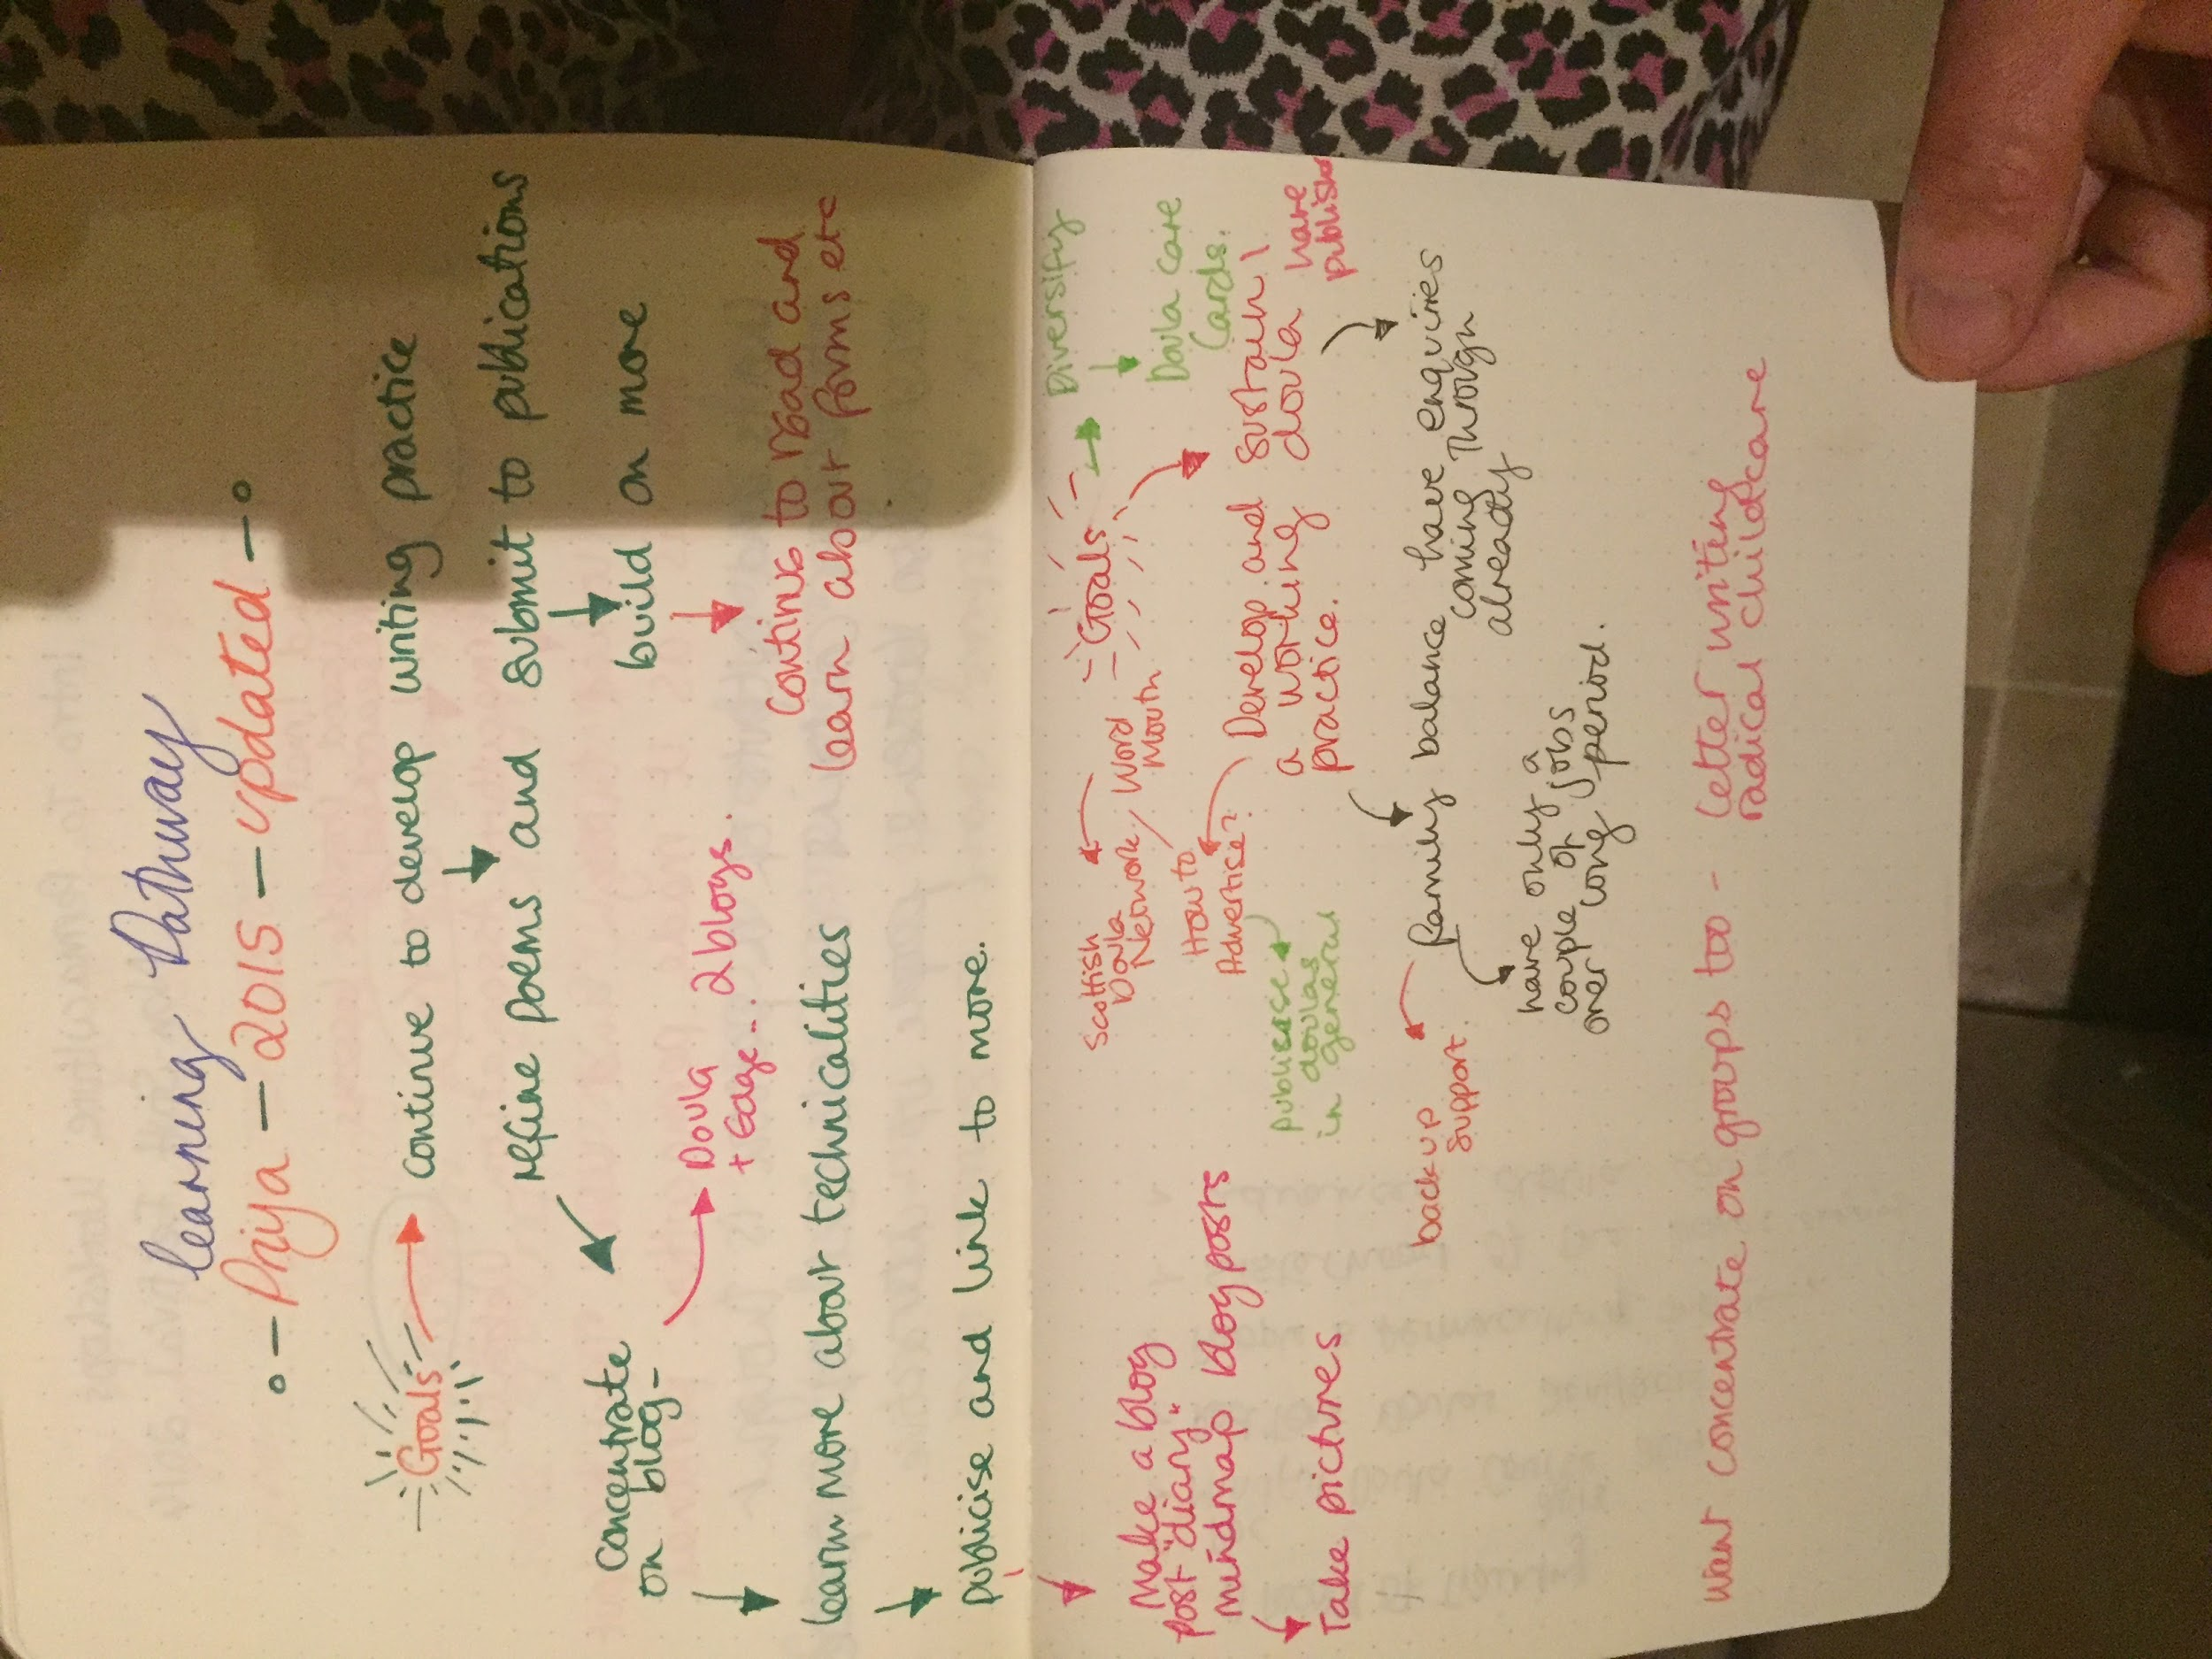

Reflecting on why I wanted to undertake a permaculture diploma in the first place

I wanted TOOLS to align my actions with my intent and define goals.
I was a mother of three young children who had just given birth for the third time and was considering major life changes - i.e.: choosing to home educate and changing approaches to life in a new country when I decided to do a diploma.
Also most deeply wanted to ignite my own creativity and bring a creative practice into my life along with an intentional nature connection practice. I wanted tools to redefine my vocation too. I wanted to take responsibility for my life and my own actions.
Getting growing and gardening skills was definitely a priority too.
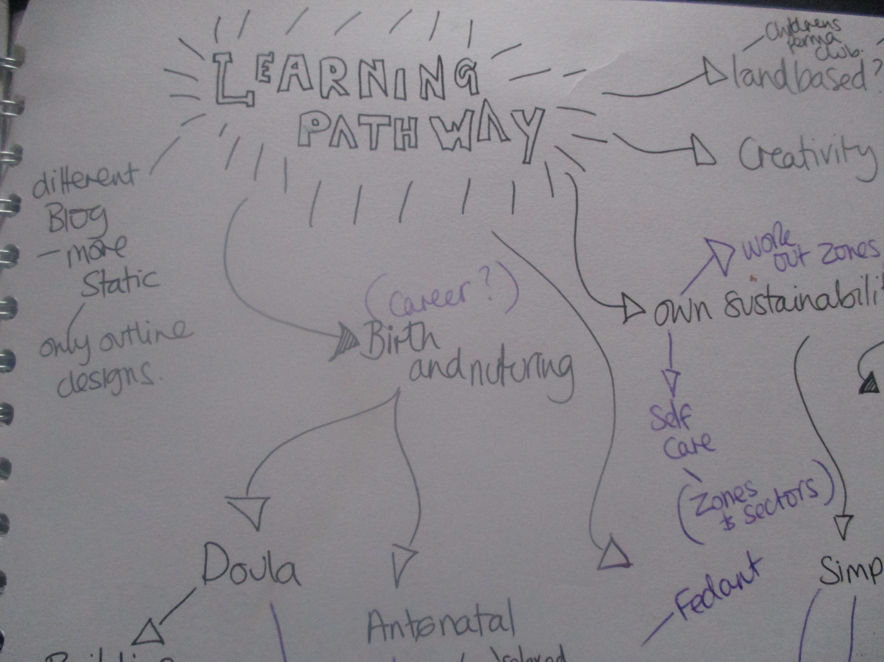

Time frame:

This design will be starting from April 2021 taking into account the past too.

What is a Diploma Action Learning Pathway?

An Action Learning Pathway (ALP) is a personal plan of your intended journey whilst on the diploma. At the end of the pathway is your “vision” of who you want to be, the skills you want to have….. and to get there you design your route, this is your “pathway”. The route will include your other designs which are chosen to help you and give you the skills that you need to achieve your ALP vision. The ALP also contains a time frame of when you will have tutorials and assessments, start new designs, build in celebrations, review the actual pathway itself and finally your accreditation/presentation event. It is recommended that the ALP becomes one of your 10 designs. You may want to give it quite a bit of detail in the early stages and then review it after 6 months. As such you may have several versions of your initial ALP as you move through the diploma process and life takes its course. Everyone’s ALP will be unique to them, ongoing and will develop – as all permaculture designs are.
The questions offered with the design web are just some that might be useful pointers to start our thinking. They aren’t complete and you might find that some are not relevant or thought provoking for you, so do feel free to adapt to your own list. You are also invited to use creative approaches to making and presenting your ALP.
There are examples of ALPs on the Permaculture Associations website.

Written by Deborah Simmonds

Design Framework Choice

I am using Looby Mcnamara's Design Web.

BRIEF: Goals and Aims

Brief: To create a design which I can follow to complete my diploma.

Goals:

- Balance of designs across the portfolio to meet the diploma criteria
- Create a structure and timeline for finishing my diploma
- Do more with land based work
- Finish my diploma
- Present it well and clearly

Permaculture Ethics

How they are upheld throughout the diploma.

Completing a diploma Applied Permaculture Design means I am committed to considering the Permaculture ethics in the projects I undertake in my life and work.

Earth Care

Permaculture has a strong Earth Care foundation and using the frameworks of the diploma brings an attitude of Earth Care to all of the work I undertake.

People Care

Having the initiative to be able to enact and sustain action and make results is highly satisfying and nourishing. Having a range of tools, resources and approaches is something that takes care of me in many ways and passes on to my children and family.

Fair Share

Many times in my diploma pathway I have been encouraged to look at ways that my life or things I am doing affects the whole. It also curbs an individualistic competition that can be emphasised in other ways.

Design Web

Template created by Looby Macnamara

Vision

Who do you want to be when you have completed your diploma?

- Good at planning and growing gardens and spaces
- Established creative practice
- Some streams of expertise, pointers where to develop next
- Better self understanding of strengths and weaknesses
- Deeper understanding of using permaculture
- Confidence to initiate and lead projects
- Understanding ecosystems
- Community minded working models
- Real life skills
- Plant knowledge

What skills do you want to have?

- Growing food
- Horticulture knowledge
- Community Gardening
- Managing Projects
- More awareness of nature - foraging etc
- Less Wasteful
- Making more/repairing
- More frugal
- Self employment skills
- Writing and Art
- Design Skills

Helps

What are your motivations for doing the diploma?

- To develop skills to design my own practices
- Be more creative
- More self sufficiency in terms of food
- Deep understanding of healthier and more productive ways to live and learn
- Self sufficiency
- To be able to share knowledge
- Better wellbeing

What internal resources do you have?

- Motivation
- Experience and exposure to a big number of sustainability projects
- Creativity
- Curiosity

What external resources do you have?

- Time
- Mentoring with art and permaculture
- Allotment
- Some spare money
- Networks through gardens and permaculture and also creativity

Limits

What are your limiting factors?

- Focus
- Time
- Perseverance to log and write long duties

What other distractions are there?

- Other duties and roles.
- Full time mother/carer

Patterns

What are the patterns of success from other learning experiences in your life?

- The honeycomb pattern rings a lot of bells. Stacking many things together and not needing them all to be one thing.
- Perseverance brings good results.
- Learning in real life, not just from books, is helpful.
- Sometimes I forget to celebrate and acknowledge what I have achieved.

What are your learning patterns?

- Love learning new things.
- Need some feedback and results.
- Need variety and different mediums - immersion and learning from others as well as books.

What are the typical points in a learning cycle at which you want to give up?

- When I don’t feel like I am getting anywhere before I am proficient or there is any sureness of the plan working.
- Finishing things at the very end.

What are the patterns of design processes and tools which you have used?

- Getting to the design process can be the trickier point using my analysis correctly. I really enjoy using different design processes.

Where are your learning edges in terms of permaculture design tools and processes?

- Having a full fluency in terms and design processes.
- A more well rounded knowledge around land based skills
- Confidence in delving into my edges

Ideas

What ideas do you have for projects?

- A collection and workbook course around igniting creativity through connection with the elements.
- A garden initiative with communities
- My own land based garden practice/business perhaps encompassing education too
- Being more self sufficient - making more of my own things, buying less

Principles

How can you use the principles to help you plan your pathway?

I have decided to use this graphic that I have often stumbled across when looking for principles online it was drawn by someone called Colleen Stevenson

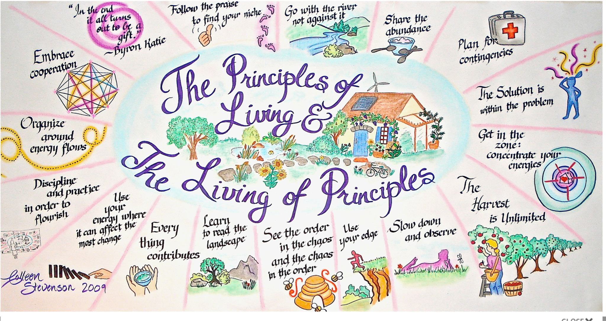

- Discipline and Practice in Order to Flourish This is one that speaks to me. I want to create regular practice and time blocks to create containment and regularity around my study, arts practice - including writing, and any work.
- Share the Abundance I like the idea of using anything that I have a fair amount of experience in now such as writing blog posts I will look for opportunities to share that and swap skills.
- Use your energy where it can affect the most change This really speaks to me with where I am at the moment, I have chosen to relinquish quite a few roles and responsibilities because they were ultimately draining and not affecting any change.
- Slow down and observe. In order to replenish my energies and also connect more deeply with what I am doing I aim to develop a more spiritual connection with the living world.

Integration

What are the needs of the design?

Clarifying the last few designs in my diploma.

Making a plan to honour what I want more of.

What limiting factors need to be overcome?

Running out of time during the day.

Not valuing the time that I have.

Not enough time for creativity.

Needing more time to study/ having a really clear vision

Mentoring and support

The crux of this design:

Diploma criteria

Criteria | Progress | Next steps
Completion of a PDC | Yes 2012 - Glasgow | N/A
Member of the Permaculture Association | Done - Ongoing | N/A
Actively apply permaculture over a period of at least two years since the completion of your PDC | Yes, Ongoing | Finish final three designs
Produce a portfolio of 10 designs that fulfill the assessment criteria | Completed six so far this design will be number seven | Complete this and then move on to complete the next three with an awareness of what has already been done and filling in blanks
Put permaculture theory into practice and make relevant changes to your life, as evidenced through your design work | I feel I have put a lot of permaculture theory into practice and made changes in consumption, growing more food and bringing general awareness in | I will attempt to summarize these effects in a personal design.
Reflect upon your permaculture practice and learn from it, as evidenced through reflections and evaluations for every design | Completed. | N/A
Upload at least three of your assessed designs to the Permaculture Association website, or provide a link to your own portfolio website. | To be done. | Review which ones to share and upload
Diversity amongst your Designs:  - Sizes  - Personal/Community/ land development  - Design processes  - Design tools  - Principles  - Presentation format | Design numbers  - Community:  - Land:  - Personal:  - See Log of Processes, Tools, Frameworks | To do:  Analysis of the different variables, see below. Then choose 3 designs, their processes, tools, principles. Then do the 3 design following this:  1 small design: school allotment.  1 personal design : Medium small size  Fill out gaps in Logs, processes frameworks  Make a Video presentation
A Majority of your Designs Implemented | Yes | Almost all are implemented
Demonstrate Progression | Yes | Include in this design
A Review of Relevant Activities | To do | Need to do
Your Designer’s CV | Not done yet | Will do after this

PA definitions of size of design:

 |  | Design number:
Small Design | 1000-3000 words | 3, 9
Standard Sized Design | 3000-5000 words | 5,4,6, 7
Large Design | 5000-7000 words | 1,2

Type of Design | Design Numbers
Personal | 1,2,10
Community | 1, 3,4,7
Land | 5, 6, 8,9

Looking at the Log of Processes Tools I have found that I could use all of these tools in my final designs ( Including this one )

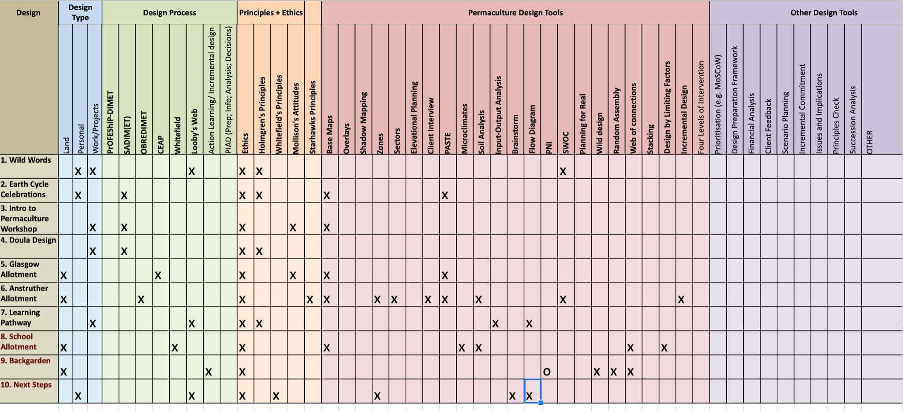

Planning for Real

Wild design

Random Assembly

Web of connections

Stacking

Design by Limiting Factors

Incremental Design

Four Levels of Intervention

Brainstorm

Flow Diagram

PNI

Overlays

Shadow Mapping

This specific design will come in at a standard size. This will make my designs have a pretty even spread of standard length designs which could mean that I could do more in Small or Large sizes.

What systems can you put in place to fulfil these needs?

Checklist and time frame to finish diploma

Present diploma

Action

What’s the timescale for action?

I want to have my permaculture diploma signed off by 2021.

Need to outline what criteria I need to fulfil.

What are the timescales for yields?

I would like my diploma finished by 2021

Momentum

How are you going to keep going?

Have weekly tutorials until everything is done.

Serious commitment

Minimise distractions

What strategies can you put in place for support?

Part of a co-mentoring group - actually two for creativity

Get one to one tutorials for the permaculture stuff.

Appreciation

How are you going to appreciate your efforts?

Really take in what I have achieved so far !

Once this design is done I am 70% through the diploma and I have had a lot of experiences that have added to a skill set and my life.

I really want to honour what I do by keeping track of it a bit more and going easier on myself during slower times.

What can you do to celebrate your successes and efforts? (these can be timetabled in beforehand)

Finishing some loose ends will really help to clear my energy and mental focus.

I have three months to finish my diploma.

Looking at a horticulture course which will take over a year .

Two/four hours a week writing. Some reflective and some for submission.

Track my progress with growing food with blogs.

Reflection

What has gone well with your learning pathway?

It has really given me a lot of clarity over the things I want to develop and things I am already doing.

What have you found challenging?

Letting go of strands that I wanted to keep going with because I had invested so much time in them.

Investing in things that I have not had much real world feedback in yet.

Maintaining the thread whilst going through many life and situational changes.

Pause

How can you rejuvenate yourself?

Getting out and about.

Being inspired by practical results.

Taking time to recharge and connect.

Making time for creativity

Spending time in the garden

Nurturing community

How can you rejuvenate your enthusiasm for permaculture?

By focusing on the fruits and variance, getting involved with more things community based.

Learning more.

Practising

Seeing results

How can you get started again after a pause?

Having a strong anchor to what I am doing.

Having a daily writing and reflection practice.

INPUT AND OUTPUT ANALYSIS

Did doing a permaculture diploma go towards developing my personal goals and vision.

PERSONAL VISION | INPUTS | OUTPUTS
Good at planning and growing gardens and spaces | Observation, research, looking at a wide range of projects | The ability to contribute and shape projects personally and for others.
Established creative practice | Time, nourishment, peace, self honouring | Having the satisfaction of adding things of beauty in the world.
Some streams of expertise, pointers where to develop next | Dedication, practice, apprenticing, reflection. | Having a vocation, and focus
Better self understanding of strengths and weaknesses | Self reflection, looking at mistakes, accepting criticism | Less energy wasted through making the same mistakes.
Deeper understanding of using permaculture | Time taken to absorb learning. Regular reflection. Reading, workshops and learning. | Increased ability to analyse what tools I will need across other projects.
Confidence to initiate and lead projects | Experience. Taking risks. | More opportunities, more projects.
Understanding ecosystems | Reflection, study, observation | More connection with ecological ways to be in the world
Community minded working models | Experience in the settings, learning about systems, reflecting on the community projects I am involved in | Having the ability to work in the world with a wide variety of people. Designing systems that work with others.
Enhanced real life skills | Building skills, going through the cycle of competence, taking classes, teaching myself. Trial and error | More self reliance in action.
Better plant knowledge | Experience, broadening my garden repertoire, keeping a nature journal | More skills for design, understanding the plant kingdom better skills as a land based practitioner.

DESIGN
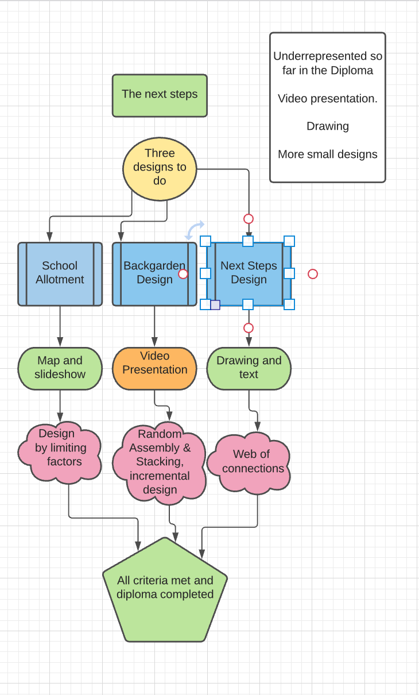

Timeline:

Next design to complete: School Allotment. Will roughly take four hours.

Have a checklist of log and design processes to inform next designs

Create a Designers CV

EVALUATION

This design was really useful in terms of mapping where I have been with my diploma and analysing what I needed to do to complete my diploma. It has enabled me to see that the original vision for my diploma has been upheld by the process and that the range of design solutions have been supportive of my ability to plan and implement a wide range of solutions.

Looking at the logs, frameworks and processes has also given me a really good picture of the gaps in my designing history which means I know where to go next with regard to improving my repertoire.

This will definitely inform my final three designs with a view to making my diploma diverse and a showcase of the ability to understand and work with a broad toolkit.

This design presents me with a clear pathway to do the other designs, a checklist of what I need to do to finish the diploma. It worked in that I felt finishing the diploma was in sight, with a clear overview about the different designs, tools, sizes, processes which I have used so far. Helped narrow things down based on the observation and analysis.

REFLECTION
I have valued the systematic approach of looking at my learning pathway with regard to the diploma through the lens of fulfilling criteria. It was very clear to me, which it hadn’t been until now, that I relied on a small range of design processes for the first few designs. This isn’t really a flaw but it feels like it shows my growing confidence as I know I am now very motivated to add in more skillsets and processes as I have more of a baseline understanding of what is possible.

Some of my designs go back years now and I feel a little disconnected from where I was when I did them. Land based designing has taken more of a front seat since then though I hope to add more community projects after I finish my diploma.

It was exciting to acknowledge that I am almost completed what has been a large chapter of my life and this marks an important step in my journey.

