Personal Design

Background: 1
Goals 2
Observation 2
Past Experiences 2
Analysis 5
Concept 7
Permaculture's role in art and creativity. 7
Principles: 8
Slow and Small Solutions 8
Use edge and value the marginal 8
Integrate, don’t segregate. 9
Design 9

Background:

The original motivation for pursuing a permaculture diploma was to establish a creative practice and become a confident designer. A wide range of self-directed projects can be achieved using permaculture as a guide thanks to its endless adaptability.

I have always been passionate about painting and creative writing in particular. As I have studied for my diploma over the past few years, I have gradually realised I have the tools to shape any course of study or direction I desire and I want to honour both my creative practice and my commitment to learning more about tools I can use to give shape to any project I wish to pursue.

Design Process - The Creative Process.

( I found this in a book called Change Here Now by Adam Brock and originally cited to Laurence Halprin in the RSVP cycles.)
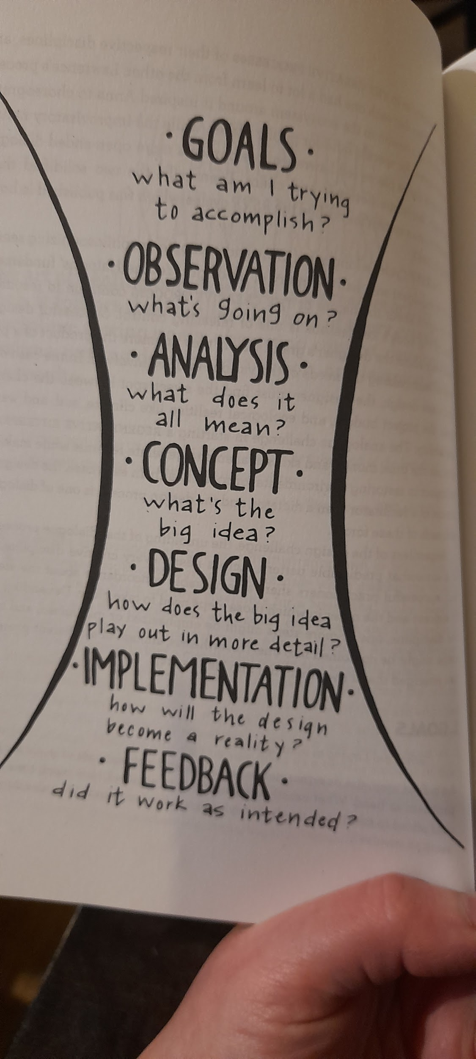

Goals

My main aim:

To create a sustained creative practice.

Sub-goals:

- Use permaculture to design a routine and commitment and vision.
- Setting work goals and igniting momentum and confidence.
- I want to design a path that feels intrinsic, organic and tied to my own journey.
- Simplicity of design

Observation
“What is going on ?”

Past Experiences

- I Have always drawn, painted, written and made art in one way or another. It is something that is deeply nourishing and meaningful for me (especially when I shift the focus from result to process). It allows me to shift things, and also produces something I can look at tangibly.

• The axiom: as above and below, is an apt mantra for personal practice, I see it as encompassing a holistic way of being, a reminder to nourish the roots and remain with the larger process and live the questions ( as poet Rainer Maria Rilke put it). So it can be in internal journey

These observations may or may not be useful to the overall design process and are in no particular order.

Key points:

- I want to nurture the work that I have started and delve into the beginnings of projects and ideas I have built up. Looking at whether they are seasonal, perennial evergreen or deciduous. I also want to let go of anything I don’t need to create space.

- Using deep time as a metaphor if I allow space and commit time and energy ideas and work will seep through and start to shape themselves into larger pieces.

- Plan is to build a complete work - a collection of poetry & pictures based on the works that I have already started on the themes of birth, connection and germination - to give me a specific time bound goal. A container and something completed !

- Also using small and slow solutions is the only way to grow meaningfully I have grappled with the reality of where I am now vs where I “should be'' but is often a matter of starting, trusting, momentum etc - Reminder: anything truly rewarding and worthwhile takes a long time, struggle and hard work. Build rest, self care and recharging into that! A book I recently reread Care of the Soul by Thomas Moore he states a good cure for self destructive impulses is having an image of oneself and loving it. This attachment takes away a compulsive desperation to make something in the outer world which can be the driving force of overambitious ideas of achievement or perfectionism all of which blocks real authenticity and satisfaction.

- The soil or ground of one's life needs to be nurtured. What goes in is reflected in what comes out. By having access to an allotment and the opportunity to incorporate white space into my daily life, I have a tangible sense of gratification when I work with the land and allow my mind to nestle ideas, emotions, and content that allows me to keep my sanity and pace during the slow development of the larger themes and projects. To keep momentum, Julia Cameron's Artist's Way suggests artist dates and consciously nurturing the subconscious through activities that can take root in our minds and hearts. In addition, I need to reduce the amount of polluting distractions I am exposed to and pay close attention to what I read, listen to, and do.

Looking back at all the creative works and wanderings that have built up in spurts and nooks and crannies throughout the years, I can clearly see that seeds of my own practice have been sprouting almost self-willed over the years. The next step therefore is building a wall or container around the many strands and making some of it concrete and manifest.

A key step going forward is in making a clear structure and container to carry the impulse forward.

Building some self accountability into the process and giving myself a balance between goals and free time will be helpful.

Analysis

Inputs (important to think about )

Time is obviously an important factor.

Silence, simplicity and space.

Nourishment: in terms of taking things in and having time to digest them.
Ease of access to materials and opportunities.

Outputs

Increased skill and confidence.

My own self expression as a pathway to meaning and identity. Belonging starts with ourselves. I feel more alive when I am creative.

Awareness and understanding of personal interests and abilities: clarity to see the direction I want to go.

A body of work that I can have as an example.

Current Patterns

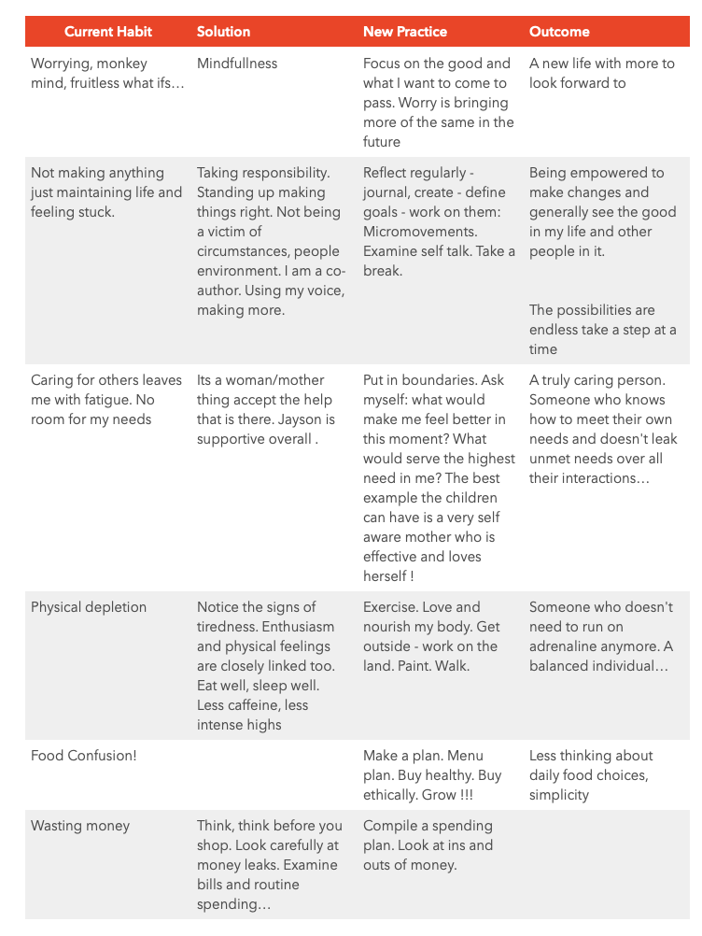
Patterns

Being drawn in a few directions - the branching pattern comes to mind.

The honeycomb pattern - sometimes it feels like lots of separate projects i.e. without any central cohesion means the energy can dissipate or lose out to each other.

More positively I could look at the honeycomb pattern as a holding pattern and one that means that not everything needs to be merged.

Creating positive spirals of abundance is also a good way to create unknown positive benefits that may influence other aspects of my life.

Having a daily pattern that compliments what needs to be done will make it easy to keep going.

Input and Output Patterns

I thought about wellbeing and the inputs and outputs

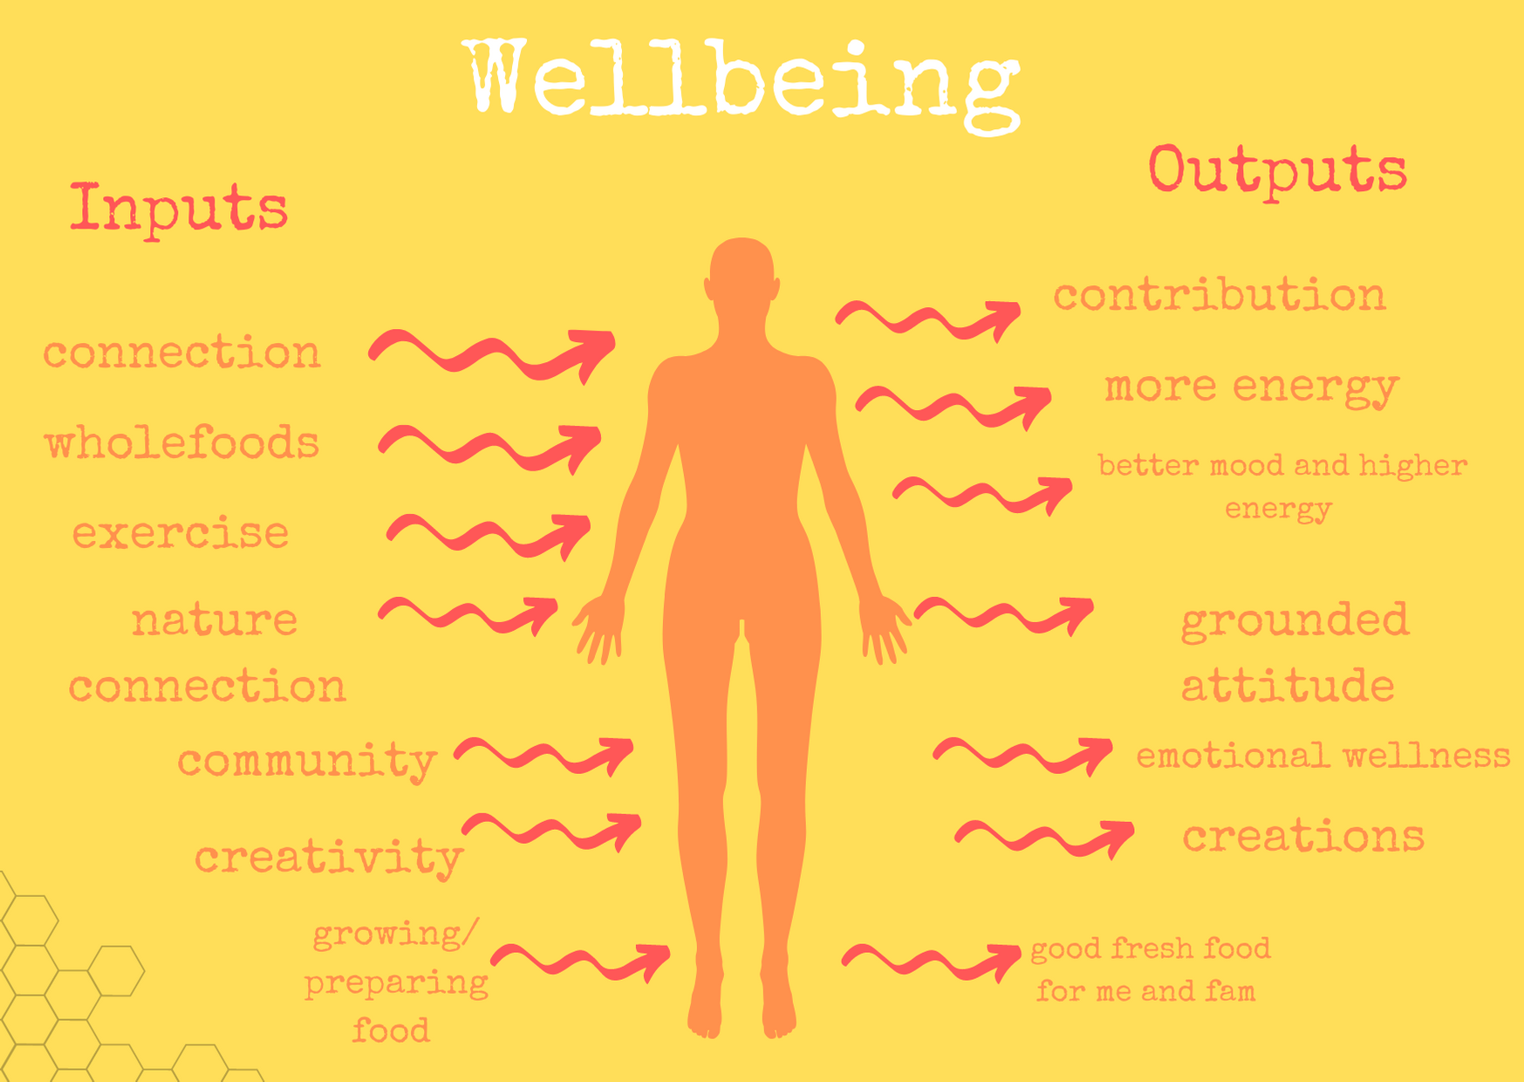
I made this image thinking about the whole idea of inputs and outputs, with a reminder about what I put in.

Other Patterns: Feed what you want to grow

A lot of what makes me feel good, hopeful and grounded is being closer to the earth, being creative/reflective and working with my hands.

Journaling and writing is also a very nourishing practice that is easy to sustain. Discursive journaling can be incredibly helpful.

Concept

With this design, I am underlining my commitment to intentionality to creative practices.

With structures that enable the tides of life and activity to ebb and flow without decimating my practice, I keep developing both emotionally and technically.

I want to create a structure and space for honouring and nurturing what I create.

Why is creativity important?

The first thing that came to mind was a sense of agency.

A sense of agency in a person's life can lead them to make more responsible decisions. It’s a ripple effect.

When we get a taste for making and creating, we become more ourselves, which also impacts other areas of our lives.

Culture building hinges on creativity and empowerment as well

In my own life, being creative, regenerating, and reflecting extinguishes and tempers my desire for many other "pseudo-satisfiers."

(Pseudo-satisfyer: something that claims to satisfy a drive but does not)

Reclaiming our voice and inner authority and carving out our own place in a world that encourages us to purchase, ignore or suppress our identity is a revolutionary and powerful act.

As Hungarian Psychologist Mihaly Csikszentmihalyi, explorer of the concept of the deeply creative state of flow put it: “consuming culture is never as rewarding as producing it.”

American writer and researcher Brene Brown writes about unexpressed creativity being a major source of pain and emotional toxicity which causes the need to escape in unhealthy ways. When we numb to our own pain we also numb to the pain of those around us and feel apathetic. Reclaiming our creative power can nourish us inwardly, allowing us to be awakened to the realities of our actions, thoughts and emotions enabling real change and choice.

This fact is also explored at length by Joanna Macy in the Work that Reconnects - reconnecting with our power and interconnection with the world and each other can be very painful but is in fact the only way to truly live and experience existence and larger empathy.

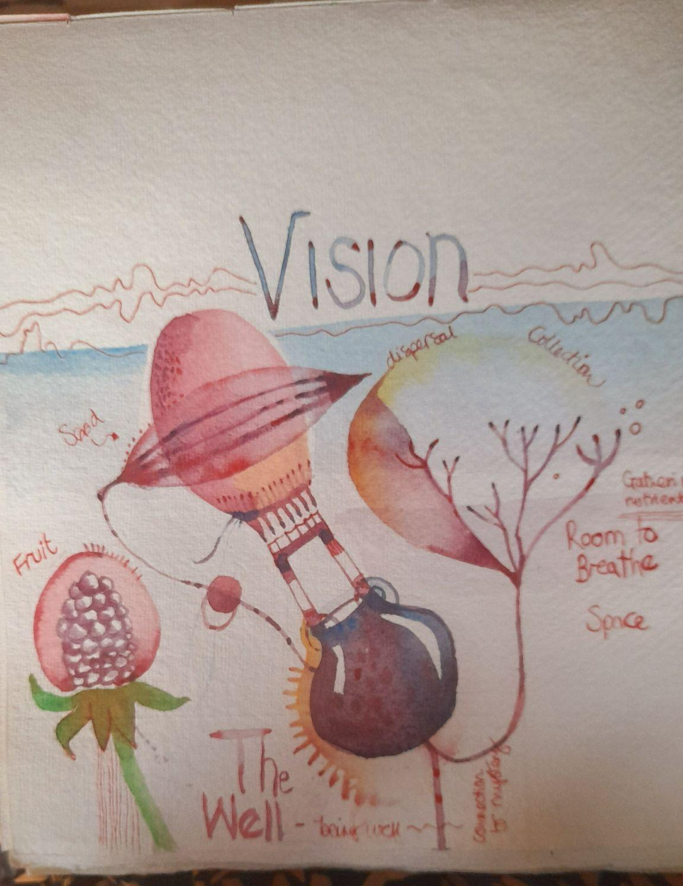
I painted this picture that aims to encapsulate what the concept behind my design is. There is a cauldron, it is rooted, there is also the air element which symbolises creativity and catching ideas. Letting things breathe and settle is also a good and healthy habit for me.

The Cauldron. In cooking up creative works the cauldron is a metaphor that springs to mind - in Celtic lore the cauldron signifies the womb, the goddess and the underworld. The underworld is also our unconscious and all that wants to come forth but is as yet unknown to us this needs space and boundaries. In fact it can also allow us to form true boundaries in our life and consciousness.

True creativity has an element of mystery, surprise and innocence in it. This is clearly evident in the natural world for instance in the moment of conception in the womb or in the soil when a seed germinates. At this point of conception and creativity, although the shape is known and determined in the fullness of time the coming together of the ground and the potential needs slow, trusting, deliberate nurturance and is subject to many external factors and variables.

Principles:

David Holmgren Principles that tie in with the concept of the design, these were very helpful to think about.

Slow and Small Solutions

The meaning we can discover when we slow down and allow ourselves to truly see the small and everyday is encapsulated by William Blake’s idea of seeing eternity in a grain of sand.

In shifting our vision with deep observation the sometimes consuming desire for more and more stimulation and distraction disperses, allowing us to see the depth and beauty in the everyday and the ordinary.

In a practical sense it means that I can take ten minutes to write something or sketch something out or mediate and look at or listen to something interesting around me and do this often.

Use edge and value the marginal

I can create time boundaries around it so as to nurture small pockets of time ongoing emergence. Being committed to building patterns within the day - 5 minutes to write or sketch can be the seed to a bigger piece of work is the key to truly creating and exploring meaning which entails letting go of perfectionism and daring to create and stand by that process.

Value diversity

Having a few different approaches to wellbeing honours our need for change and flux throughout life.

Taking photographs, drawing and learning new recipes are a few simple ways that this principle can inform the design.

Integrate, don’t segregate.
Instead of needing to separate art practice from life or needing a lot of time or space, having something simple like a notebook to practice line drawing in with me or a notebook of poetry will help me integrate it with my daily life. It also allows me to see the artistry in what is there in the world around me rather than something separate and illusive.

Designing

Transformer

Much of what is needed within the design is a dissolution of what is blocking me and things like procrastination. I read a good quote about sustaining creative practice which basically said - don’t just vision the result, vision yourself doing the work.

Building a creative practice, or anything worthwhile in fact, means being able to deeply immerse yourself in the work which then has an almost indescribable life of its own. (Building personal style is an organic process and one that requires dialogue, trust and momentum and love of what we are doing.)

Table: Blocks, and transformers

Blockage | Sitting With it | Transformer
Procrastination | It becomes uncomfortable, energy builds if left too long | Doing one small thing, getting something moving, changing mediums ( paint don’t write, take photographs, cut things up.
Feeling uninspired | Can feel heavy, frustrating, end up ruminating on cliches | Take heed of what I am taking in, read a poem, go for a walk - think of things in lots of ways
Self critical | Feeling like my skills are not where they ‘Should be’ ending up giving up | Allowing myself to have fun being bad at something, putting music on.
Impatience | Seeing the end goal way off in the distance and feeling like I can’t get there ! | Appreciate: I have so much already started and in pieces and feedback and reflection has been very encouraging and important.
Overwhelm | Having a sense that things are just too much, feeling overwhelmed by inputs | Simplify: an analogy of the small doorway. I need to pare down and concentrate on the seeds I have started with the attitude of abundance and seeing what is there already.
Comparison | Being stuck in a comparison pattern I don’t see what I am doing, only what I am not. | Allow myself to get back to the physical reality of what I am doing and why, I almost named this design the

How to display/share my work with the world. Because this motivates me to do more, improves mental health. What are my options?
- Website: create own for free
- Paid subscription website: £12 per year
- Instagram
- Peer support
- Shop selling cards
- Shared art project (find someone to work with e.g. Edinburgh friend)
- Being paid for art? (is my creative practice included in the work I am doing anyway?)

Option | Positive | Negative | Interesting
Website Create Own Webpage | Have a certain amount of freedom, Can put a lot on there. Is fairly open in terms of how I do it. Free options and can upgrade. | Needs a bit of output, sometimes it is unclear if anyone looks at any of it ! They certainly don’t without having external links., | I have really enjoyed looking at very simple websites recently, there was an old belief that everything needed to be on there.
Paid, Online Portfolio | It comes up high in search results if you just look for a name. The cost is quite low. | Not sure who looks at it. It is good for when I have submitted examples of my work. | They are good virtual holding places with high resolution.
Instagram | It is super easy to use, and images and words can be uploaded from a phone. It is good for inspiration too. Very easy to network | Getting distracted there is very easy. It is also a very competitive place so it is hard to keep up with people who devote a lot of time to making videos etc. Can feel like an energy drain. | Social Media can encourage adjusting style by hitting you with popular algorithms which creates a skewed version of reality. This is really obvious now when I engage that what I see is linked to what I have looked at previously.
Having Stock in Shops | Means I could potentially have customers and visibility. | Means I have to preprint and produce things. Could end up as a loss. Hard to get stocked by bigger/busier places as there is a lot of competition | Physical things can be motivating ! I like things that are not all online !
A collaborative art project | New energy, a feeling of connection, support, new ideas. | Needs a initial bit of organising, am dependant on peoples schedules and can be sidelined by people | The energy of doing something with someone else may produce interesting results ! It could also be very motivating.
Being paid for things ( Am I being creative in my existing projects ) | I have a job and other projects that can benefit from creativity. I also do things with the family. | Sometimes I miss out on the peaceful intention if I allow myself to just get swept up by other types of busyness. | Can be great to link up with wider projects and let that push me on in terms of skill and output volume.

Ethics

Earth Care

I think that creating art, writing and painting, especially if it is informed by the world around you, is a form of caring for the earth. In my paintings I am often inspired by the natural world as in plants and animals and this is obvious.

I don’t use natural paints however, as they are just standard watercolours. I use these as they are so low maintenance and can be moved around easily, they also produce very vibrant results. As I have been mastering my way around a paintbrush it has been good to not have everything be new though I have also been very interested in researching making my own paints and inks at some point and even bought a book on it a while ago.
I think that even more being creative in the broadest sense allows a piece of me that is satisfied and curious about my life to awaken rather than be caught in a consuming mindset that gets things I will never use. I realised that much of my hoarding came from a sense of wanting to make or write but not having time so buying a book on poetry or painting instead. Of course I know I could start collecting every paint going but having a sense of sustainable practice allows me to curtail that and also reduce consumption in what I make. It would be great to start including more repurposed materials in what I do.

Fair Share

I'm really interested in the concept of outsider art, the contemporary art world without the injection of real life is often referred to as stale! Whenever I get critical of myself not having a degree in fine arts and therefore not a ‘proper artist’ it actually gives me some fuel as I don’t think this is a state that should be encouraged or a stance that has value. Everyone who builds practice, and I feel that more people would be happier with creative practice is making art and is an artist.

People Care

I loved the chance to run some Maternal Journal ( art based workshops for those who have had children designed by a variety of artists ) over the past few years and get into doing something supportive of mental health and not complicated that hopefully allows people to get in touch with something illusive. I think there is so much overwhelming evidence about the power of creativity and how healing it is.

It has certainly helped me in many ways and allowed me to move energy. I did a program called Cultivate in 2020 and it focused on the movement part of creative practice and it showed me how movement and stillness, as well as meditation could directly channel new ideas and even skills to me in that I arrived at the page - to draw or write with a clarity that was more honed. I think movement is also huge in mental health and I have been working with that for some time with Somatic healing.

Implementation

Time:

Spend a minimum of ten minutes working on what I already have.

Materials:

Paper, watercolour, photography.
I have an abundance of art materials and notebooks. I have plenty of inspiration.

Focus :

Create a series of work based on the studies I have started and been building up.

Momentum:

Ten minutes or one page every day, keep a journal on the process when possible.

Keep learning and reflecting.

One artist's date a week - this can be a half hour stroll somewhere inspiring. ( The idea is that it is an open activity mostly solitary that facilitates growth)

How to display/share my work with the world, what is the goal?

Sharing work motivates me to do more, improves mental health. How is the best to do this? mentor?

Goal:

Steady myself and also produce some fruit which in itself is a great motivator.

Maintaining Design

To Do | For instance/ What helps
Nurture Support | Join an art class, Poetry group
Have things close | Keep a basket of materials
Tie Up Loose Ends | Build a folder of work, slowly, sort through what i have
Have at least ten minutes a day, more if possible. | Set aside a small amount of time when the energy is right, often in the evening.

Feedback

I want to go through my original goals and understand if I have attained or will attain the goals.

Use permaculture to design a routine and commitment and vision.
Yes I think that having a set routine, commitment and vision has been enhanced by using permaculture to go through this process and remind myself why it is important to me and also underlines the more ecological way of setting goals.

Setting work goals and igniting momentum and confidence.
I feel like I am at the beginning of this stage, one thing that came clear. My work goals have now become obvious to work on developing skills and getting more of them is about graft rather than just the creative flourish .

I want to design a path that feels intrinsic, organic and tied to my own journey.
As a design I feel that it is flexible enough to flex with my needs and also stay responsive. Having something written down has helped focus my mind. Journaling is a huge part of being connected to my own journey in a conscious way.

Simplicity of design

This is really important - I think for it to be a consistent and ongoing process and places emphasis on the practice side of it rather than the outcome.

I have decided to make a website, the goal for this is to have something centrally, I think this is because it is free and also doesn't need a huge amount of input.

I have also joined Spilt Milk Gallery again which is a public platform and a collective online course around meditation and poetry. This is really supportive as I get to hear others' work and be guided by prompts.

Next steps will be to finish a few pieces of visual art and get things to a standard I am happy with.

Reflection

It was good to see this design for what it really was, which is about practice, the slog, showing up at the page, taking ideas down. Starting things small, rough but consistent and letting things take root. After investing time into this , I realised that I definitely have ebbs and flows when it comes to inspiration. However, showing up to a page and writing or drawing, or just copying something creates a sense of peace and space that is soothing and nourishing.

What happens when I do this is that the inspiration flows and I get more ideas, it is a bit like raindrops when they first penetrate hardened soil.

Skills are a massive part of this too and I want to also commit time to stretching my skills in terms of writing, painting and drawing ( I also have lots of ideas about other things I would like to do in terms of dressmaking and just learning more about traditions and techniques ). Doing this design and going through the process has shown me the importance of taking a more diligent approach to practise, building up skills over time but sticking with it.

I am aware also that energy will ebb and flow. I know the importance of keeping going, but also having that based on enthusiasm and interest. I would like to build my learning using art and running workshops about journaling and mental health - have done some of these before - Maternal Journal.

The design process was called the Creative Process which was new to me and this was partially the reason I chose it. I liked that it was based on a more social structure and that it was aimed at creative design.
I really liked the ‘Concept’ part and I thought this was quite focusing on the framework behind the design, I feel though that this could have easily gone before the other steps and informed the ‘Goals’ and then ‘Analysis’. I think that once we got to ‘Design’ It almost didn't matter that there was a difference.

