Anstruther Primary School Allotment

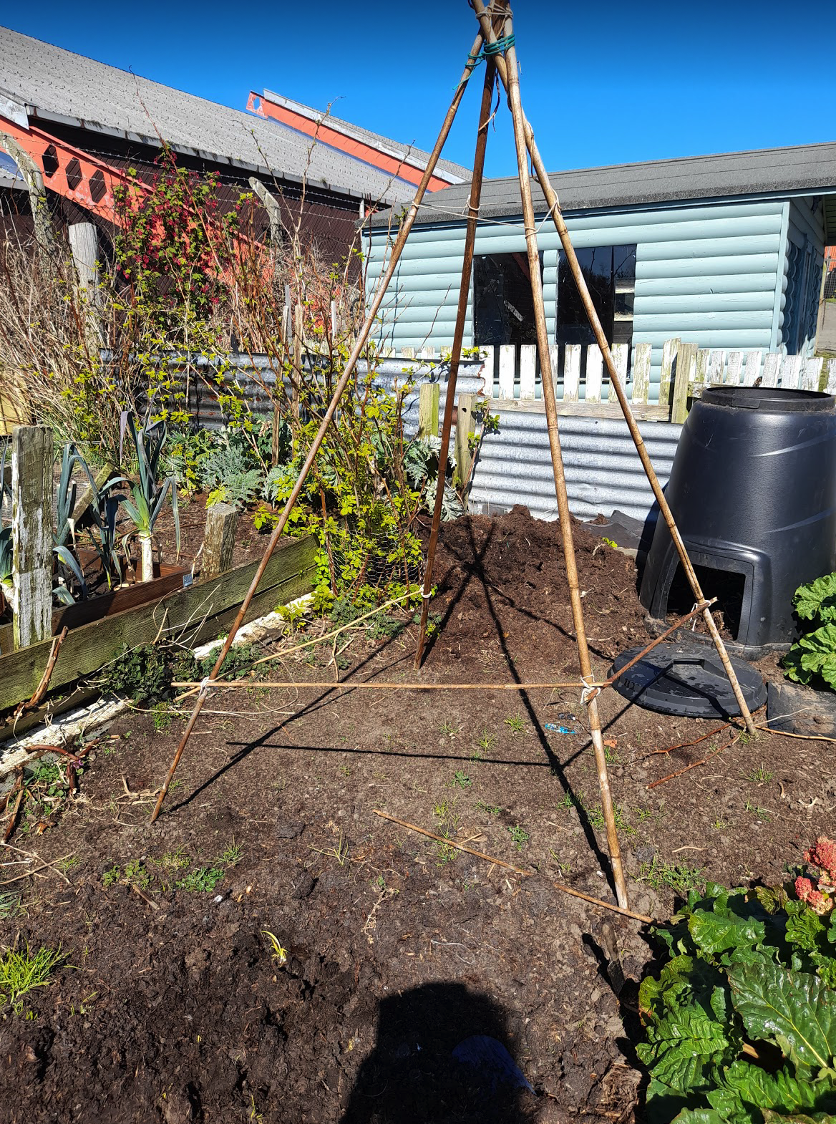

Anstruther Primary School Allotment 1
Background 3
Client 3
Design Process 3
History of the site 4
Goals Of Design 5
Base Maps 5
Site Survey 9
Soil Test Results 9
Climate 9
Design Quest 9
Evaluation 10
PASTE ANALYSIS 11
Plants 11
Animals 13
Structures: 13
Tools 13
Events 13
Resources 14
Time 14
Money 14
Physical resources 14
Principles 15
Make the least change for the greatest possible effect 15
The yield of a system of theoretically unlimited 16
Work with nature not against. 16
Ethics 16
Earth Care 16
Fair Share 16
People Care 16
Design Proposal 17
Design By Limiting Factors 17
Walkways 17
Planting Plan 18
Time and Money 19
The plan 19
Implementing the planting plan 21
Implementing rebuilding the front wall 22
Implementing richer soil 24
Maintenance over time 25
Web of Connections on Site 25
Evaluation 26
To make the site as productive as possible and streamline effort needed to maintain it. 26
Fix up some structural issues, the wall is falling down at the front 26
Provide spaces for children 26
Have wildlife awareness built in 27
Make it look good 27
Enrich the dry soil 27
Make sure that the crops don’t get wasted 27
Save some seed 27
Plant things that are easy for children to get involved in 27
Reevaluation 28
Reflection 28
A few follow up photos from later in the season 29

Background

At the end of 2020 since my daughter was attending Anstruther Primary School and as a family we had two allotment spaces at the same site we volunteered to take over the running of this site.

It is primarily an education resource for the school to do a bit of learning about growing and they plant things up there and do activities with at least two of the school staff.

They also use some of the produce for their harvest festival.

One problem is that sometimes when the site is most abundantly prolific in terms of what is being produced the school is either on holiday OR they are too busy to harvest and use what’s there.

Client

Anstruther Allotment Association
Anstruther Primary School
Organiser: Priya Logan

Design Process

For this design I am going to use the Patrick Whitefield design process, namely to try it out. It will be useful to become more familiar with the tools and processes.
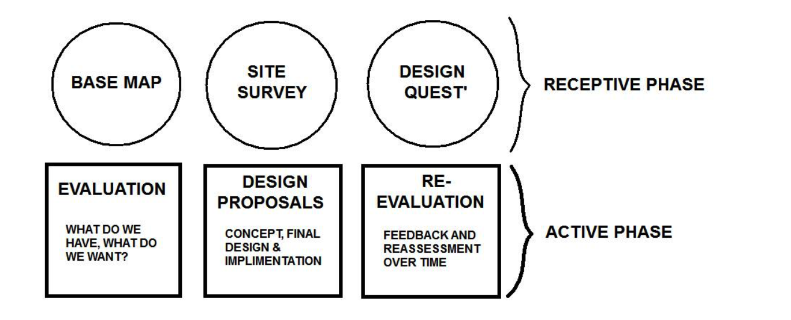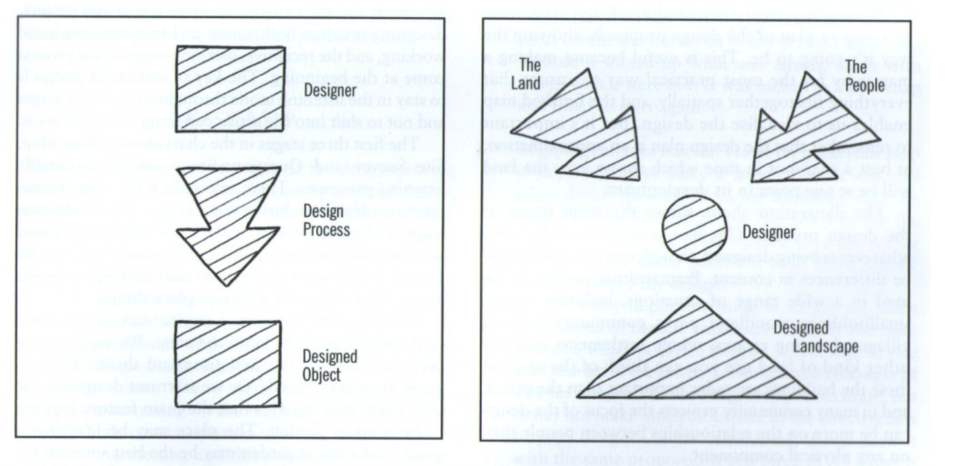

History of the site

It has been a school plot for ten years, since the beginning of the Anstruther and District Allotment Association

We are taking over more management from Carl Van Der Lee and his wife Nuala who have facilitated lessons and been the principal growers.

Anstruther Primary School is ten minutes walk away.

Goals Of Design

Simple planting plan with awareness of clientele and access points.

Base Maps

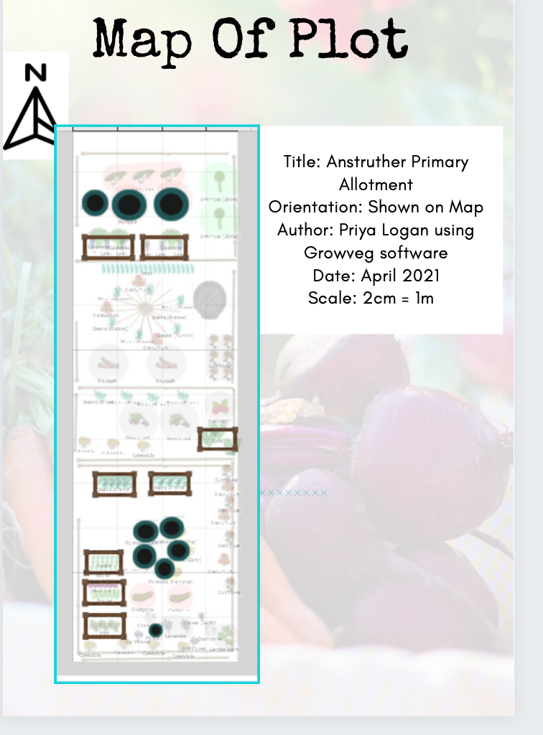

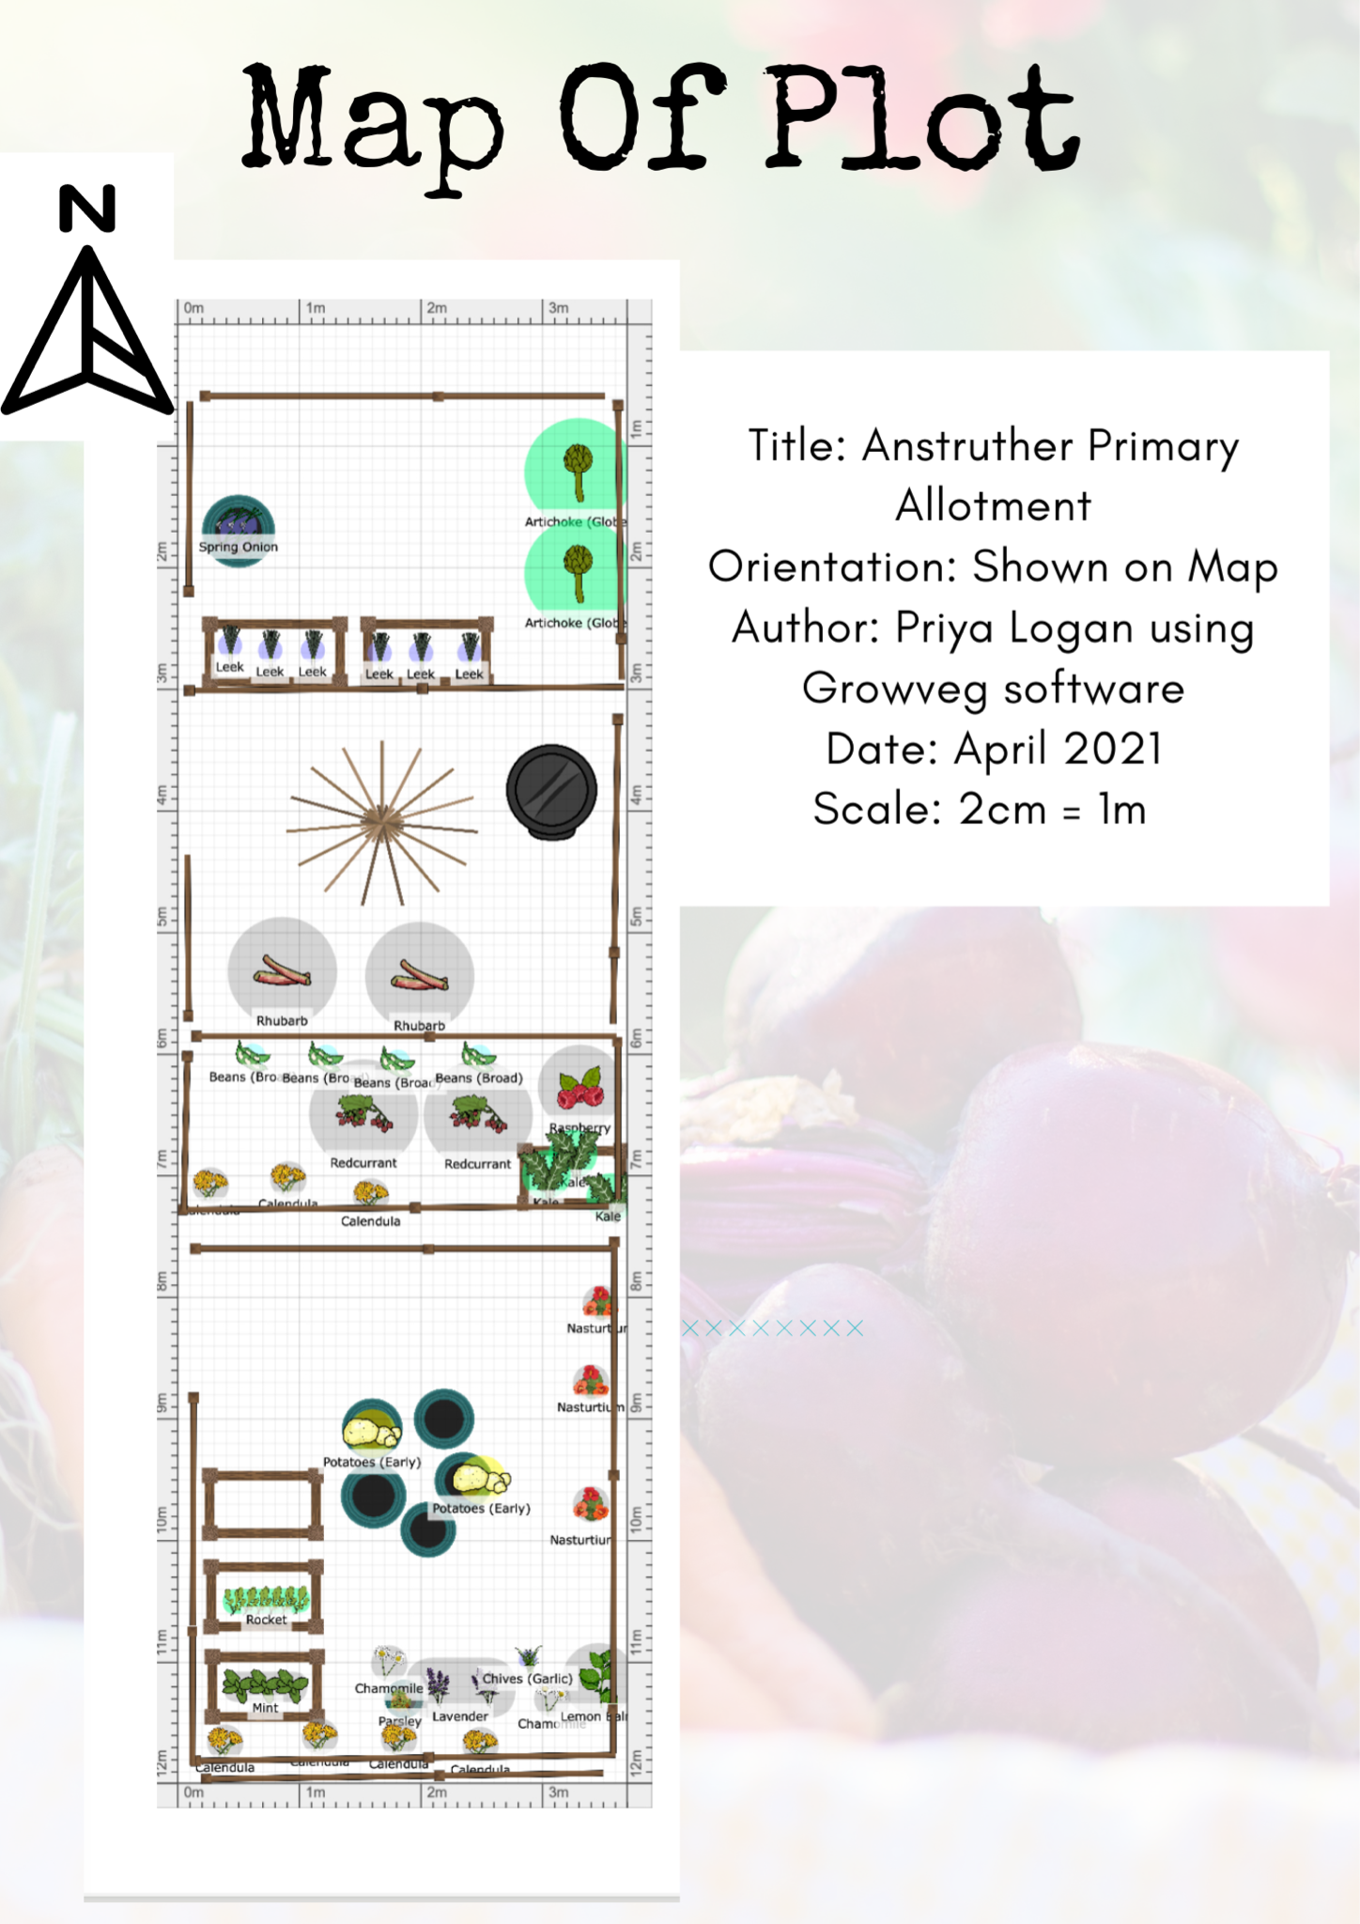

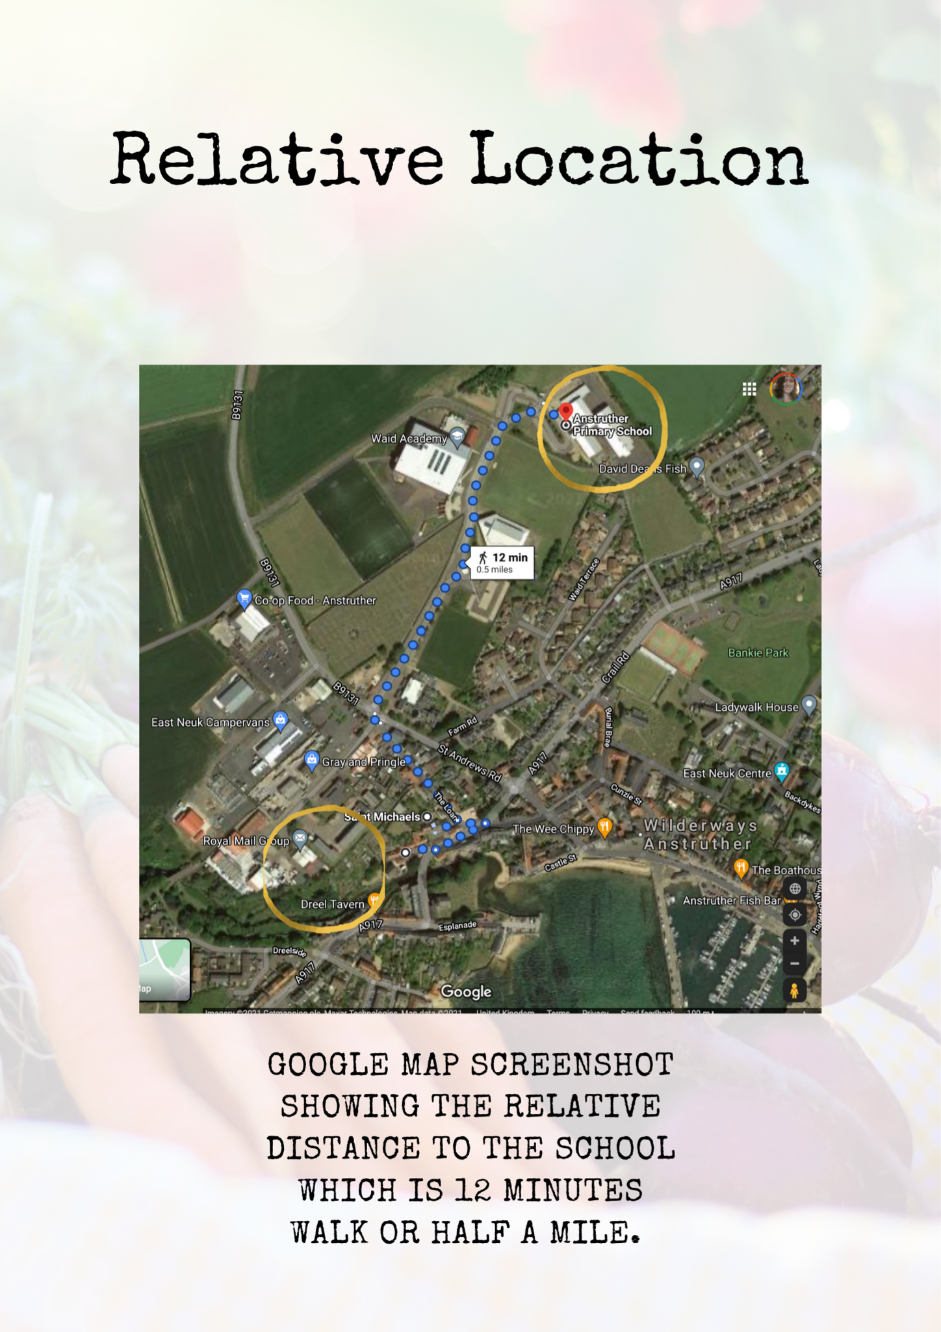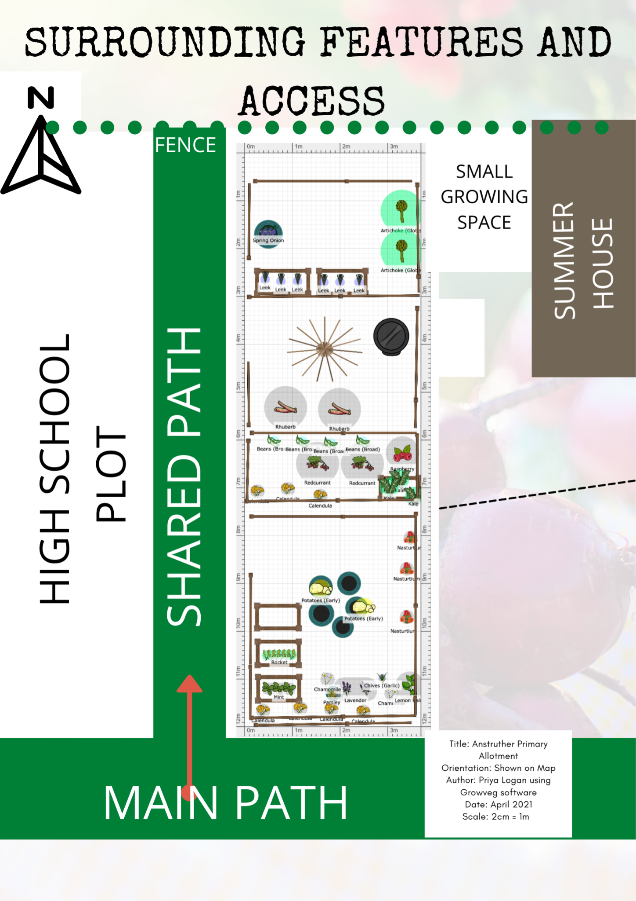

Site Survey

Soil Test Results

The soil test showed that the soil was sandy, stony and dry, it came out as Sandy Loam with the jar test. This isn’t a surprise as I have an allotment on the same site.

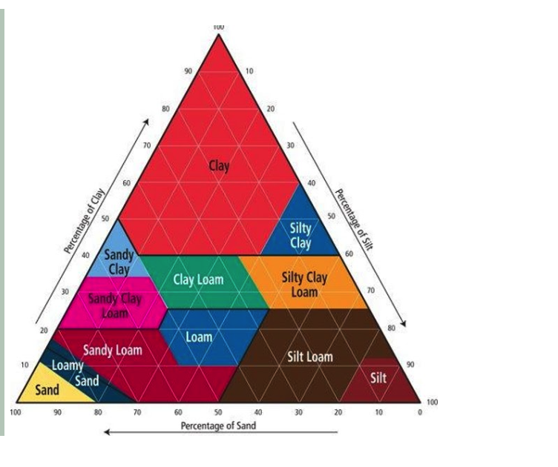

Climate

The microclimate of this part of Fife and particularly Anstruther is that the soil can get very dry and there can be weeks without much rain either.

The aspect is very great for all day sun and there is not a huge amount of wind thanks to the relatively sheltered site.

Design Quest

- To make the site as productive as possible and streamline effort needed to maintain it.
- Fix up some structural issues, the wall is falling down at the front
- Provide spaces for children to play?
- Have wildlife awareness built in
- Make it look good
- Enrich the dry soil
- Make sure that the crops don’t get wasted
- Save some seeds
- Plant things that are easy for children to get involved in

Evaluation
Client name: Anstruther Primary School
Address: St Andrews Road Anstruther
Property size: ½ size allotment
Number of people on site (typical/average): Classes of up to 30 once or twice a month, other than that one or two volunteers
Groups that use the site: Primary School - East Neuk Centre also get some of the produce.
Physical challenges that need to be considered (blind, wheelchairs etc): small children access, having enough space.
Occupations & skills: Teachers, volunteers, children
Lifestyle/ethos of group: Volunteers
Eating habits: They use the crops for their harvest and the East Neuk Trusts Community Fridge will use anything extra we have
Age ranges: 5 to 12
Numbers of Children that visit at any one time Between 8 and 20

Financial situation (vis-a-vis the design): Modest - all the seed requirements rely on donations by the people involved. Funding may be available down the line.
On site resources: Water, Shelter, Tools, Compost
Site tenure (owned freehold, leasehold, rented): Rented allotment annual renewal.
Restrictions on land use (tenancy agreements, covenants etc). There is an expectation of taking reasonable care and keeping it fairly tidy as it is part of the Beautiful Fife Awards entries, it is an organic site.
Potential catastrophes (vandalism, flooding etc): It is a secure site with a few people looking over it. Flooding is not really a risk as drainage is high. There has been some wind damage but it didn’t affect our site
Plans and drawings: A map made through growveg.com
Goals: Good community engagement through the school
Privacy (views, difficult neighbours, respecting other people’s privacy
where site is overlooking others) It is fairly private from the main roads
Priorities for the site: Education plus food production, getting to zero waste in terms of crops. Some wild spaces factored in for pollinators and birds etc
Water general - Mains Tap on Site, have water butts that will save mre
Soils - Tend towards sandy
Erosion- The dry soil means it can wash away nutrients easily.
Aspect - North South Aspect

PASTE ANALYSIS

PASTE ANALYSIS

Plants

There are many plants including perennials already onsite. See the map for position

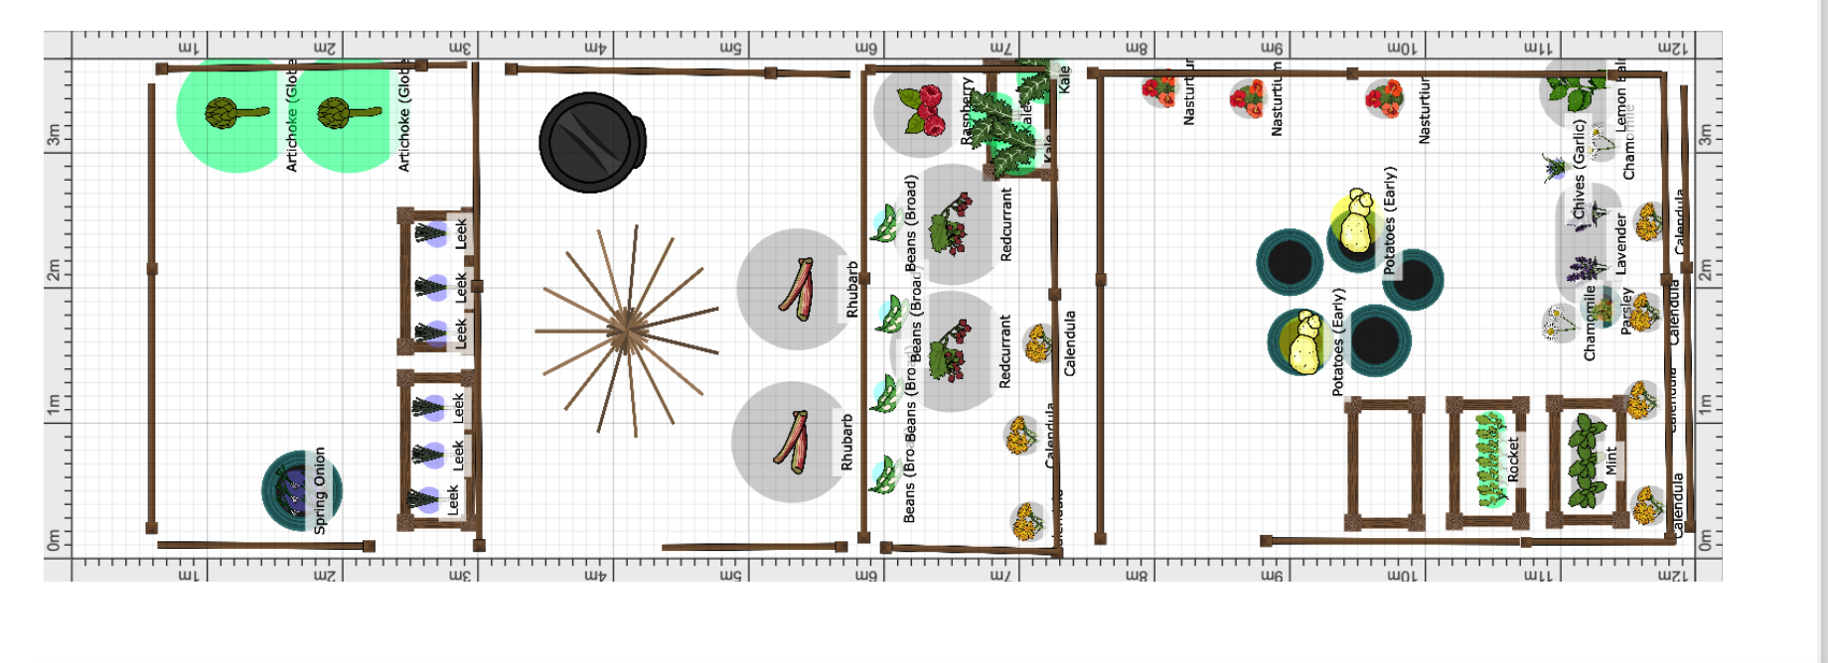

DAFOR

Dominant/abundant/frequent/occasional/rare

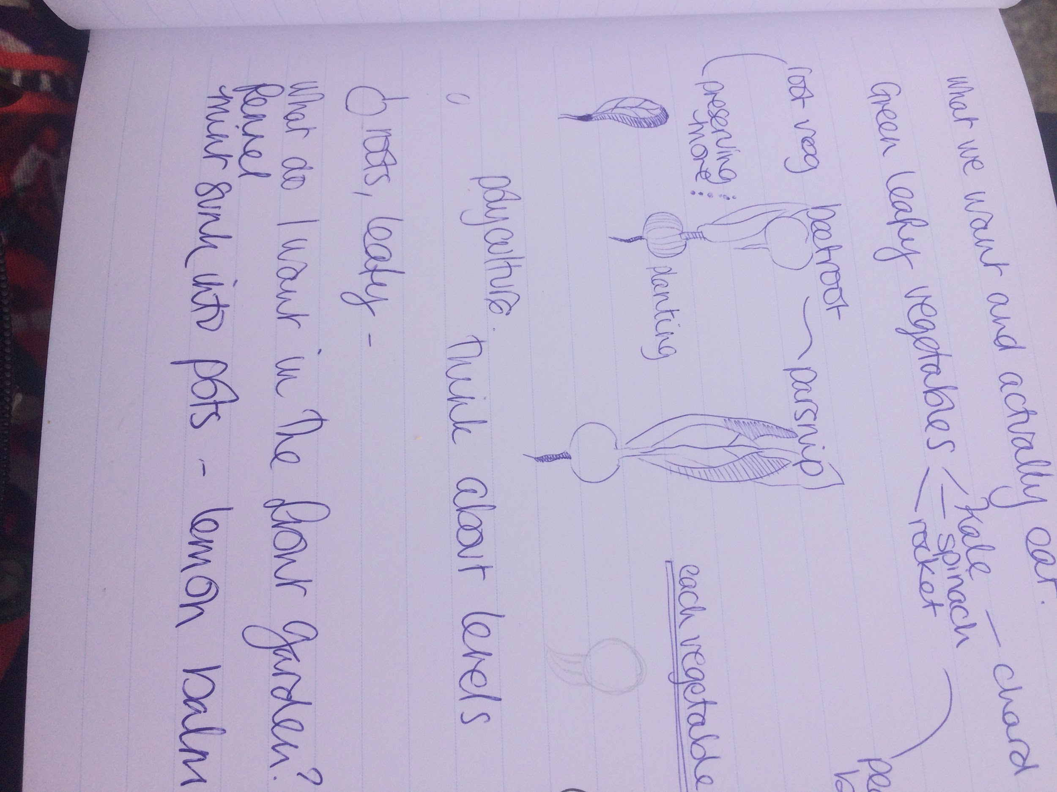
Dominant | Creeping Buttercup  Couch Grass
Abundant | Dock  Rocket  Kale self seeded  Rhubarb
Frequent: | Raspberry  Nettle  Groundsel
Occasional: | Shepherds purse  Prickly milk thistle
Rare: | Mares Tale

Animals

- Some wild rabbits
- Many wild birds pigeons love the brassicas
- Molehills
- Mice and voles noticed on site
- Some dogs
- Rats

Structures:

Nearby that we can use:

- There is a large summer house - shared which has been used for lessons in the past
- Three Shared Sheds with tools
- Large Compost Bins
- Wheelbarrow “station”
- Polytunnels x 2 The School Has one small site they can use to start things off and continual growing.
- Taps on site ( only one can be used at a time as low pressure. ) In dry weather there is a shortage. We are planning on water collection sites soon.

Tools

We have access to general garden tools that are onsite including wheelbarrows, spades, forks etc.

Events

We are planning to have school visits in term twice a month waiting to make plans now. They generally come for one hour or so with at least two staff.

We will do a range of activities:

- Wildlife education
- Gardening
- Sensory Awareness
- Nature Connection
- Harvesting
- Tasting

Resources

Time

- Tend to visit the site daily at the moment because our allotment is there.
- Have allowed for two hours per week to do work on site.
- Any school dates will need at least two hours for setting up and clean up
- Will give time for lesson planning and communicating with the school max one hour per week

Money

- There is no money for the allotment site but Carl and Nuala who have taken care of it in preceding years tend to donate seeds and seedlings.
- Funding could be something to look into for the future too.

Physical resources

- Seaweed for enriching soil
- Manure
- Freshly rotted compost on site
- Seed donations
- Seedling Donations
- Old Building Materials
- 2 communal polytunnels nearby, the school has a seedbed
- Shared shed with all tools
- Shared summer house

Plants & Seeds Carl already has

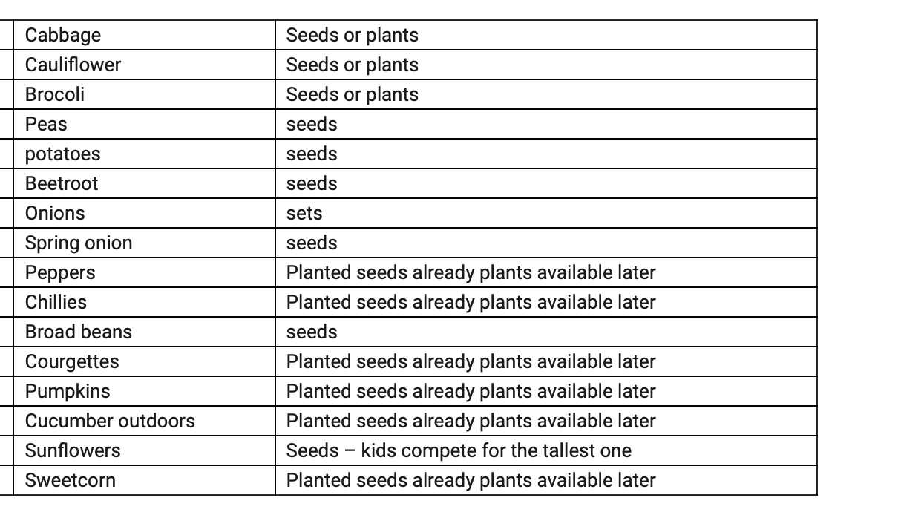
Plus we have:

- Runner Beans
- French Beans
- Herbs
- Radish
- Flowers - cornflowers, sunflowers, nasturtium
- Broad beans
- Cabbage
- Potatoes
- Courgette
- Rocket

Principles

Make the least change for the greatest possible effect

This is a big one for this site as there is a question as to whether the school plot will move when new allotment sites are developed. It could happen quickly or take a long time but nevertheless with everything it made sense to look at this plot and just work around the structures that already existed. I think the plan looks set to be successful and it simply drew on the work that had been put in previously and the seedlings/ plants and seeds that we had among us.

The yield of a system of theoretically unlimited

The design is made to be straightforward yet diverse. The planting of perennial plants and flowers that appeal to senses as well as being beneficial to pollinators, birds and relatively low maintenance means that a good section is taken up by things that add a lot.

Work with nature not against.

Thinking of working with the nature of children making spaces that they could easily walk around and sit in is important as well as working with plants that were either nice looking or easy to plant, harvest and handle was important.

Ethics

Earth Care
- Focusing on rebuilding the soil naturally.
- The design will make sure that many plants are there for wildlife purposes.
- Organic design

Fair Share
- Excess produce will go to community fridge
- Access to allotment for school children means everyone can have the same experience

People Care
- Looking at seating means its more enjoyable
- Having good walkways and appealing colours and nooks mean it satisfies many needs
- Getting kids into a garden is great for wellbeing.

Design Proposal

- Make it look appealing, children often only have an hour there and things need to grab attention
- Appeal to senses, sight, smell, touch, taste
- The site must be accessible for people to wander around
- Have things that are not too delicate
- Things that can be picked
- More seating
- Easy grow things as everything is voluntary timewise so it should be relatively low maintenance

Design By Limiting Factors

Walkways

Need walkways so we will look at access points and make sure all crops are reachable for planting and harvesting then fill in all gaps with woodchip.

We will make sure each bed is clearly defined and has a wood chip path and is edged by red brick.

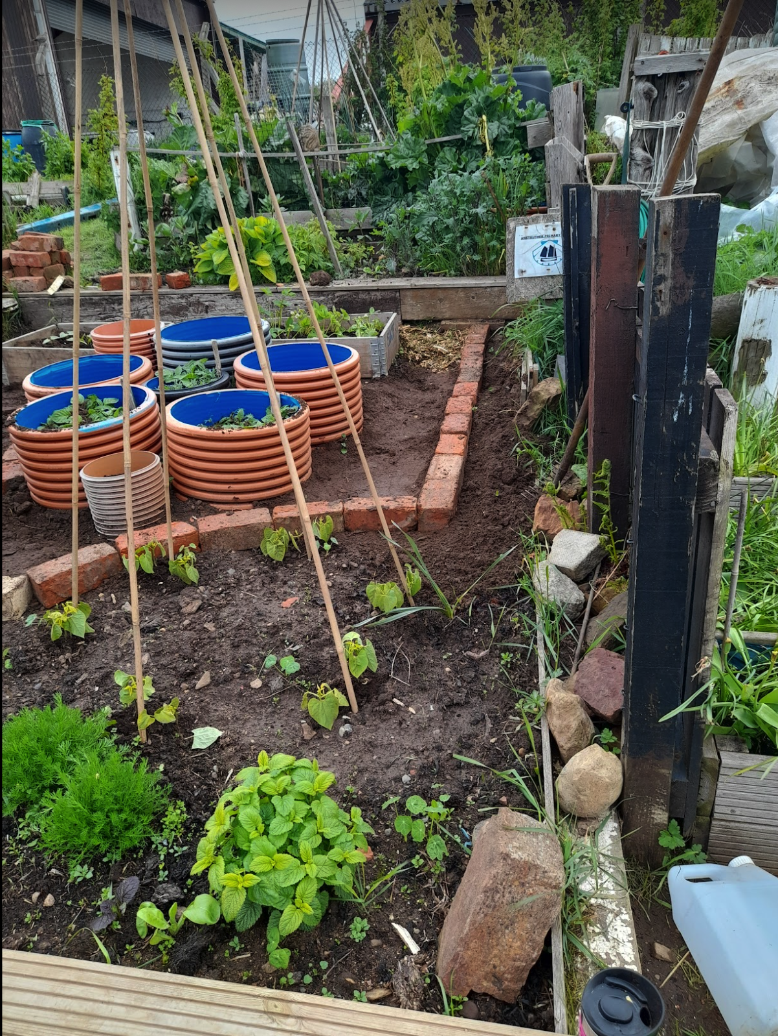

Seating Areas

There has been a funding application for more seating. We submitted an application for improvements at £500 from a local organisation The Murray Library Trust at the start of July. We just got word that we received £250 which will go towards a bench and table.

In the meantime we have designed the front beds to have built in seating along the edges of the retaining walls.

There are also areas by the summer house for seating with tables and indoor chairs and tables in the Summer House.

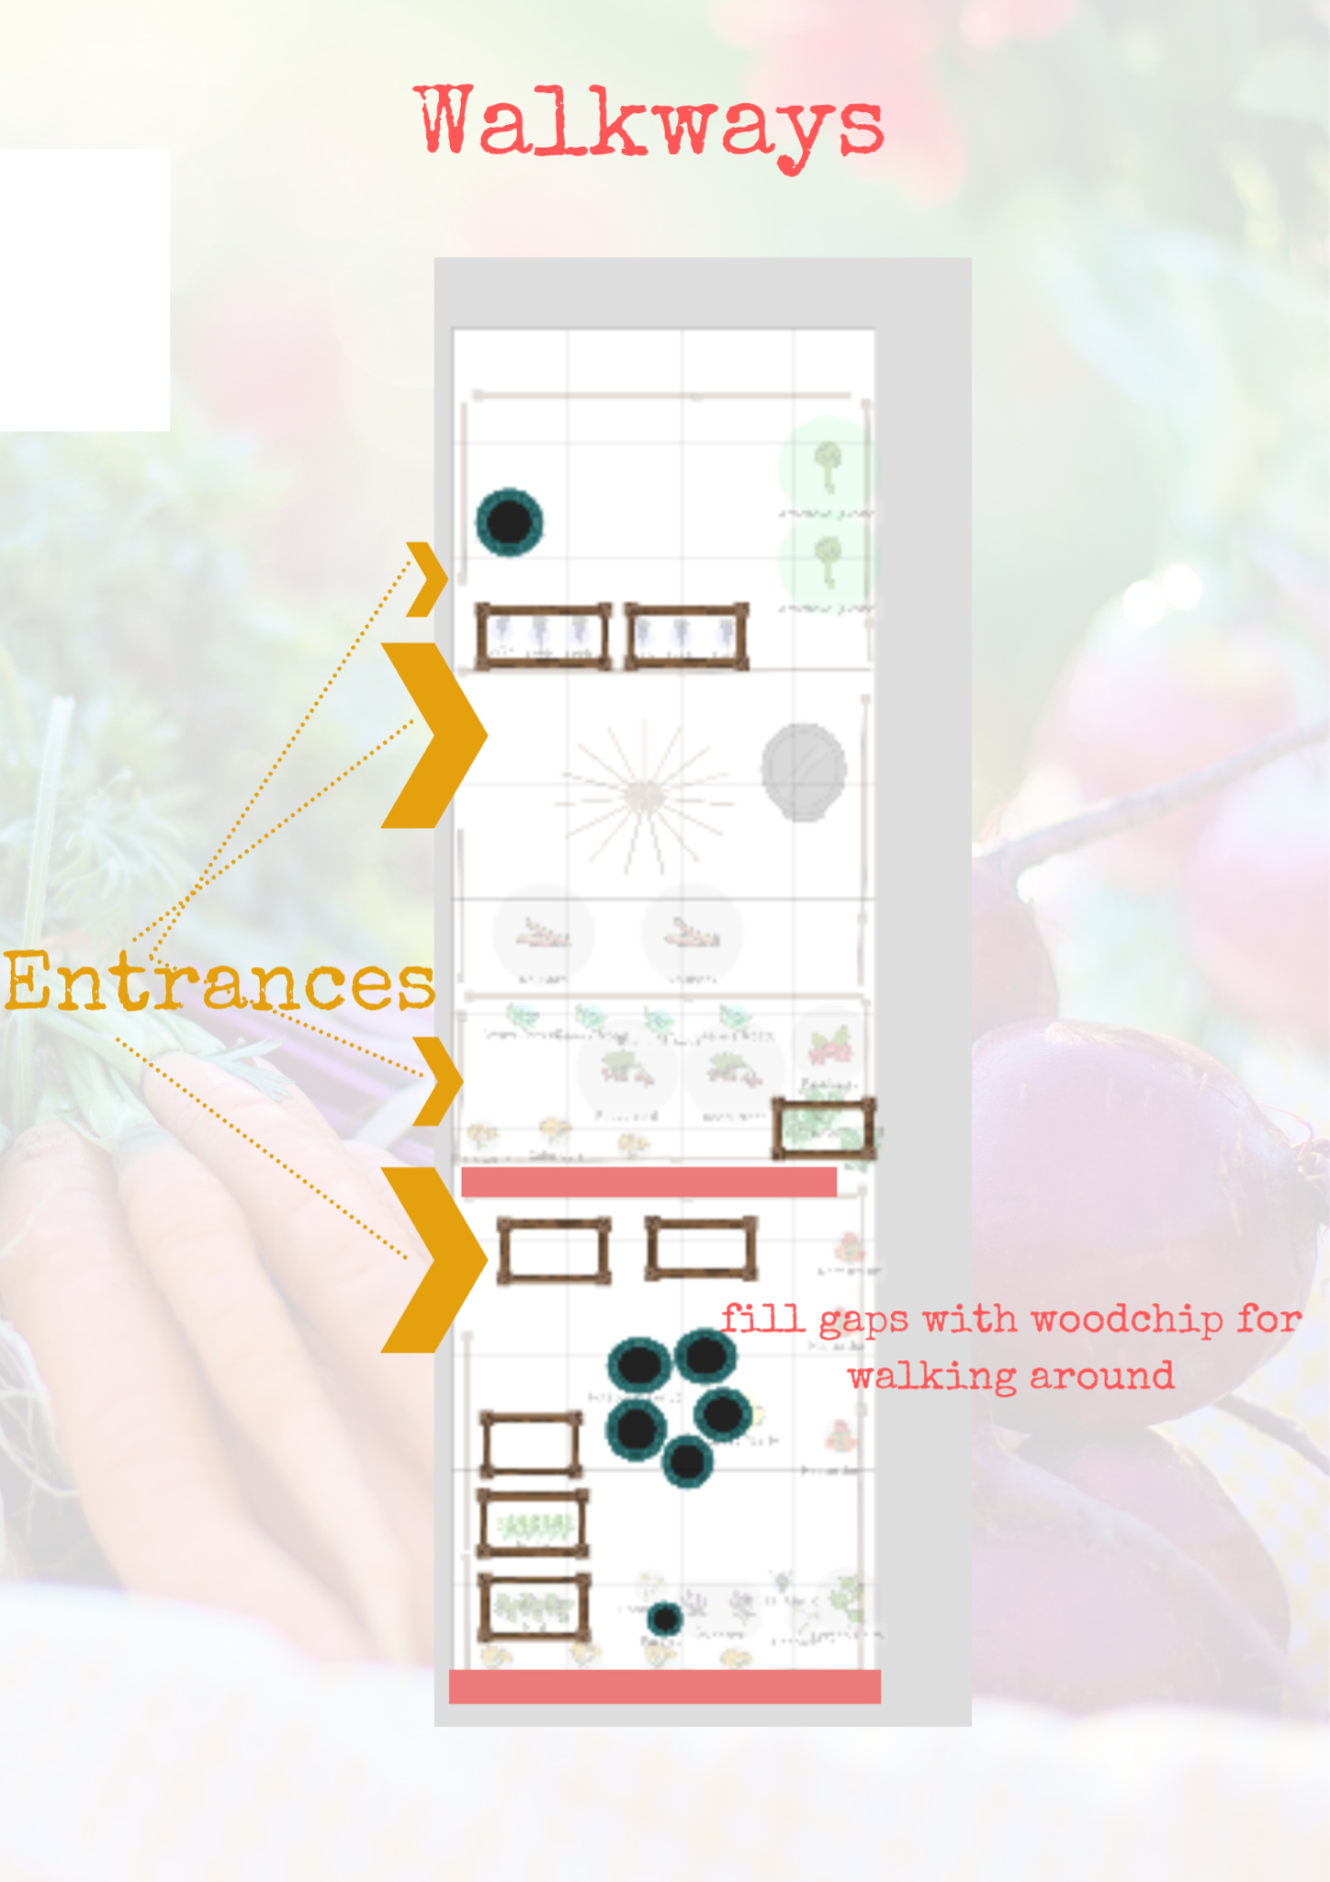

Planting Plan
Working around what is there again, and the needs of the design here is a general guide I have worked out with the limiting factors.
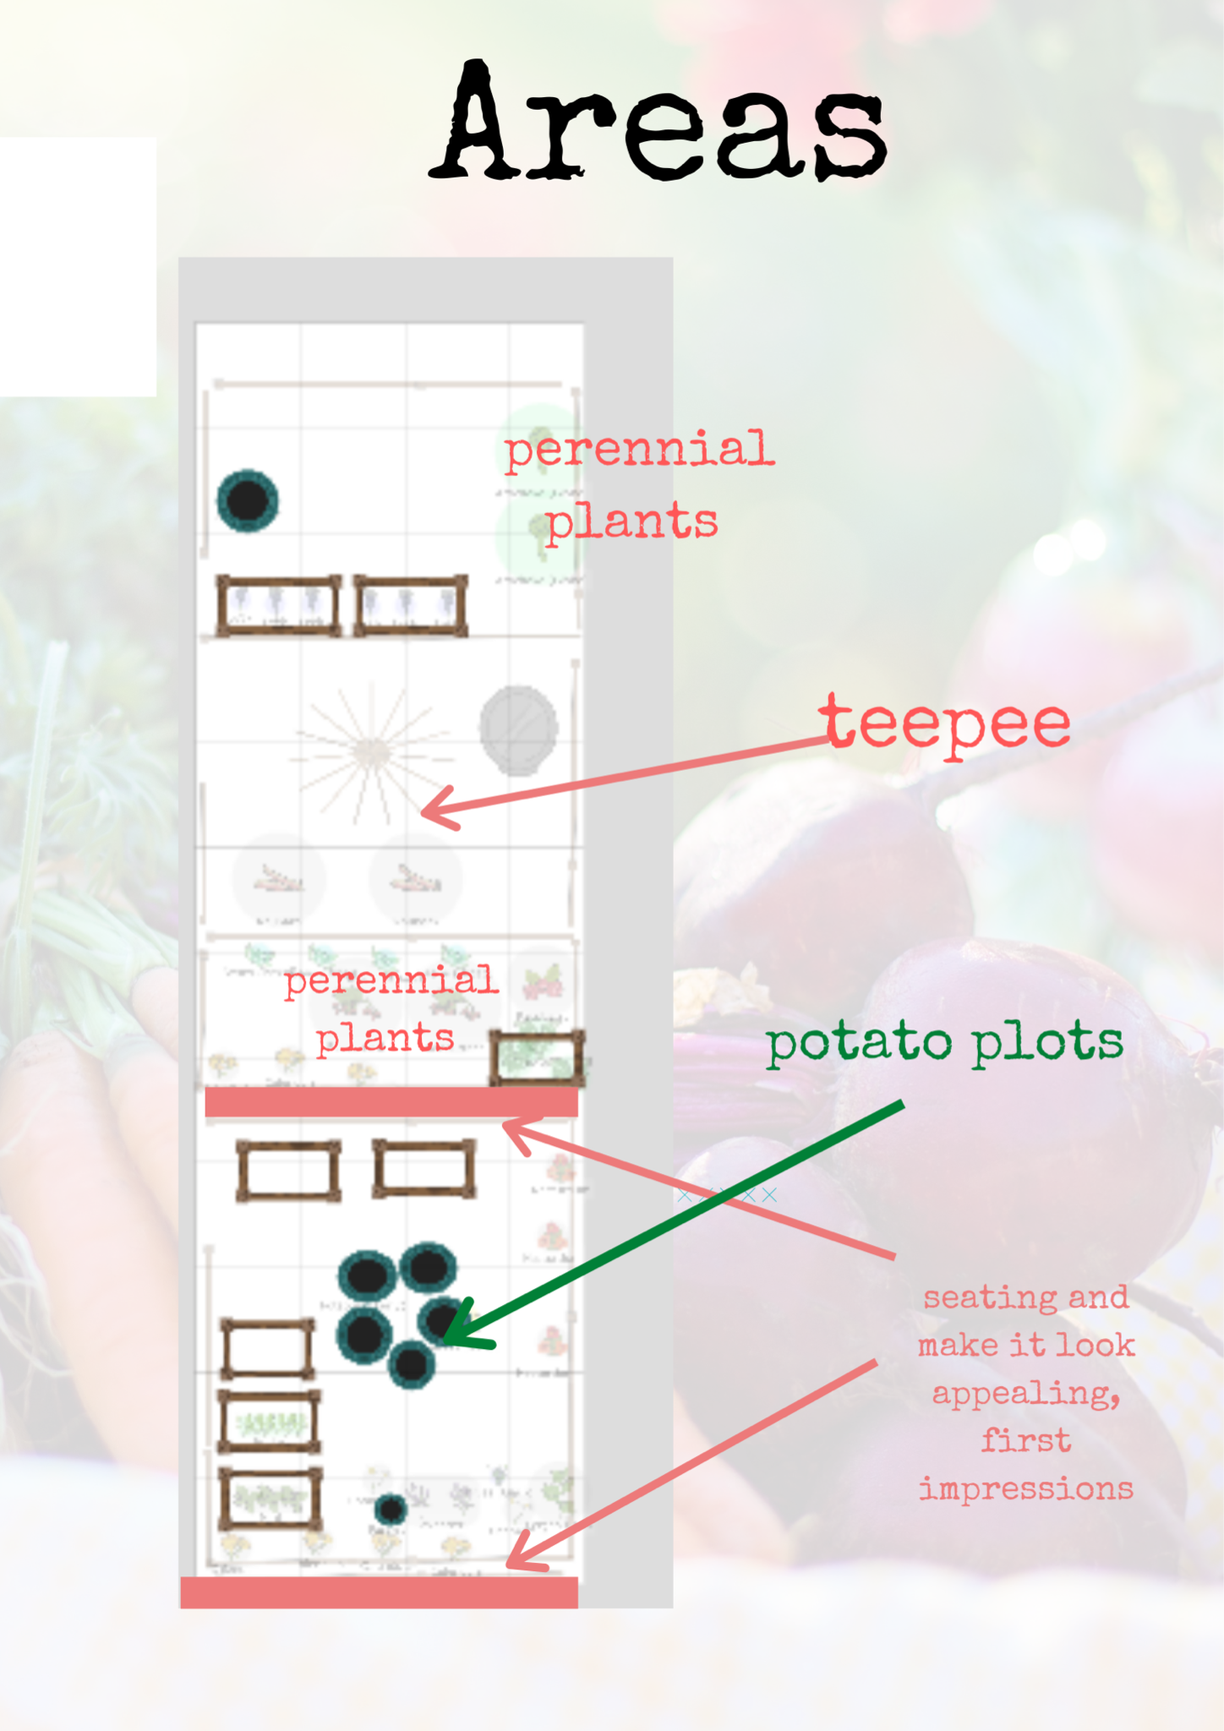
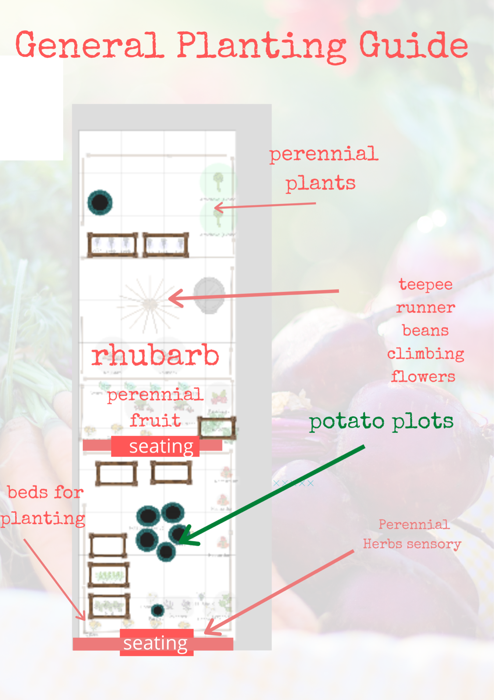

These are the basic structure of what can be planted here in basic areas so looking at the list of what we have it’s just about fitting it in.

Time and Money

As a limiting factor it makes sense to just go with what we have and plant in everything already allocated to the School Allotment.

We will use our own excess seeds and ask everyone at the allotment to donate anything extra. ( There are always extra seedlings hanging about )

The plan
Is as follows close ups of each section

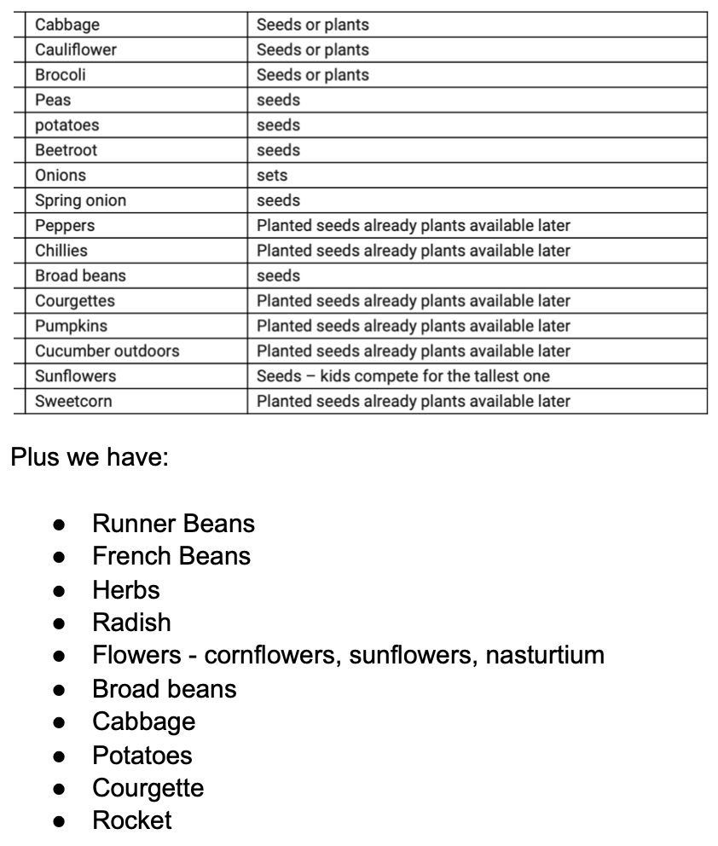
Chillies won’t be planted outside but here is a reminder of our plants.

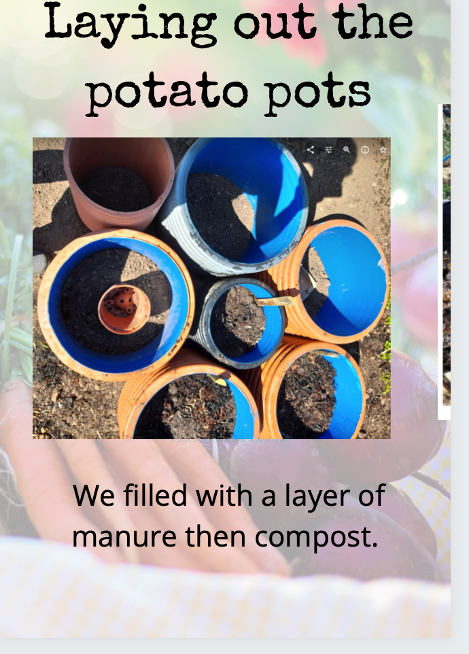
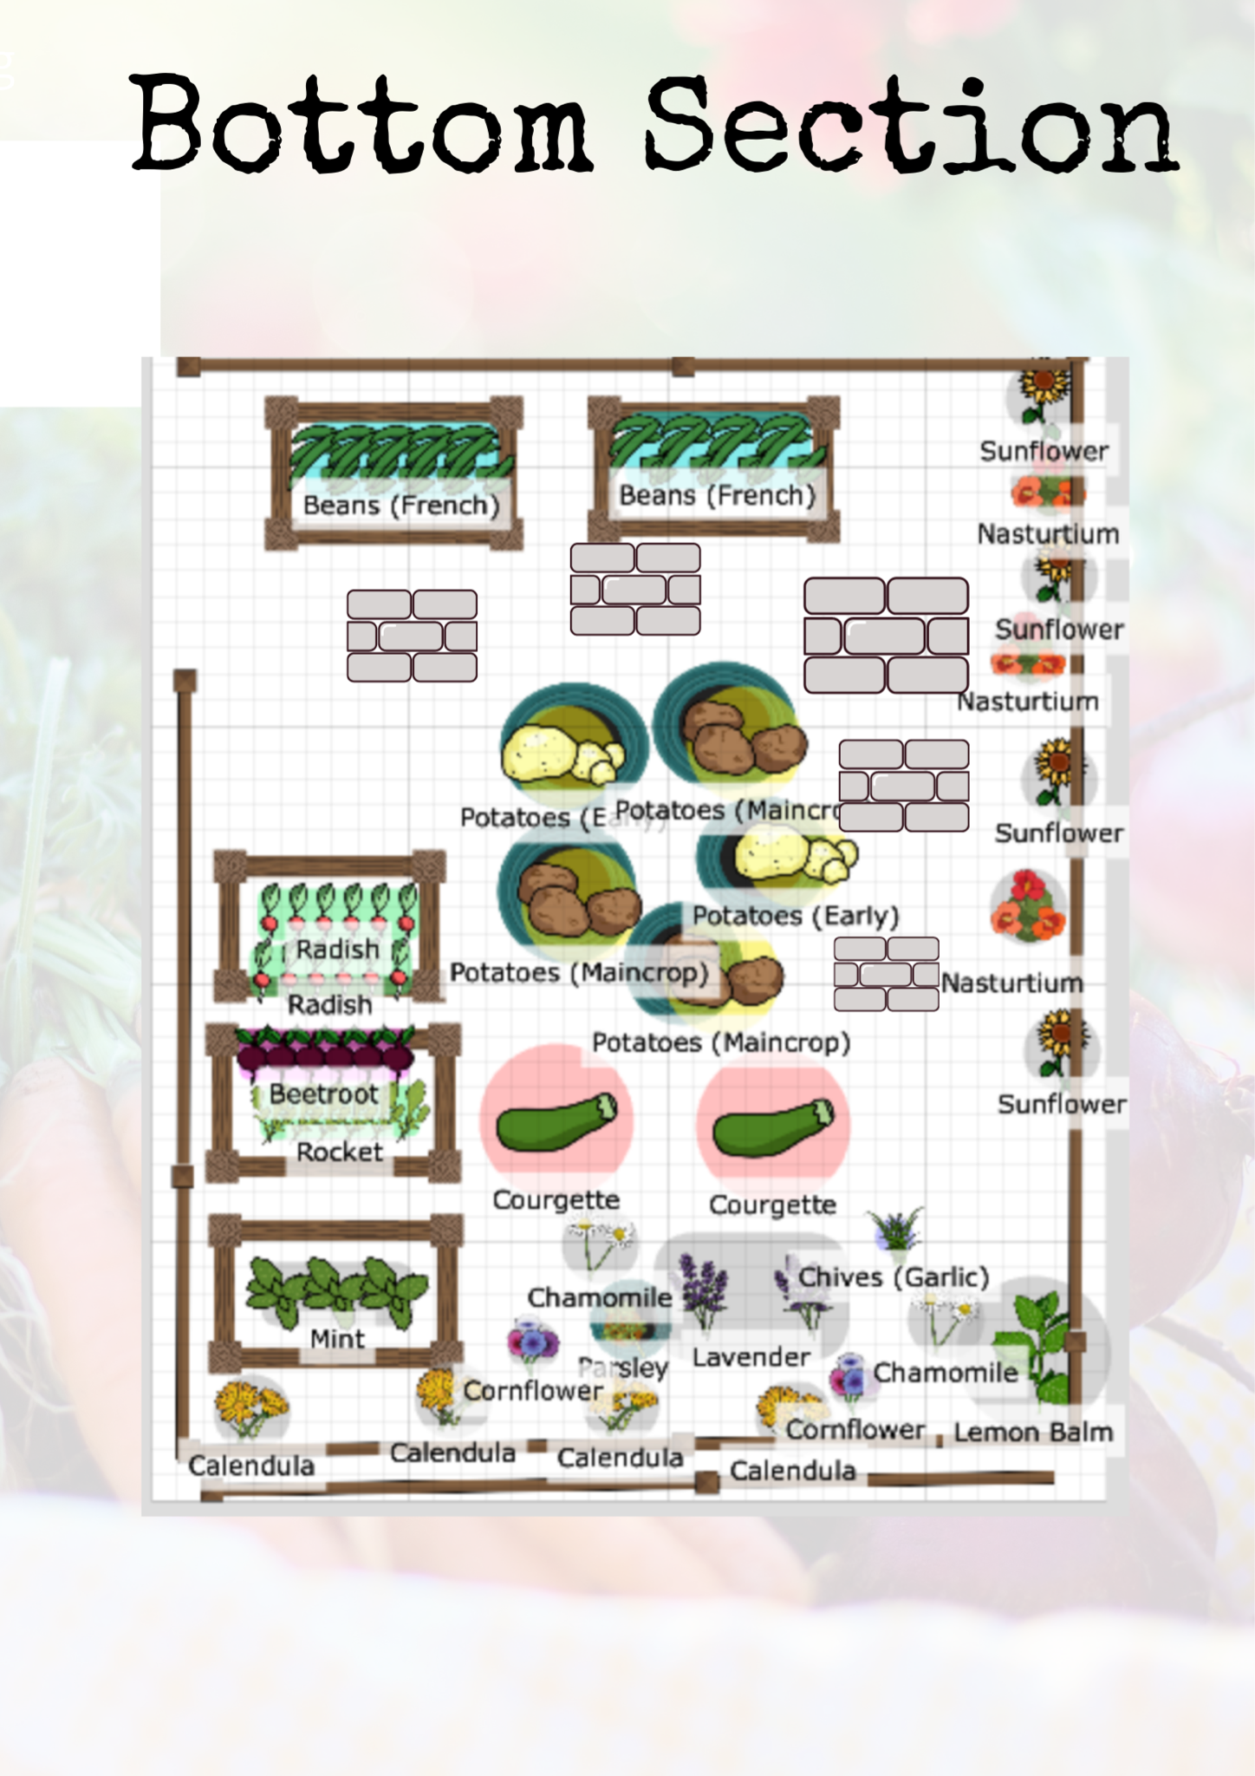
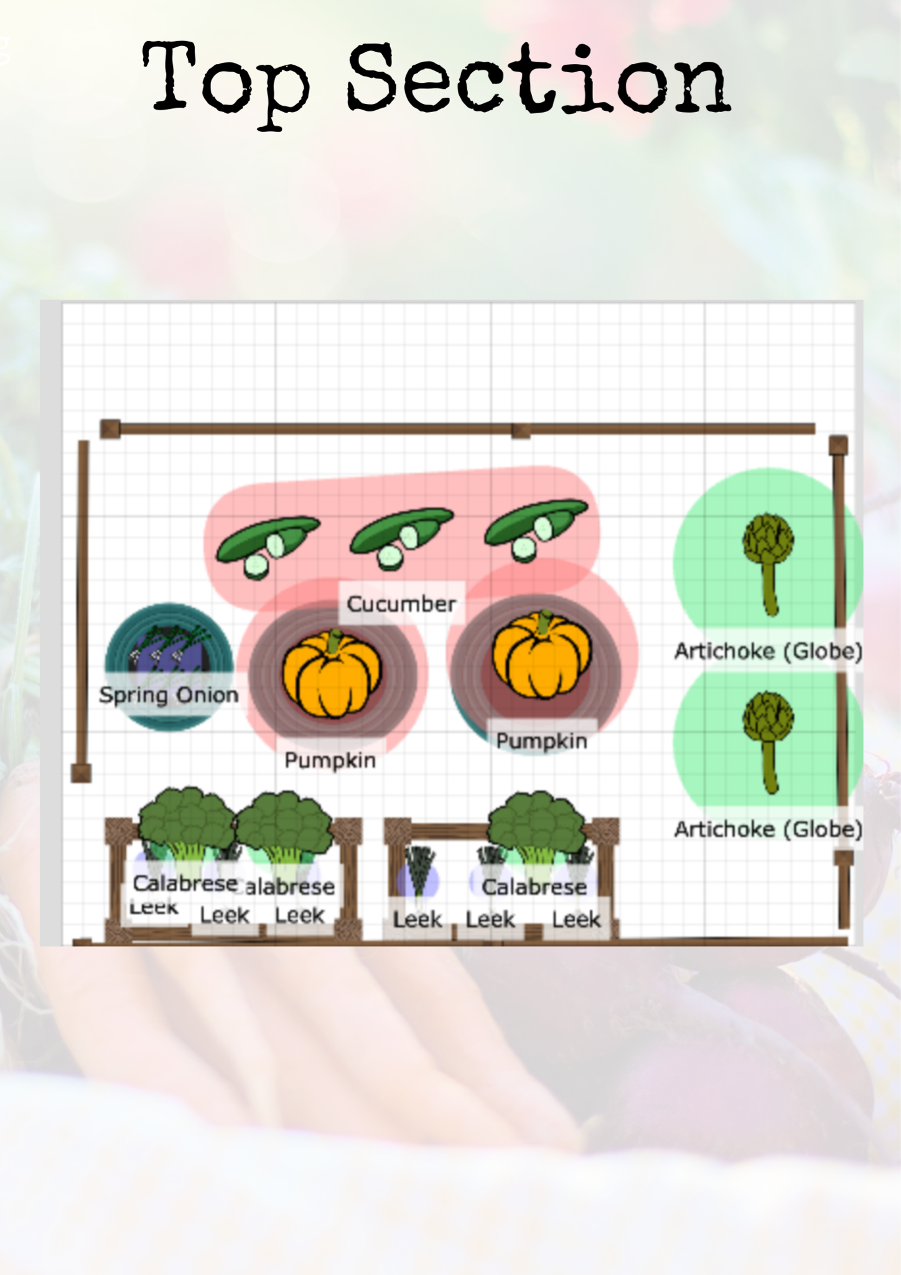

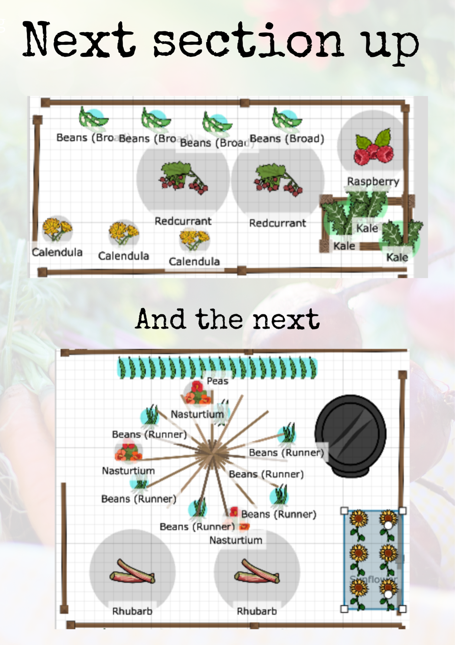

Implementing the planting plan

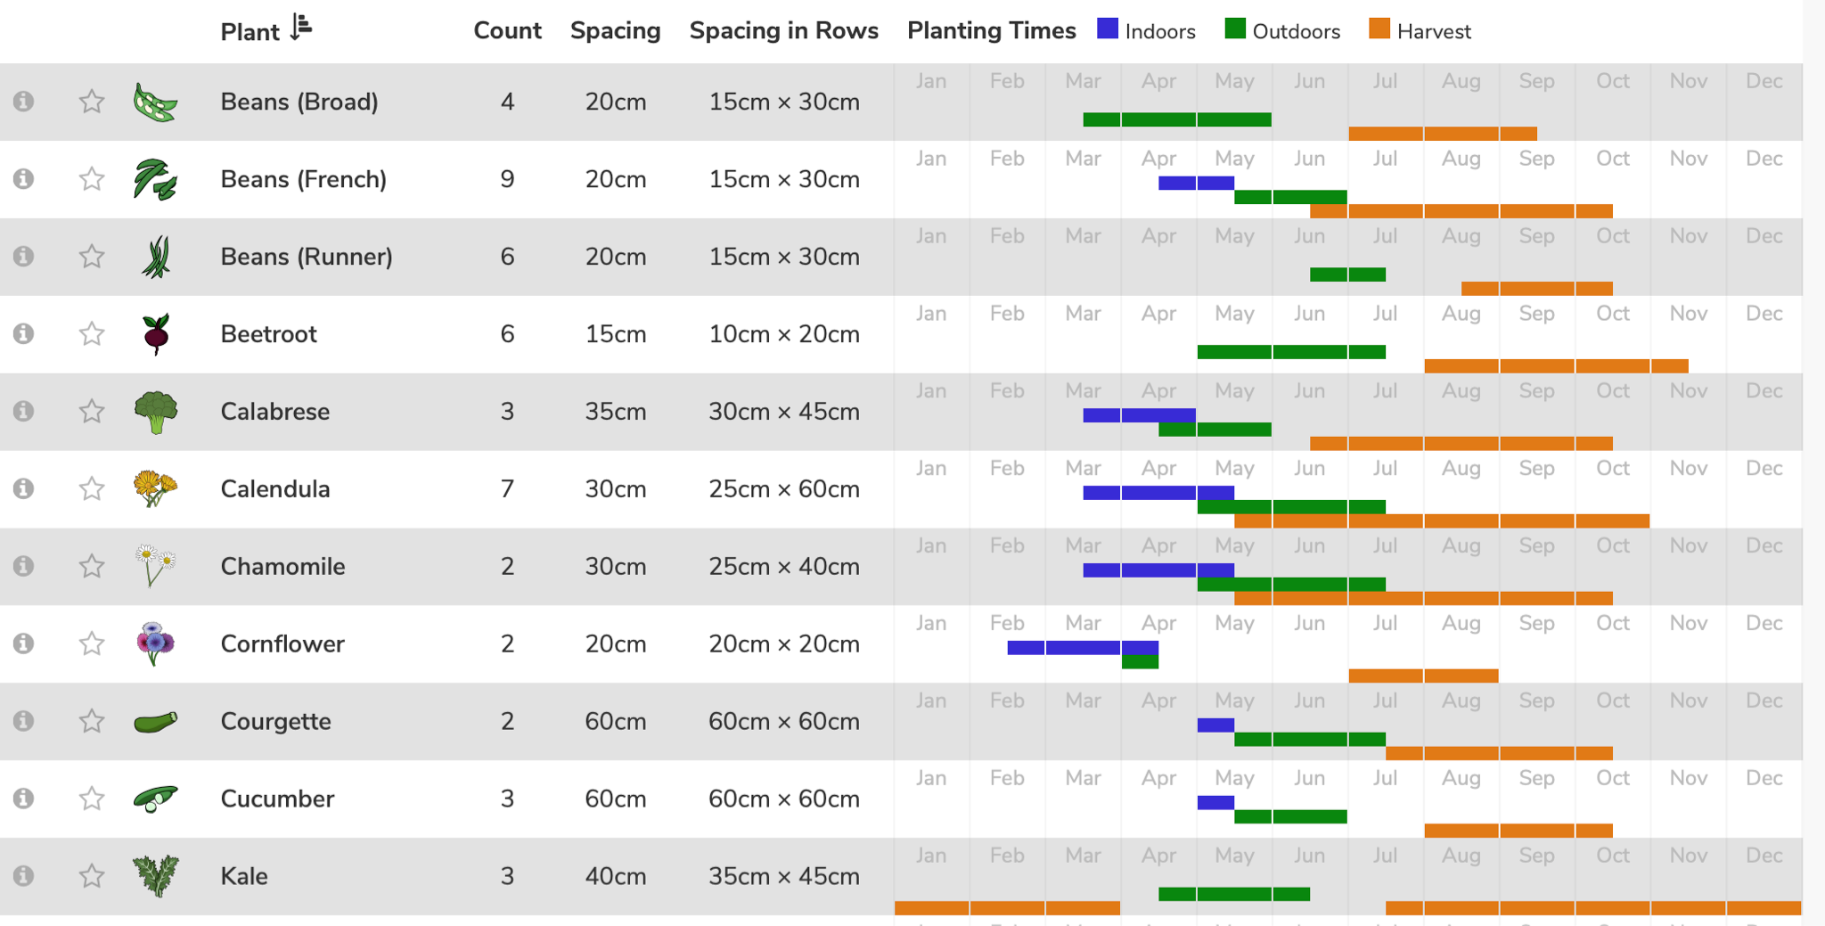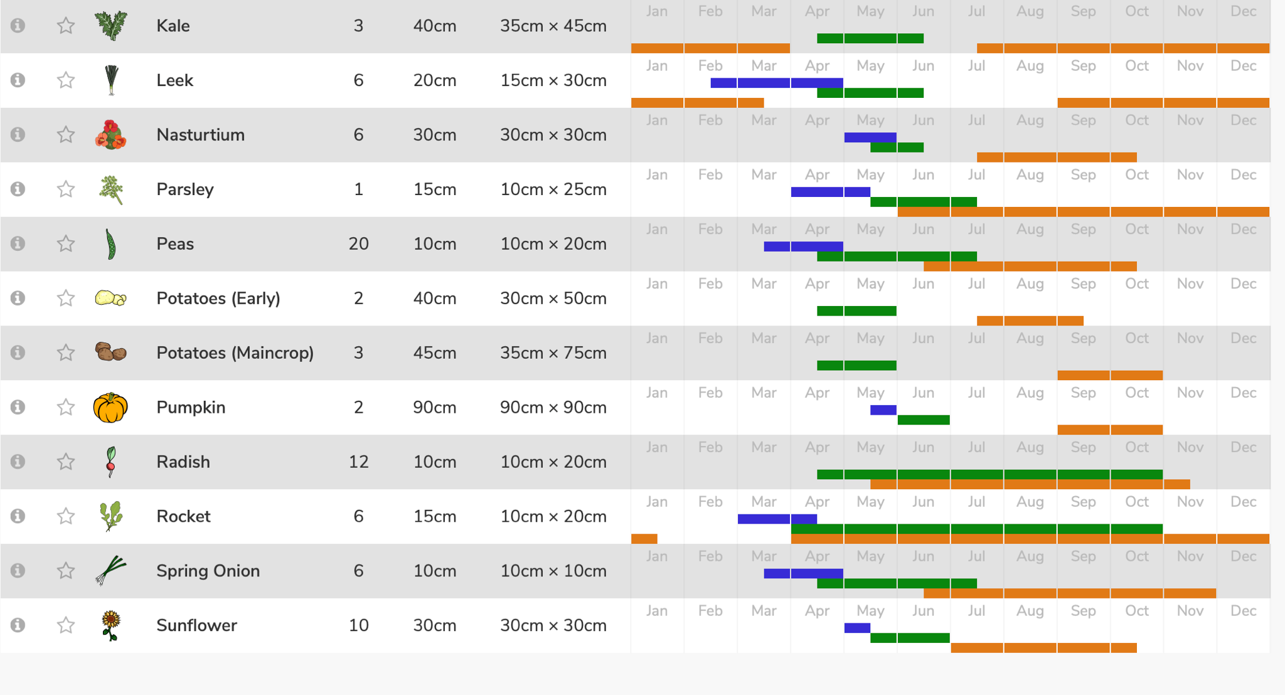

Implementing rebuilding the front wall

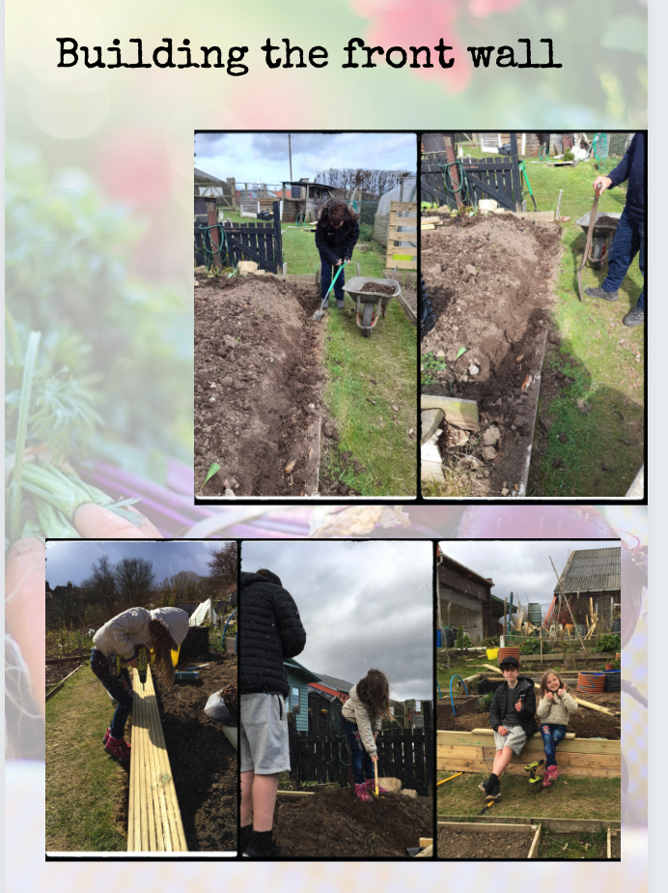

Implementing richer soil
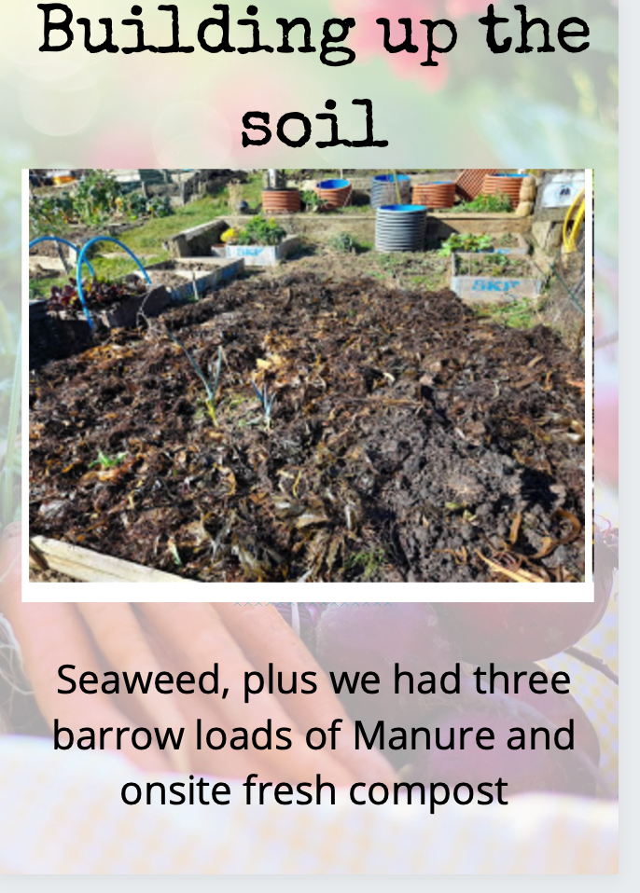

Maintenance over time

Three sessions of work per week varying between half an hour to two hours minimum, this will not always be done with the children. Much of the maintenance can be done and needs to be done without the children.

Review how things went, evaluate learning and production.

Maintain communication with School - aim for a visit a fortnight with the school.

During summer or holidays make sure volunteers take over care

Review planting at the end of year to change next year.

Web of Connections on Site

It is important that the site maintains a community ethos and analysing the interactions it was really interesting to look at the connections.

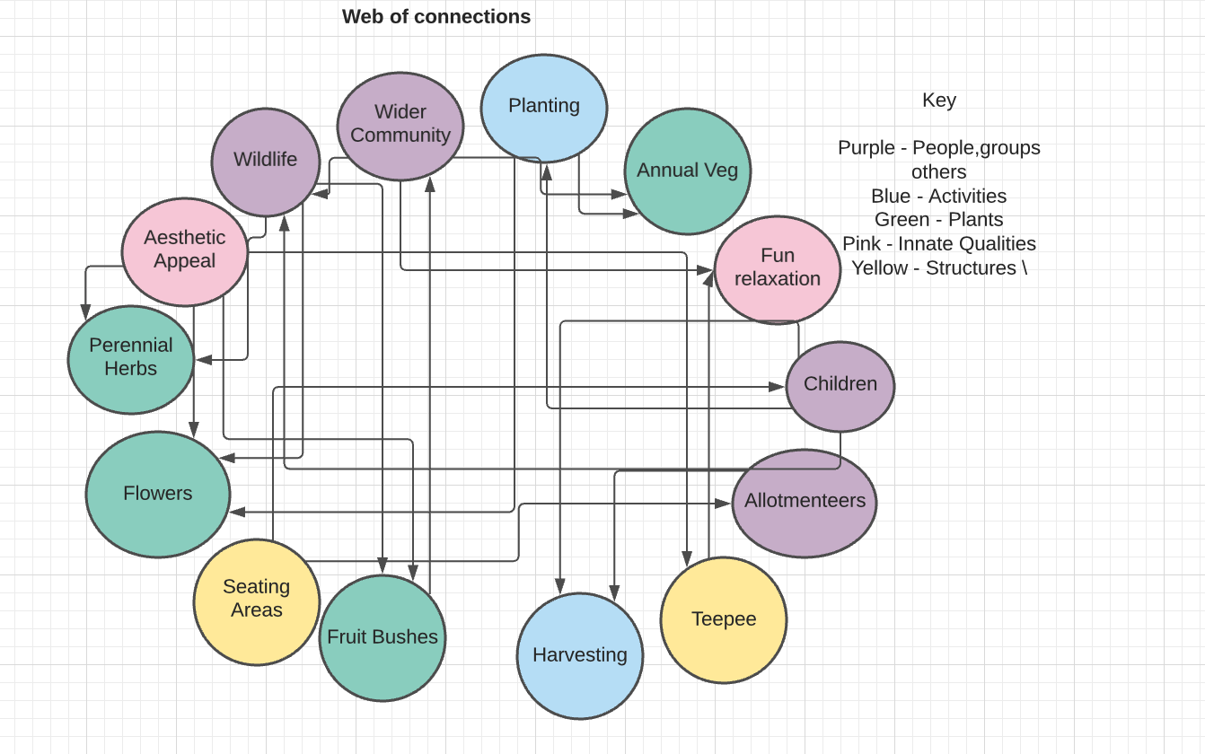

Evaluation
Looking at the original Design Quest

To make the site as productive as possible and streamline effort needed to maintain it.

We have come up with a simple planting plan that is straightforward and uses the resources we already have.

Fix up some structural issues, the wall is falling down at the front

We fixed the wall and also made it a seat which increases the possible use, thereby stacking functions.

Provide spaces for children

Through the bean arch and the seating area the spaces are diverse.

There are also clear pathways throughout.

Have wildlife awareness built in

This has been a consideration throughout. We have spaces for flowers and pollinators as well as a no chemical policy. There are also plans for a bug house.

Make it look good

Fixing up the front wall has made it look much better already. Planting herbs and flowers will keep it looking fresh, interesting and inviting through time.

Enrich the dry soil

Keeping the soil mulched and using seaweed and manure as well as continuing to build up compost is definitely helping.
There will also be green manure planted at the end of the season which will help restore what has been lost.

Make sure that the crops don’t get wasted
This has been a big one in the past as the children are off school for summer holidays just as a lot of the veg needs to be harvested.

Donating excess to the Community Fridge who can take fresh veg immediately combats that.

Save some seed

At the end of the growing season it is important to leave a few plants in, including legumes and brassicas so that we can harvest and make a stock of our own seeds

Plant things that are easy for children to get involved in

This has also been a consideration through the planning. If the seeds are fiddly then we simply grow seedlings for them to help with transplanting.

Reevaluation

To be done at the end of the growing season.

Reflection

This design process worked really well for the purposes of creating a quick workable plan to improve and maintain the School Allotment. I liked using a different framework and may have missed a couple of pieces but regardless it created a flow that will be very helpful as we step into a busy season.

It was really good to outline time commitments and using onsite resources and those we already had because one of the main things it needs to be is running in a fairly low maintenance way as we have limited help at the moment.

It is showing that the next stages are going to be productive and attractive so it will be a recharging, stimulating and informative place to learn.

Evaluation

A few follow up photos from later in the season

