Fife Gingerbread Plot at Kelty Earls Row

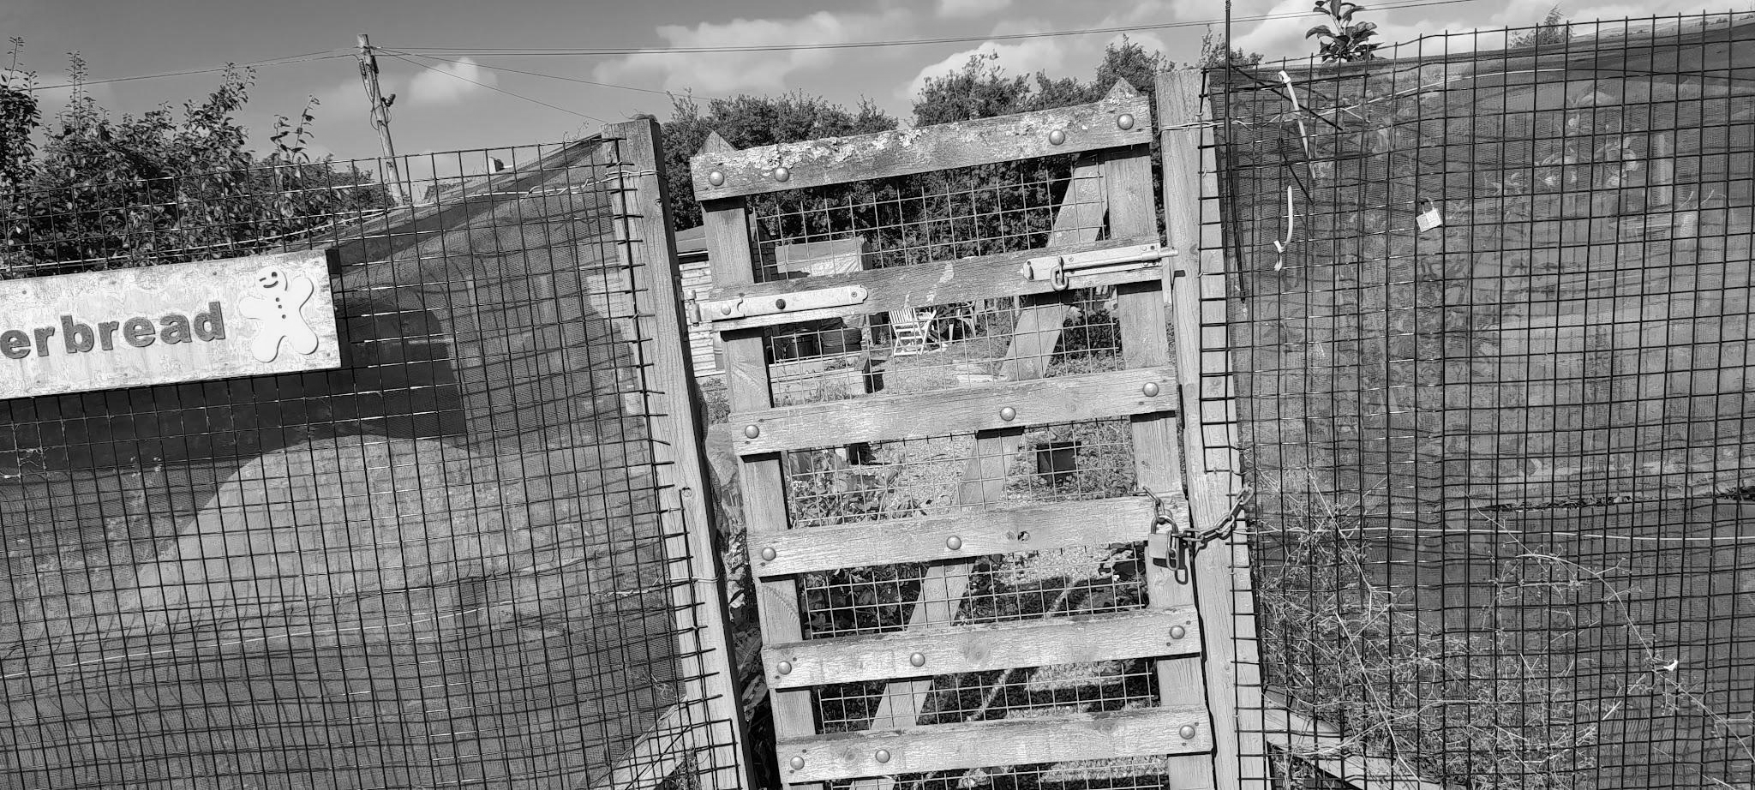

SURVEY 2
Client Needs and Background 2
The Client is Fife Gingerbread 2
About the Location - Kelty Fife 3
Distance from home 3
Design brief. 4
Full Details 4
What we have: 5
Physical Resources: 5
Other resources 5
Goals: 6
Needs: 6
Possible range of activities 6
Base Maps 7
Weeds on site 8
Soil and Fertility 9
Climate 9
Initial draft thoughts/ideas 10
Ideas basket 11
Analyse 11
Limiting factors 11
DESIGN 12
IMPLEMENTATION 13
Next Steps 14
To do over the next few weeks. 14

Design process: SADI

Design brief: To bring the allotment back into good repair and to enable the local community to collaborate and grow together.
Start date: 1st September 2021
End date: 5th January 2022

SURVEY

Client Needs and Background

The Client is Fife Gingerbread

Fife Gingerbread is a voluntary sector organisation that provides information, advice and support to lone parents and families in need all over Fife. The head office is based in Glenrothes and the Allotment itself was in Kelty.

I saw the job advertised on Goodmoves and was interested in the aims and project, particularly the aspect of designing an outdoors community space. The fact that it was an hour's drive from my house was initally a limit but when I applied for the job I was offered full pay for travel and compensation. I also went to visit the site and it piqued my interest. It seemed like a fantastic project so I then agreed to get involved on a sessional basis.

About the Location - Kelty Fife

“Kelty is a former coal mining village located in Fife, Scotland. Lying in the heart of the old mining heartlands of Fife, it is situated on the Fife/Kinross-shire boundary and has a population of around 6,000 residents.”
( sourced from Wikipedia 25/12/21 )

Distance from home

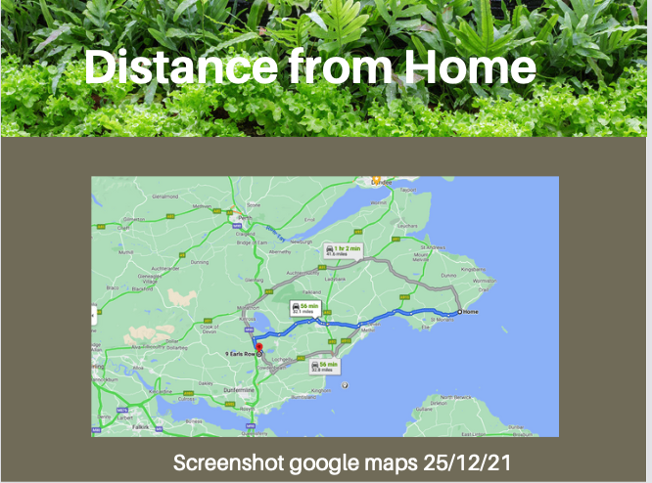

Design brief.

Create an easily maintainable, attractive and stimulating space that can be used by people of all ages and interests.

Site overview

- This had been a well attended, well maintained site until a little while before lockdown.
- It became difficult to meet for over a year and several things have fallen into disrepair.
- The site is large and is made up of two allotments put together one of which is unmaintained and new to fife Gingerbread.
- The general layout is clear there are 8 raised beds, one of which is strong and has been maintained well, it had previously been a sandpit.
- A few of the raised beds on the right hand side of the plot as you go in are broken down, there is a lot of grass there and this could be easily cut back and cleared.

Full Details
Address: Earls Row Kelty
Property size: 2 full allotments at a total of 20.11m x 22.5m
Number of people on site (typical/average): 2 - 10.
Groups that use the site: Support workers with families.
Physical challenges that need to be considered: Small children access the site. Needs to be made safe with no tripping hazards, exposed nails or toxic plants.
Having micro spaces so that people can have relative privacy if needed.
Clients who use the site. Teenage parents, families and support workers
Financial situation (vis-a-vis the design): £1000 to get things going, We may be eligible for getting free plants, donations etc too.
On site resources: Water, Shelter, Tools, Compost
Site tenure (owned freehold, leasehold, rented): Rented allotment annual renewal.
Aspect - Nearly South facing ! Good all day sun.

What we have:

Physical Resources:

Budget: £1000

On site there are many physical resources some of which need to be either discarded/recycled or mended.

- Tyres - Could be used for planting especially potatoes. Could be painted.
- Tables - need to be fixed up and repainted or thrown away.
- Wheelbarrows- two one of which is missing a wheel.
- Chairs - a couple could be salvaged and fixed up
- Shed - The roof is caving in but could be fixed with a plyboard and roofing felt. Someone could do it with time and a budget.
- Raised beds - many are still usable, some could be mended with wood to make them more defined.
- Spades, forks, strimmers etc.
- There is one Polytunnel which will need to be recovered and cleared out.
- Water - there is a water butt which needs to be reconnected once the shed is fixed.

Offsite we have:

- Storage chairs
- Petrol Strimmer ( Kath )
- Mud Kitchen
- Old Decking at Angelas

Other resources

Nearby:

- Kelty primary school
- The community centre
- The nature reserve lies outside and there are several other allotments.
- Corporate Partners

Through discussion with:
- Support workers - who spoke to their clients.
- Manager
- Volunteers
- Community Council

We ascertained the following.

Goals:

- Provide a space for people to come and work with their clients.
- Produce edible crops.
- Have a space for education and healing.
- Volunteering opportunities.
- Have a maintenance plan.
- Fix up some structural issues, including shed, weedy paths and broken raised beds.
- Provide spaces for children to play.
- Have plants for other activities such as pumpkin carving, dye plants, tea making etc
- Have shelter for rain and sun.

Needs:

- Low maintenance
- Attractive
- Safe and accessible
- Interesting
- Shelter
- Activities
- Space for everyone to contribute and get involved

Possible range of activities

- Wildlife education
- Making cosmetics/ tea
- Gardening
- Just a place to be, an outdoor community centre.
- Cooking
- Sensory Awareness
- Nature Connection

Base Maps

This is an outline of the space as is now:

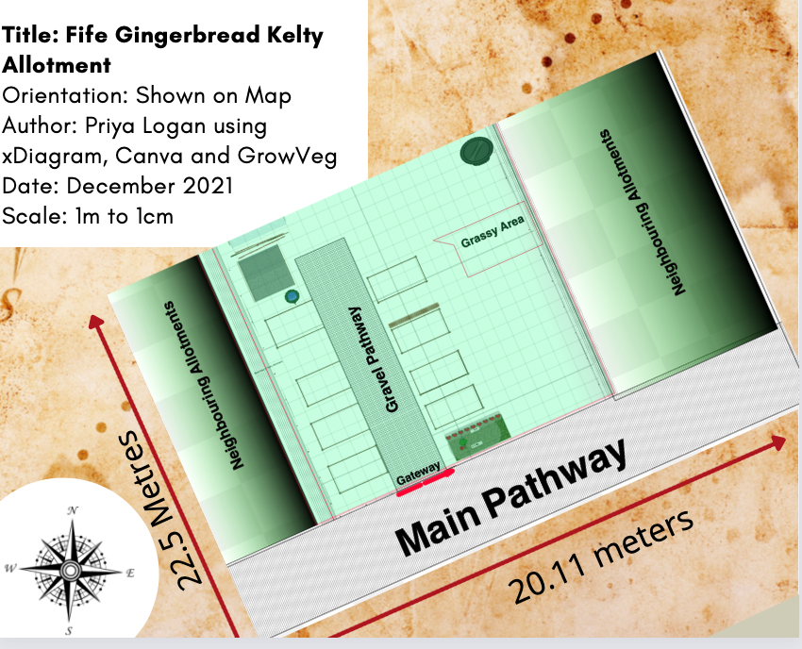

This is the sun path of the site which shows it gets good sun.

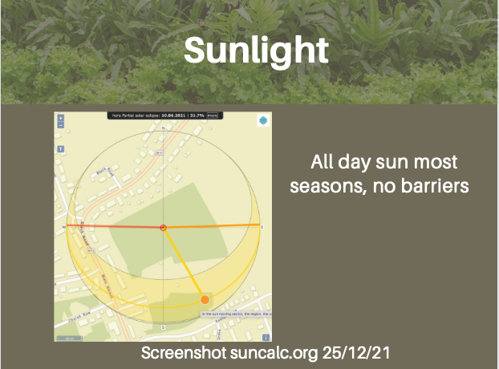

Weeds on site
Dominant/abundant/frequent/occasional/rare

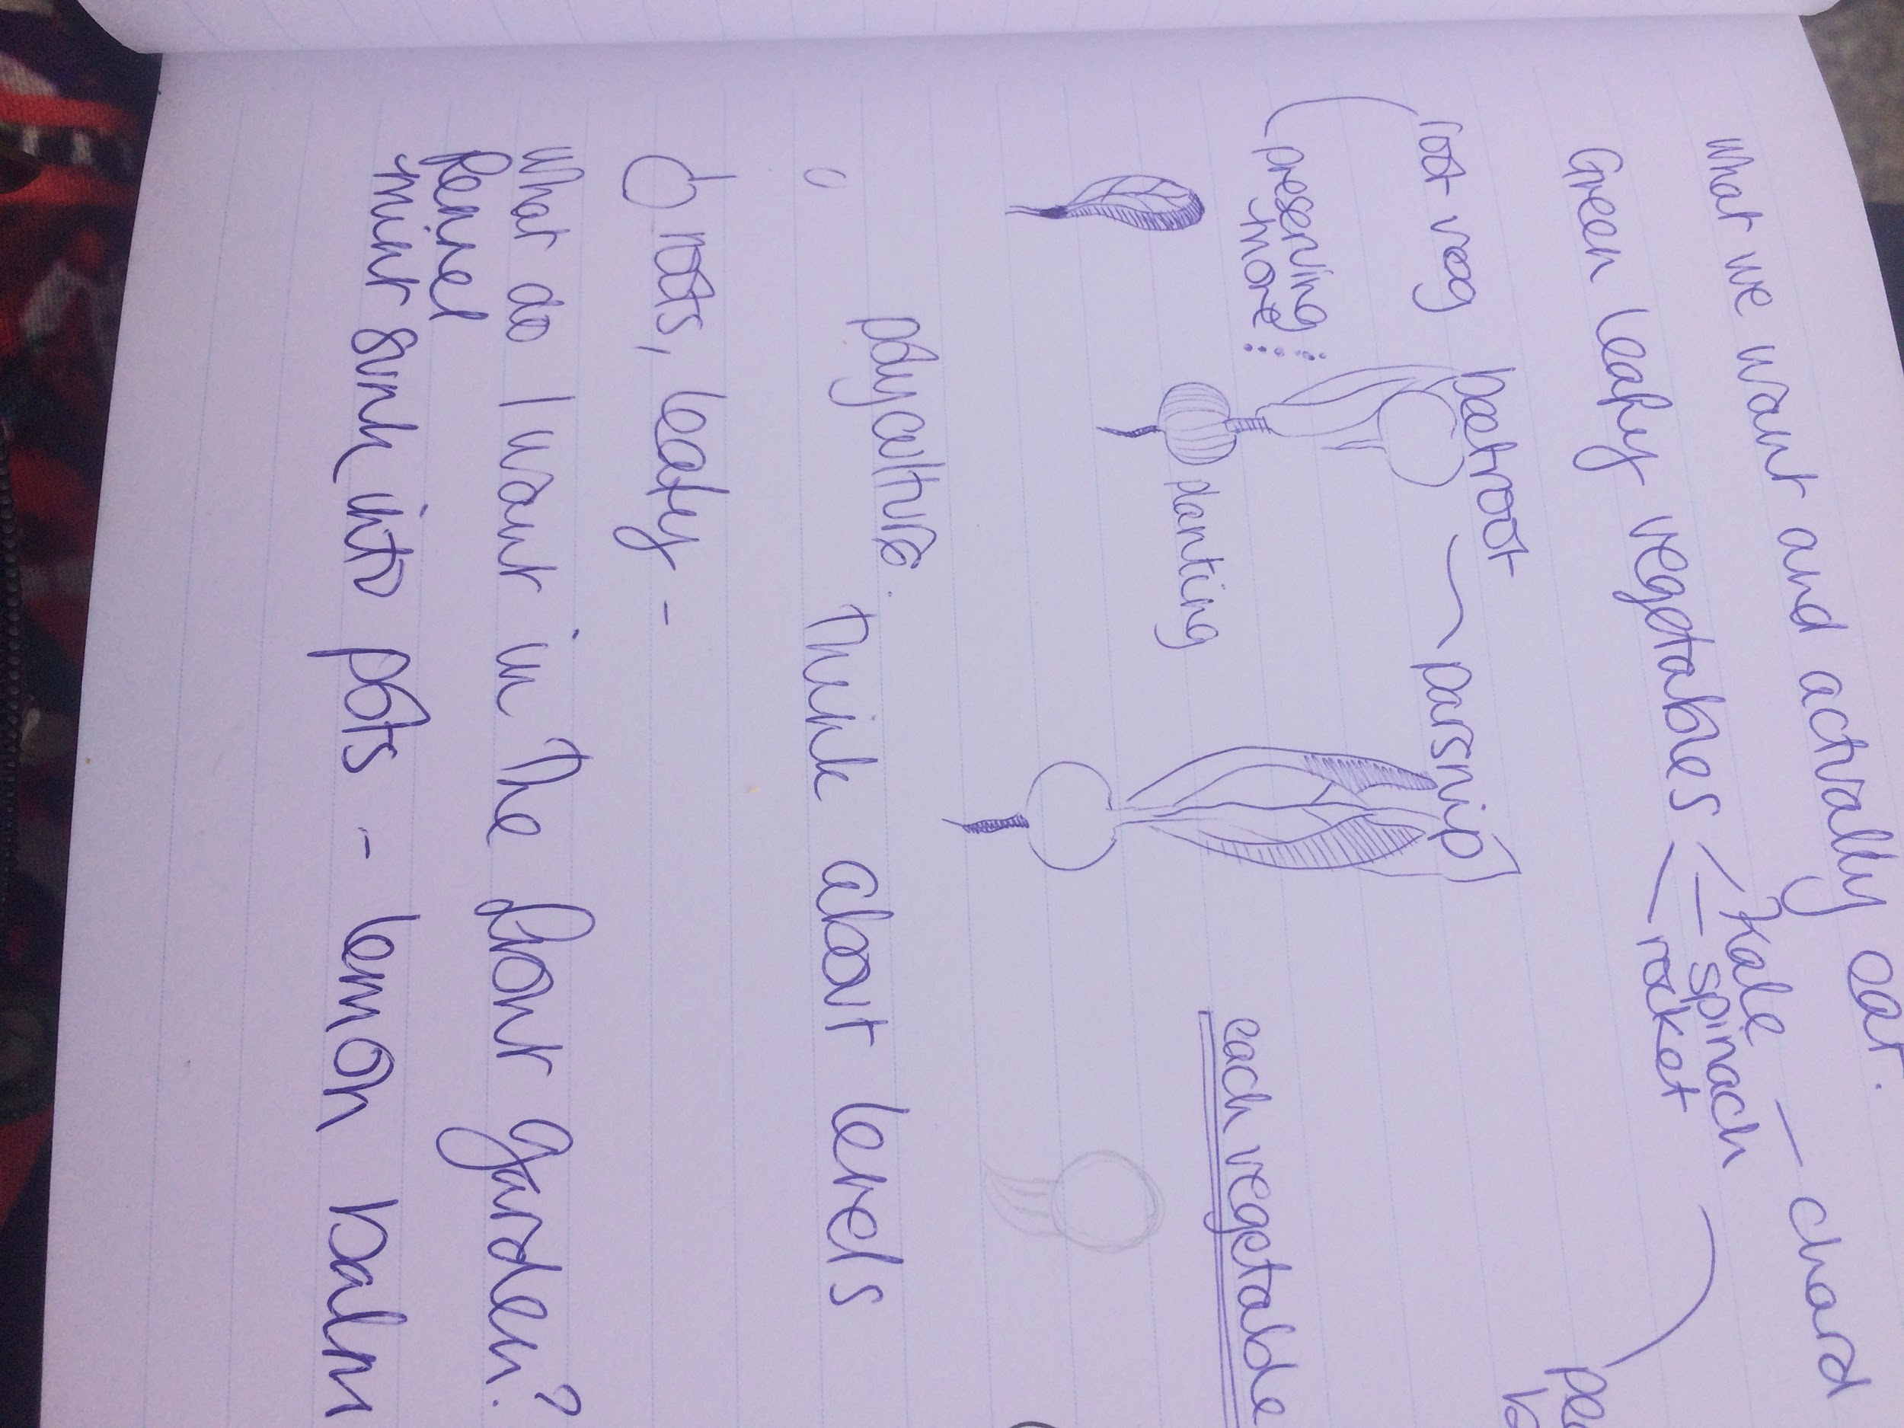
Dominant | Creeping Buttercup  Couch Grass  Other grasses  Brambles  Dandelion
Abundant | Comfrey  Dock
Frequent: | Willowherb
Occasional: | Shepherd's purse  Prickly milk thistle
Rare: | Mare's Tale

Soil and Fertility

Looking at the indicator species and plants on site the soil is fertile.
It is a Clay loam

Climate

The aspect is very great for all day sun and there is not a huge amount of wind thanks to the relatively sheltered position.
Copy and paste some climate data from other design.

Current Risks

For parents and children.
Hazards on site
Paving slabs sticking out
Nowhere clear & pleasant for children to play
Wood with nails sticking out

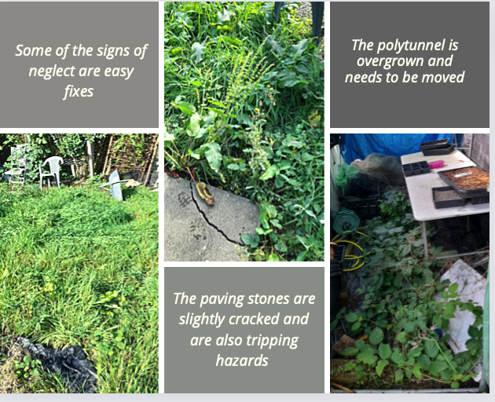

Initial draft thoughts/ideas

Ideas basket
- Seating
- Chairs - a couple could be salvaged and fixed up
- Flowers for cutting
- Dye plants
- Herbs
- Mulch beds
- Straighten paving slabs
- Signage
- A raised bed just for Angela
- Strim the grassy areas.
- Remove wood with exposed nails.
- Clear brambles.
- Fix up the shed roof.
- Take away junk, clear out polytunnel
- Get a planter box for the back of the allotment measured up and priced. This will tidy up this area and remove rust risk.
- Make contact with local resources such as wood chip suppliers and local nurseries.
- We have been given around 7 fruit trees that need a bit of TLC from Hedgehogs nursery in Glenrothes and we can plant them once the area is cleared - cherry, pear and apple.
- Recruit volunteers
- Get some winter crops in front beds after they’re cleared
- Tyres could be used for planting, especially for potatoes. Could be painted.
- Tables could be fixed up and repainted or thrown away.
- Fix wheelbarrow
- Raised beds could be mended with wood to make them more defined.
- Re-cover the polytunnel and clear it out.
- Reconnect the water butt to the shed, once the shed is fixed.

Analyse

Limiting factors

- Small children
- Labour: other people involved
- Time ( only there 5 hours a week )
- Budget £1000
- Limited time for other workers
- Size is large to maintain
- Kelty can be difficult to get to.
- Gate is quite narrow
- I don’t live nearby - it’s an hour’s drive each way.
- My time is paid 5 hours per week
- Gardening knowledge of support workers is low

DESIGN

Ethics and Principles.

Earth Care

This plot will be managed organically and in the longer term the vision is that the allotment area will be a haven of biodiversity and natural health.

The site will also be a place where people can learn about taking care of the environment and do crafts that are ecologically sound and mindful of people's impact on the earth.

People Care

The whole plot at Kelty is based very much on taking care of people and providing a space where families and individuals who may be affected by adversity can find sanctuary. As such it was important to consider human needs in the design. It is hoped that it can be a nurturing connective space.

Fair Share

The garden was a space for people on lower incomes to do things that didn’t cost a lot of money. We wanted to make it a place of natural abundance that was accessible to everyone. We also were able to get donations of plants and materials from local plant nurseries and stately gardens.

Principles

For this design I am using Bill Mollison's principles:

Make the least change for the greatest possible effect.

The site is strongly sorted into spaces from when it was up and running previously. So there are pathways and beds, the shed is large and would be hard to be moved again. It seemed like the best idea on evaluating the situation to work with what was there and work and tidy up around it.

The problem is the solution.

Half of the site is also grassy and mainly flat with some wooded edging in the ground, it was obviously raised beds that were not maintained. It could have been turned back into raised beds or something more complex added. But thinking about this principle, removing the wood and embracing the open space gives a needed area for younger children, saves money and provides energy to make the next steps. We can also add in apple trees easily creating a space that can be developed over time.

Everything gardens

Although I was employed as a gardener it was partially my role to include support workers and their clients in the process by leaving areas for others to experiment and learn. This means that it wasn’t about having a top down controlled process but about creating a structure that allows for divergence.

The yield of a system is theoretically unlimited.

By giving people a chance to experiment and relax in a garden it is possible that this could lead to all sorts of changes in their mindset and skills.

As the plot is now

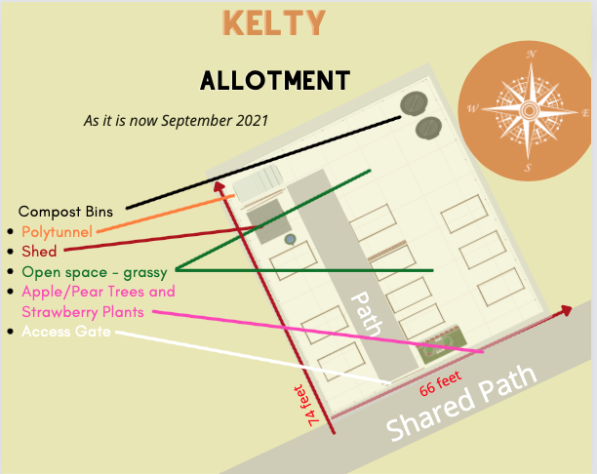

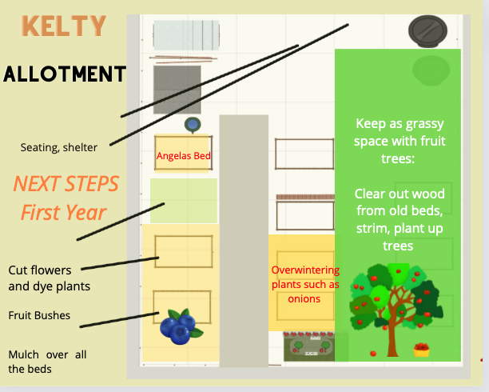

Clean up edges and make a direct impact.

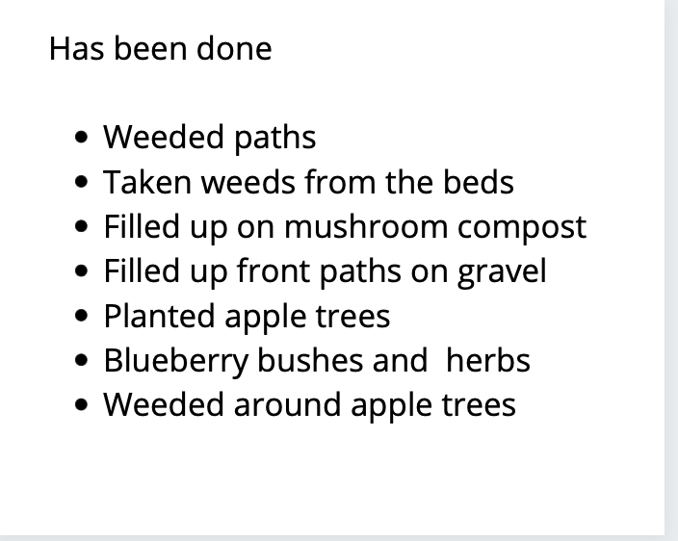

IMPLEMENTATION

Next Steps

To do over the next few weeks.

- Get the grassy areas strimmed.
- Fix hazards pictured below: Uneven paving stones, exposed nails.
- Clear brambles.
- Strim grass and mulch beds
- Fix up the shed roof.
- Take away junk, clear out polytunnel
- Get a planter box for the back of the allotment measured up and priced. This will tidy up this area and remove rust risk.
- Make contact with local resources such as wood chip suppliers and local nurseries.
- We have been given around 7 fruit trees that need a bit of TLC from Hedgehogs nursery in Glenrothes and we can plant them once the area is cleared - cherry, pear and apple.
- Start looking for volunteers
- Get some winter crops in front beds after been cleared

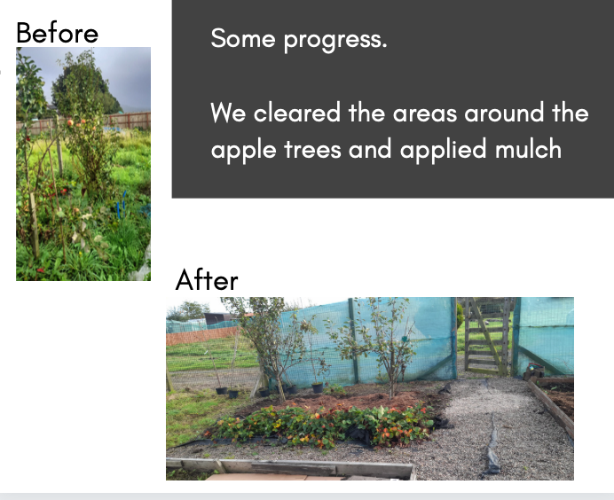

Evaluation
In terms of doing what we set out to do, the plan and adjustments hit the mark.

We had a goal of making an accessible space and there are plans in the footing to do just that.

After writing the majority of the design the plot has been taken over by a local woman who is very keen and she has a lot of contacts within the community which will overcome some of the limitations I spotted.

It was a fairly restricted design and I had a lot of help with the existing structure that was there as well as the input of those who used it regularly and wanted to use it.

We definitely met the goals and in the coming months it will prove to be a valuable, biodiverse nurturing space once again.

Reflection

I found this design to be quite an inspiring one because the space was open and there were a decent amount of resources. It was a good chance to use the ideas and design tools I had acquired in previous designs and personal experience on what was a bigger canvas. The distance was a big barrier for me however and I know that I could have done a lot more to get the community involved with the project if I had lived nearby. I could have also worked on my own time to fix up little things. As it was I always wanted to limit how much I travelled that far so it felt like a limitation.

